Police Operations and
Data Analysis Report
Santa Clara, California
November 2015




475 K Street, NW, Suite 702
Washington, DC 20001
www.cpsm.us
716-969-1360

Exclusive Provider of Public Safety Technical Services for
International City/County Management Association

The Association & The Company

International City/County Management Association (ICMA)
The International City/County Management Association (ICMA) is a 100-year-old, nonprofit professional association of local government administrators and managers, with approximately 9,000 members spanning thirty-two countries.
Since its inception in 1914, ICMA has been dedicated to assisting local governments in providing services to their citizens in an efficient and effective manner. Our work spans all of the activities of local government — parks, libraries, recreation, public works, economic development, code enforcement, Brownfields, public safety, etc.
ICMA advances the knowledge of local government best practices across a wide range of platforms including publications, research, training, and technical assistance. Its work includes both domestic and international activities in partnership with local, state, and federal governments as well as private foundations. For example, it is involved in a major library research project funded by the Bill and Melinda Gates Foundation and is providing community policing training in Panama working with the U.S. State Department. It has personnel in Afghanistan assisting with building wastewater treatment plants and has had teams in Central America providing training in disaster relief working with SOUTHCOM.
The ICMA Center for Public Safety Management (ICMA/CPSM) was one of four Centers within the Information and Assistance Division of ICMA providing support to local governments in the areas of police, fire, EMS, emergency management, and homeland security. In addition to providing technical assistance in these areas we also represent local governments at the federal level and are involved in numerous projects with the Department of Justice and the Department of Homeland Security. In each of these Centers, ICMA has selected to partner with nationally recognized individuals or companies to provide services that ICMA has previously provided directly. Doing so will provide a higher level of services, greater flexibility, and reduced costs in meeting members’ needs as ICMA will be expanding the services that it can offer to local governments. For example, The Center for Productivity Management (CPM) is now working exclusively with SAS, one of the world’s leaders in data management and analysis. And the Center for Strategic Management (CSM) is now partnering with nationally recognized experts and academics in local government management and finance.
Center for Public Safety Management, LLC (CPSM) is now the exclusive provider of public safety technical assistance for ICMA. CPSM provides training and research for the Association’s members and represents ICMA in its dealings with the federal government and other public safety professional associations such as CALEA. The Center for Public Safety Management, LLC maintains the same team of individuals performing the same level of service that it has for the past seven years for ICMA.
CPSM’s local government technical assistance experience includes workload and deployment analysis using our unique methodology and subject matter experts to examine department organizational structure and culture, identify workload and staffing needs, and identify and disseminate industry best practices. We have conducted more than 200 such studies in 36 states and 155 communities ranging in size from 8,000 population (Boone, Iowa) to 800,000 population (Indianapolis, Ind.).
Thomas Wieczorek is the Director of the Center for Public Safety Management. Leonard Matarese serves as the Director of Research & Program Development. Dr. Dov Chelst is the Director of Quantitative Analysis.

Center for Public Safety Management Project Contributors
Thomas J. Wieczorek, Director
Leonard A. Matarese, Director, Research & Project Development
Dov Chelst, Ph.D. Director of Quantitative Analysis
Sarita Vasudevan, Senior Data Analyst
Zachary Weixelbaum, Data Analyst Intern
Wayne Hiltz, Senior Public Safety Consultant –Team Lead
James E. McCabe, Ph.D., Senior Public Safety Consultant
Marilyn Diaz, Senior Public Safety Consultant
Dennis Kouba, Senior Editor

Contents
Tables vi
Figures viii
Section 1. Executive Summary 1
General Observations 1
Recommendations 4
Section 2. Overview 11
Santa Clara Demographics 11
Uniform Crime Report/Crime Trends 11
Section 3. Administration 14
Section 4. Field Operations Division 15
Patrol Division 15
Demand 15
Alarm Reduction Program 17
Automobile Accidents 18
Miscellaneous 19
CFS Efficiency 20
Patrol Deployment 22
Deployment 22
Schedule and Staffing 31
Spatial Representation of CFS Demand 33
Traffic Unit 40
Section 5. Investigations Division 47
Detective Section 47
Special Enforcement Team / AB109 53
Forensic Services 53
Crime Analysis 55
Records Section 56
Section 6. Special Operations Division 61
Temporary Holding Facility (THF) (Field Operations Division) 65
Section 7. Administrative Services Division 68
Administrative Services Lieutenant 68
Information Technology 68
Internal Affairs Unit 69
Professional Standards 72
Recruitment Unit 72
Civilianization Career Development 73
Policy 74
Use of Force 75
Communications 75
Nuisance Suppression Unit 78
Mental Health Issues 81
Evidence and Property Unit 82
Training 84
Police Activities League 87
Police Explorers 87
Community Services Unit 87
Crime Prevention Unit 87
Drug Abuse Resistance Education (DARE) 88
Crossing Guard Supervisor 89
Permits Unit 89
Section 8. Departmentwide Issues 91
Workers’ Compensation 91
Performance Evaluation Instrument 94
Fleet 95
Litigation / grievances 96
Section 9. Data Analysis 97
Introduction 98
Workload Analysis 99
Noncall Activities 120
Deployment 126
Response Times 139
All Calls 140
High-Priority Calls 144
Variation by Year 146
Traffic Units 150
Event Day Variation 154
Appendix A: Call Description Classification 157
Appendix B: Uniform Crime Report Information 166
Appendix C: Staffing Overview 169

Tables
TABLE 2-1: Reported Crime Rates in 2013, per 100,000 12
TABLE 4-1: Calls for Service 16
TABLE 4-2: Alarm History, 2013 and 2014 17
TABLE 4-3: CFS Efficiency 21
TABLE 4-4: Patrol Shift Schedule/Staffing 31
TABLE 4-5: Calls and Work Hours per Day, by Year and Beat 37
TABLE 4-6: Sample 11-Hour Shift/Staffing Schedule 40
TABLE 4-7: Traffic Unit Calls by Category 41
TABLE 4-8: Traffic Unit Noncall Activities by Description 42
TABLE 4-9: Total Traffic Accidents in Santa Clara, 2012-2014 44
TABLE 5-1: Reported Santa Clara PD Clearance Rates in 2013 50
TABLE 7-1: Internal Affairs Investigations, 2012-2014 70
TABLE 7-2: Internal Affairs Allegations and Findings, 2012-2014 71
TABLE 7-3: Average Dispatch, Travel, and Response Times, by Call Priority 77
TABLE 7-4: Evidence & Property Inspection 84
TABLE 8-1: Workers’ Compensation Claims, 2012-2014 92
TABLE 8-2: Nature of Injury, Workers’ Compensation Claims, 2012-2014 92
TABLE 9-1: Events per Day, by Initiator 101
TABLE 9-2: Events per Day, by Category 102
TABLE 9-3: Calls per Day, by Category 104
TABLE 9-4: Calls per Day, by Initiator and Months 106
TABLE 9-5: Calls per Day, by Category and Months 108
TABLE 9-6: Primary Unit’s Average Occupied Times, by Category and Initiator 110
TABLE 9-7: Average Number of Responding Units, by Initiator and Category 112
TABLE 9-8: Number of Responding Units, by Category, Other-initiated Calls 113
TABLE 9-9: Calls and Work Hours by Beat, per Day 115
TABLE 9-10: Calls and Work Hours per Day, by Category, Summer 2014 116
TABLE 9-11: Calls and Work Hours per Day, by Category, Winter 2015 118
TABLE 9-12: Average Noncall Occupied Times, by Category 121
TABLE 9-13: Activities per Day, by Month 122
TABLE 9-14: Activities per Day, by Day of Week 123
TABLE 9-15: Activities per Hour, by Hour of Day 125
TABLE 9-16 Average Response Time Components, by Category 142
TABLE 9-17: 90th Percentiles for Response Time Components, by Category 142
TABLE 9-18: Average Dispatch, Travel, and Response Times, by Priority 144
TABLE 9-19: Calls per Day, by Year and Months 147
TABLE 9-20: Average Response Time by Year and Call Priority 148
TABLE 9-21: Calls and Work Hours per Day, by Year and Beat 149
TABLE 9-22: Traffic Unit Calls by Category 150
TABLE 9-23: Traffic Unit Noncall Activities by Activity Type 151
TABLE 9-24: Number of Calls by Stadium Event Day 155
TABLE 9-25: Event Day Calls by Category 156
TABLE 9-26: Call Descriptions, by Category 157
TABLE 9-27: Noncall Activity Codes, by Activity Type 165
TABLE 9-27: Reported Crime Rates in 2013, by City 166
TABLE 9-28: Reported Municipal, State, and National Crime Rates, by Year 168
TABLE 9-29: Reported Santa Clara PD Clearance Rates in 2013 168

Figures
FIGURE 2-1: Reported Violent and Property Crime Rates in Santa Clara, by Year 12
FIGURE 2-2: Reported Combined Crime Rates, Santa Clara and California, by Year 13
FIGURE 4-1: Deployment and Workload, Weekdays, Summer 25
FIGURE 4-2: Workload Percentage by Hour, Weekdays, Summer 25
FIGURE 4-3: Deployment and Workload, Weekends, Summer 26
FIGURE 4-4: Workload Percentage by Hour, Weekends, Summer 27
FIGURE 4-5: Deployment and Workload, Weekdays, Winter 27
FIGURE 4-6: Workload Percentage by Hour, Weekdays, Winter 28
FIGURE 4-7: Deployment and Workload, Weekends, Winter 28
FIGURE 4-8: Workload Percentage by Hour, Weekends, Winter 29
FIGURE 4-9: Spatial Representation of Other-Initiated CFS (Red=100 CFS) 34
FIGURE 4-10: Spatial Representation of Crime-CFS (Red=100 Crime CFS) 36
FIGURE 4-11: Traffic Unit Deployment and Total Workload, Weekdays, Summer 2014 43
FIGURE 4-12: Traffic Unit Deployment and Total Workload, Weekdays, Winter 2015 43
FIGURE 9-1: Percentage Events per Day, by Initiator 101
FIGURE 9-2: Percentage Events per Day, by Category 102
FIGURE 9-3: Percentage Calls per Day, by Category 104
FIGURE 9-4: Calls per Day, by Initiator and Months 106
FIGURE 9-5: Calls per Day, by Category and Months 108
FIGURE 9-6: Average Occupied Times, by Category and Initiator 110
FIGURE 9-7: Number of Responding Units, by Initiator and Category 112
FIGURE 9-8: Number of Responding Units, by Category, Other-initiated Calls 113
FIGURE 9-9: Percentage Calls and Work Hours, by Beat 115
FIGURE 9-10: Percentage Calls and Work Hours, by Category, Summer 2014 116
FIGURE 9-11: Percentage Calls and Work Hours, by Category, Winter 2015 118
FIGURE 9-12: Percentage Activities and Work Hours by Category 121
FIGURE 9-13: Activities per Day, by Month 122
FIGURE 9-14: Activities per Day, by Day of Week 123
FIGURE 9-15: Activities per Hour, by Hour of Day 124
FIGURE 9-16: Deployed Officers, Weekdays, Summer 2014 127
FIGURE 9-17: Deployed Officers, Weekends, Summer 2014 127
FIGURE 9-18: Deployed Officers, Weekdays, Winter 2015 128
FIGURE 9-19: Deployed Officers, Weekends, Winter 2015 128
FIGURE 9-20: Deployment and Other-Initiated Workload, Weekdays, Summer 2014 130
FIGURE 9-21: Deployment and Other-Initiated Workload, Weekends, Summer 2014 130
FIGURE 9-22: Deployment and Other-Initiated Workload, Weekdays, Winter 2015 131
FIGURE 9-23: Deployment and Other-Initiated Workload, Weekends, Winter 2015 131
FIGURE 9-24: Deployment and Main Workload, Weekdays, Summer 2014 133
FIGURE 9-25: Deployment and Main Workload, Weekends, Summer 2014 133
FIGURE 9-26: Deployment and Main Workload, Weekdays, Winter 2015 134
FIGURE 9-27: Deployment and Main Workload, Weekends, Winter 2015 134
FIGURE 9-28: Deployment and All Workload, Weekdays, Summer 2014 136
FIGURE 9-29: Deployment and All Workload, Weekends, Summer 2014 136
FIGURE 9-30: Deployment and All Workload, Weekdays, Winter 2015 137
FIGURE 9-31: Deployment and All Workload, Weekends, Winter 2015 137
FIGURE 9-32: Average Response Time, by Hour of Day, Summer 2014, and Winter 2015 140
FIGURE 9-33: Average Response Time by Category, Summer 2014 141
FIGURE 9-34: Average Response Time by Category, Winter 2015 141
FIGURE 9-35: Average Response Times and Dispatch Delays for High-Priority Calls, by Hour 145
FIGURE 9-36: Average Calls per Day by Year and Months 147
FIGURE 9-37: Average Response Time by Year and Call Priority 148
FIGURE 9-38: Traffic Unit Deployment and Total Workload, Weekdays, Summer 2014 152
FIGURE 9-39: Traffic Unit Deployment and Total Workload, Weekdays, Winter 2015 152
FIGURE 9-40: Reported Violent and Property Crime Rates, by Year 167
FIGURE 9-41: Reported Municipal and State Crime Rates, by Year 167

Section 1. Executive Summary
The Center for Public Safety Management, LLC (CPSM) was commissioned to review the operations of the Santa Clara Police Department (SCPD). While our analysis covered all aspects of the department’s operations, particular areas of focus of our study were: (1) identifying the appropriate staffing of the agency given its workload, community demographics, and crime levels, (2) operational effectiveness and efficiencies, (3) assessing special event planning related to events held at Levi’s Stadium, and (4) use of technology in police operations.
We analyzed departmental workload using operations research methodology and compared that workload to staffing and deployment levels. We reviewed other performance indicators, which allowed us to understand the implications of service demands on current staffing. We reviewed the department’s organizational design to determine if the many functions required of a modern police agency are staffed appropriately.
Our study involved data collection, interviews with key police and city administrative personnel, on-site observations of the job environment, data analysis, comparative analyses, and development of alternatives and recommendations.
This report is made up of two parts. The first part (Sections 1 through 8) is comprised of our operations assessment of the department based upon the review of numerous documents provided by the city and the site visit by the CPSM team. The second part (Section 9) is CPSM’s data analysis, primarily of patrol workload activity, and based upon the records from computer-aided dispatch (CAD) provided by the department. These parts complement each other. You will note that some information, including tables and figures, are reflected in both parts of the report, as material from the data report was used extensively to assist in the operational assessment.
Overall, the Santa Clara Police Department was found to be a well-managed organization. Department staff who were interviewed appeared to be enthusiastically committed to the betterment of the organization and community.
As part of this Executive Summary, we have listed general observations that we believe identify some of the strengths of the department and the challenges it faces. Additionally, we have included a master list of recommendations for consideration; we believe implementation of these recommendations will enhance organizational effectiveness. In the pages that will follow, we will address specific divisions and units and provide details that formed the basis for the recommendations offered.

General Observations
These observations are generally applicable to or have an impact upon the entire department rather than solely a specific division. They are identified here for that reason, but may be addressed further under the assessment and recommendations for specific divisions/functions.
- FBI Uniform Crime Report (UCR) data show that Santa Clara enjoys a relatively low violent crime rate at approximately one-third of the statewide average, while its property crime rate is slightly below the state’s average. Given recent changes in the law and sentencing guidelines for a variety of offenses, the city should anticipate increased criminal activity, particularly as it relates to property crimes.
- Santa Clara, as noted above, enjoys a relatively low crime rate. In comparison to studies conducted by CPSM of other law enforcement agencies, Santa Clara’s crime rate and service demands (calls for service) fall below the other studies’ averages, as does the department’s sworn staffing levels. However, the Santa Clara Police Department is far more responsive to its community’s needs than some other departments. This is reflected in the fact that averages from the above studies reflect that SCPD deploys more resources and spends more time on calls for service and other activities than average. As a result, the workload hours for SCPD officers reflect higher-than-average numbers. This is also reflected in higher-than-average response time to citizen calls for service.
- The city of Santa Clara was impacted significantly by two financial forces between 2007 and 2012: the national recession and the loss of Redevelopment Agency-related funding. The police department felt the impact of revenue loss through layoffs and a hiring freeze placed upon the agency, and which ultimately reduced operational capacity and strained resources. Fortunately, the improving economic picture coupled with significant projected growth within Santa Clara may allow for some relief.
- In the recommendations section that follows, CPSM will suggest significant staffing changes. Many involve the simple restoration of frozen positions, but modest staffing increases are also warranted along with some workload realignment. Many, but not all of the recommendations will address the opportunity to add civilian support positions in lieu of new sworn positions. Throughout the department, sworn officers are responsible for a number of duties that don’t require such expertise, such as minor crime reporting, noninjury traffic collision investigations, and a variety of clerical duties. In other instances, sworn officers are responsible for duties that are better suited for a civilian with specialized expertise (such as Information Technology, Forensics, etc.). In the divisional reports that follow, CPSM will identify positions that could be handled more efficiently, effectively, and with cost savings by a civilian rather than a sworn position.
- In virtually all studies conducted by CPSM, lack of communication is cited as a major organizational impediment. That sentiment was expressed in Santa Clara as well. In some cases, the concern raised is justifiable, and in other cases, those who express the concern have subjected themselves to selective awareness. In any event, open constructive communication is vital to any organization. Though command staff does attend many of the department’s quarterly training sessions to provide updates on major projects and answer questions, consideration should be given as to whether this is the most effective way to do so. Another option that executive staff may consider is a quarterly lunchtime “State of the Department” briefing where staff can give a short status report on important issues facing the department and allow for questions or input from all employees. No, this is not a panacea, but those who are truly interested in department activities outside of their “workspace” can get a better understanding of the department’s work plan and how they may contribute to the betterment of the department. For those who have selective awareness, they have only themselves to blame should they choose not to participate.
- As an alternative to the quarterly lunch briefings, the chief’s office could consider writing a weekly/monthly message to department and community members and which addresses operational and administrative highlights, excellent work, and expanded or new services, etc. Some chiefs have found such a communication to be a useful way to update the department and the community in a timely manner. However, this method does not provide for direct interaction and a two-way exchange.
- While Levi’s Stadium is a valuable addition to the city and its financial health, its presence will have a dramatic impact on the department. CPSM was highly impressed with the planning efforts of SCPD to deal with stadium events, especially given the fact that the stadium has only been in operation for one year. The Special Events Unit is to be commended for its efforts. Planning for and staffing major events for such a venue is a complex and demanding task made all the more demanding by the size of the city and specifically, the police department. Significant outside resources will be required to staff these events, and fatigue of SCPD personnel will become an issue that will need to be monitored and addressed. Private security services must be effectively integrated into the overall security plan, and the selection and retention of a qualified security firm is imperative. A direct nexus exists between the effectiveness of the security firm and the department’s ability to control its staffing costs.
- CPSM was asked to look at the impact of stadium events on patrol operations. To do so, we looked at variations in patrol workload on event days vs. non-event days. In short, there was no appreciable difference in workload. Additional information is available in the data section. We would note, however, that the nature of an event can certainly change this assessment. For instance, jurisdictions report that hosting a hip-hop concert will have a significant impact on patrol operations while a concert with a teen or preteen audience will not.
- Substantial technology enhancements and an improvement in servicing are called for throughout the organization. This issue was both recognized by CPSM consultants, and raised as an issue by those interviewed, as the current situation has an impact on productivity throughout the organization. While the city contract with a private vendor for IT services may work well during normal business hours and therefore meet the needs of most other city departments, public safety’s 24/7 schedule does not lend itself to such service. The creation of an IT unit within the police department is essential.
- The issue of the potential for several retirements following the NFL Super Bowl in early 2016, including several supervisors, was raised by various personnel on multiple occasions. If that proves to be the case, the department will face challenges associated with the loss of experienced personnel as well as challenges associated with the hiring and training of new employees. Again, if these retirements take place, sound succession planning ahead of time will be vital to reduce the impact of this loss of personnel.
- In speaking with the Planning Officials of the city, we learned that significant development will be occurring on several large parcels of land. These projects will be primarily high-end residential properties and commercial, office-type projects. Such land use generally does not generate significant changes in criminal activities or law enforcement-related calls for service, especially in a robust community like Santa Clara. However, the addition of such very large office development as planned will dramatically increase vehicle traffic in the city—potentially beyond 100,000 additional one-way trips per day. Such a significant increase in vehicular traffic will inevitably generate additional traffic-related calls for service both in terms of accident investigations and enforcement. We believe that it will be critical for the department to prepare for this increase in advance of the actual development. This effort must include all three of the aspects of addressing traffic issues; engineering, education, and enforcement. The department should work closely with planning officials to have in place a program to meet these increased demands.

Recommendations
There are a number of recommendations put forth by CPSM that stem from interviews and assessments conducted throughout the organization. While these recommendations were identified based upon interviews and assessments specific to a departmental function such as training, they may have broader departmental impacts. Additional detail/justification pertaining to each can be found within the reporting of each subject area.
Let us be perfectly clear: these recommendations, though numerous, are in no way a reflection of any departmental deficiency. Rather, they present opportunities to build upon the strengths of this outstanding organization by offering additional steps that might be taken to improve operations. You will note that the vast majority of these recommendations involve or result from what are believed to be moderate staffing deficiencies. CPSM recognizes that economic, operational, and political realities can impact these opportunities. As well, many of these recommendations are items that must be part of a long-term improvement plan and it is unrealistic to expect effective implementation within weeks or even months. Nonetheless, each recommendation is believed to add value and is worthy of consideration. It is the responsibility of the City of Santa Clara and the Santa Clara Police Department to determine which of these recommendations may provide the greatest value to the organization should political, budgetary, or operational restrictions limit those that may be considered.
The following recommendations are offered for consideration:
- Empanel a calls for service (CFS) committee to evaluate service demands and attempt to reduce and/or eliminate nonemergency responses.
- Adjust the start and end times of the patrol shifts
- Increase minimum patrol staffing to 7 officers.
- Allocate one captain, four lieutenants, 12 sergeants, 76 police officers, and six community service officers to patrol.
- Address “hot spots” in the community with appropriate patrol and crime prevention plans.
- Adopt a strategic approach to traffic safety. Place the responsibility for traffic safety with the patrol commander and use the Traffic Unit as the research and planning arm to support this effort.
- Reconstitute the Traffic Unit into two teams that work in conjunction with the A/B-side rotation and with flexible hours of deployment.
- The department should immediately take steps to utilize/acquire a suitable case management software program that would, at a minimum, allow for supervisor review of all open cases, establish a time schedule for submission of supplemental reports on these cases, include an automated notification of delinquent investigations, and record clearances as defined by the UCR. This software should allow for query by section, unit, and individual investigator.
- Efforts should be made to restructure the Detective Section into more appropriately managed functions such as crimes against persons, property crimes, and family crimes, each to be headed by a sergeant responsible for supervising a sufficient number of skilled detectives to manage the assigned caseload. This will result in a reduction of the number of sergeants assigned to the section, while increasing the number of detectives. As well, additional detectives would be required to absorb the caseload vacated by the remaining sergeants. As an example, four sergeant positions would be downgraded to detective, and three additional detective positions would be required to absorb the caseload presently carried by the remaining three sergeants who would now provide supervision to the Section..
- A training matrix for each detective assignment should be completed to ensure that the detectives have sufficient training to allow for successful investigation of criminal activity specific to their areas of assignment. It is acknowledged that the department is presently taking action to accomplish this.
- Rotational schedules for detective assignments should be established based upon the complexity and expertise required to adequately investigate the specific crimes that fall within that assignment.
- Consideration should be given to providing “smart phone” technology — under tightly regulated conditions — to detectives for business use.
- Consideration should be given to increasing the authorized staffing in the Detective Section by one detective and transferring all auto theft and auto burglary related crimes from SET to this position.
- Consideration should be given to staffing the Detective Section with a CSO who would be responsible for completing the necessary paperwork for filing of cases with the District Attorney’s office and other clerical support as appropriate and necessary. This action would reduce the workload of virtually all detectives and allow for more thorough investigation of crimes.
- Training of appropriate department staff, including detective supervisors, should be provided on the FBI UCR criteria for “clearing” crimes to allow for those numbers to be used to improve the effectiveness of detectives and the department as a whole.
- Investigative responsibility for auto theft, vehicle burglary, and theft from vehicle cases should be transferred from SET to the investigative arm of the Detective Section. This should not result in a reduction of staffing to SET.
- The department should consider the development of a full-time forensics team staffed by civilians and under the direction of the forensics coordinator. This team would be responsible for the identification, collection, and preservation of physical evidence at crime scenes and others as appropriate.
- A tracking mechanism should be put into place to record the efficiency and effectiveness of individual and group efforts in the collection of evidence. This would allow for the establishment of benchmarks that would assist in performance measurement and the identification of training needs.
- The forensics coordinator and or/forensics team (if implemented) should receive adequate and ongoing training to serve as a resource to detective personnel in retrieving data evidence from telephones, computers, and other electronic devices.
- It is recommended that the three Records Section positions frozen in 2011 be reinstated. This would significantly aid in reducing if not eliminating the backlog of important work.
- If the three positions referenced above are filled, consideration should be given to reassigning the police officers from Records to a more appropriate assignment, such as detectives or patrol.
- The rate structure for the release of police reports, photos, etc., should be evaluated in order to ensure that the costs of providing such services are recovered as allowable by law. The side benefit of this reasonable action would likely result in sufficient new funding to support the addition of some or all of one FTE as needed and reflected in the prior recommendations.
- Consideration should be given to discontinuing the practice of accepting cash for report copies, vehicle releases, background services, fines, fees, etc., and moving to a system of accepting only credit/debit cards, checks, or money orders.
- In order to reduce the intake of nonessential calls into the Records Section, consideration should be given to creating a protocol whereby officers provide their direct telephone voice mail number when handing out business cards or direct individuals to contact them via a police department telephone line.
- The department should seek to increase permanent staffing of the Special Events Section by one FTE police officer.
- Once adequately staffed, the duties presently managed by the recruitment officer in supplying names of available “double badgers” for various major events should be assumed by Special Events.
- The department should work closely with Levi’s Stadium management and its security companies to ensure that the security companies perform at a level appropriate for such venues.
- Police staffing at events can and should be adjusted based upon anticipated crowd behaviors and the capability of private security.
- Jail service officer (JSO) staffing should be returned to the level required to operate the department’s temporary holding facility on a 24-hour basis.
- In order to reduce the redundancy created by completing both a Santa Clara County and a SCPD medical screening document as part of the booking process, an effort should be undertaken to standardize the medical screening document for all Santa Clara County law enforcement agencies.
- Consider publishing an annual report that reports on departmental goals and achievements; an organization chart; internal affairs data; individual, unit, and citizens’ recognition; promotions and retirements, etc. Only limited data of this kind can be found on the department’s website. An annual report presents important information in an organized format and does not require the reader to navigate through a website. In some departments, the Chief presents the annual report to the city council.
- Create an IT unit within the department and which is staffed with two technicians. The lack of an immediate response to IT problems in the department is an impediment to effective operations. The city’s Unisys contract has not delivered the rapid service needed in a 24/7 emergency services organization. Though assistance is eventually provided, delays result in frustration and compromise the timely completion of work throughout the department.
- A monthly IA report should be presented to the chief and command staff for review during a regularly scheduled command meeting. The report should list all cases initiated in the month, nature of complaint, involved personnel, case status, open cases carried over from prior months, and cases closed, including disposition. This report can now be easily created through the LEA IA management software.
- Consider reassigning social media duties to the staff analyst in the chief’s office. The Administrative Services lieutenant is now responsible for this; however, the lieutenant’s position is subject to a two- to three-year rotation, meaning a rotated-in lieutenant would have to take time to become familiar with social media duties. The staff analyst is in a permanent assignment working from the chief’s office and is ideally situated to handle this responsibility.
- Develop a job description for the Recruitment Unit officer.
- Reassign the double badgers and Levi’s Stadium duties from the Recruitment Unit, Administrative Services Division, to Homeland Security/Special Event Planning in the Special Operations Division. Once part-time employees are hired it should not be the responsibility of recruitment to schedule them for special events nor for the Recruitment officer to work the same stadium-related events. These duties are more closely aligned with Event Planning’s role.
- Create two new dispatcher positions in the Communications Unit. The unit is understaffed, even if the current vacant dispatcher position is filled. The shortage has resulted in supervisors not being able to attend mandated training, fatigue for the personnel required to work overtime, and insufficient call takers to handle call traffic at peak periods.
- CPSM recommends that a communications team look for ways to reduce the 2.7 minute response time between the receipt of a Priority 1 call and dispatch of the call to field units.
- Complete the communications manual.
- Install cameras in the Evidence and Property booking areas, and the gun, jewelry, and narcotics storage rooms. Cameras are valuable as a deterrent to theft and a tool in investigations, where they have been instrumental in both clearing and identifying staff involved in misconduct.
- Limit the mission of the Nuisance Suppression Unit to an achievable level and reassign other duties. The NSU is a high-performing unit, but has taken on far too many ancillary tasks for a three-member unit. Some tasks, such as mental health outreach, should be handled by a specially trained team.
- Create a method for NSU to accurately capture information about its workload and productivity.
- Transfer the CSO assigned to the North substation to split responsibilities between Permits and Evidence & Property. Both units need assistance with backlogs, and no one is crossed-trained in Permits.
- Officers who have not been through critical intervention training (CIT) should receive abbreviated training in recognizing signs of mental illness and techniques to de-escalate crises.
- Create a mental health team of police officers who can proactively address homelessness and mental illness, particularly cases and locations that result in multiple calls for service. Some departments have arranged for licensed clinical social workers to pair with police officers at no cost to the police agency. This may be also be an option to explore.
- Use salary savings from vacancies to hire retired police officers part-time to perform preemployment investigations.
- Consider appointing a committee to develop a structure for civilian career development.
- Create a recruitment team to actively recruit police employees and to participate in oral boards.
- Consider replacing sworn positions with civilians in training and range master positions as vacancies occur. The personnel in these positions are experienced and highly competent, although the trend in policing is toward placing civilians in such assignments. This is cost efficient and creates more career opportunities for civilian employees.
- Move the office specialist assigned to Training from the Administrative Services Division’s clerical desk to training sergeant’s office. The training manager and office specialist need to work in proximity to conduct business efficiently. The phone calls the specialist takes at the Administrative Services desk could be forwarded to the Training office.
- A standardized training schedule for roll call training should be developed to ensure uniformity and regularity of training. Patrol roll call training is inconsistent at times from one shift to another. The same validated training for all shifts should be presented and documented to ensure uniformity.
- Develop a training curriculum, with input from local mental health professionals, for dealing with the mentally ill. The training should be included in the two-year master training calendar at appropriate intervals.
- A two-year master training calendar for recurring departmental training should be developed. This should be an active document, subject to modification as needed.
- Address the reason for patrol officers’ noncompliance with the mandated DVD-based training courses to ensure completion of training.
- Create a department safety committee to review and determine if on-duty injuries and collisions were preventable.
- Assign a second CSO to the Crime Prevention Unit. The Crime Prevention Unit is understaffed for a city the size of Santa Clara and should have a minimum of two CSOs.
- Consider recruiting Citizen’s Police Academy graduates to volunteer in crime prevention.
- As staffing permits, continue assigning patrol officers to speak to neighborhood watch groups within their beats. This will build their speaking skills, enhance relationships with residents in their beats, and increase their understanding of the importance of crime prevention.
- The department should reevaluate the practice of sending DARE officers to nonessential calls. For example, at present, officers respond to requests from parents whose child refuses to go to school. This is arguably a parental, not a police, responsibility. Also, DARE officers will be handling increased CFS after the elimination of an officer’s position in their unit.
- Increase enforcement by the Permits Unit. The unit issues permits for 87 businesses and more than 500 individuals. Compliance checks are relatively infrequent, but highly effective when they do occur. During one enforcement operation, the NSU checked a portion of massage-related permit holders and cited nearly ninety-five percent of them for violations. Other permit holders such as taxicab drivers, contracted tow companies, firearms dealers, pawnshops, etc., generally go unchecked. This indicates a need for at least occasional compliance checks of other permit holders.
- Temporary modified duty assignments (of 30 to 90 days) should be identified and a detailed written description of the duties of each assignment should be developed, including the environmental conditions under which the work is to be performed. This will assist a treating physician in determining if the medical condition of an injured employee would allow for such assignment. Once these descriptions are ready, outreach to treating facilities should be conducted on an annual basis to affirm the availability and desirability of these temporary assignments.
- Supervisors should accompany employees seeking initial medical treatment/evaluation to the treating facility when such treatment is provided at a city-contracted facility. The supervisor should consult with the treating physician and discuss with them the availability of temporary modified duty assignments as defined above to assist in determining if such work can be performed where available.
- In the event an injured worker is found to be temporarily disabled and will be on a lost-time status, his or her first-line supervisor should be in weekly contact with the employee to ensure that his or her needs are being met, as well as provide encouragement for a speedy recovery.
- If an injured worker has a predesignated physician and seeks treatment with that provider, information on available temporary modified duty should be provided to that physician without delay, so as to inform the physician about the availability and desirability of temporary modified duty assignments.
- CPSM supports the department’s efforts to create a meaningful performance rating instrument and encourages it to move forward with this effort.
- Subsequent to the Super Bowl, staff should examine the level of need for “Unfunded Retained” fleet vehicles and retain only those as necessary and appropriate.
CPSM staff would like to thank the city and police administrations of Santa Clara for their assistance in completing this project. In particular, CPSM commends Police Chief Michael Sellers for his willingness to open the department to review as well as his cooperation and enthusiasm in ensuring a successful assessment effort. We would also like to acknowledge Captain Wahid Kazem, who served as the point of contact for CPSM requests and scheduling needs. This was no small task. Over the past several months he graciously responded to each and every request from CPSM staff, and this project could not have been completed without his cooperation and assistance. Lastly, we acknowledge that our work necessarily disrupted the normal duties of so many staff at the police and other city departments, and wish to express our appreciation for their cooperation and professionalism.

Section 2. Overview
Santa Clara Demographics
Santa Clara, the county seat of Santa Clara County, had an estimated population of 120,150 as of 2013, an increase of 3.2 percent since 2010. The city encompasses an area of approximately 18.4 square miles and is home to Santa Clara University and Levi’s Stadium, home of the
San Francisco ‘49ers. Applied Materials is the city’s largest employer.
As of 2010, the city’s population demographics were: 37.7 percent Asian, 36.1 percent White, 19.4 percent Latino, 5.3 percent two or more races. 2.7 percent Black, and 0.5 percent Native American. The percentage of persons living below the poverty level from 2009 to 2013 in Santa Clara, 9 percent, was nearly 43 percent below the California state average of 15.9 percent.

Uniform Crime Report/Crime Trends
The FBI’s Uniform Crime Report (UCR) contains seven major Part 1 offenses used to measure the extent and distribution of serious crime in a geographic area. Part 1 crimes are the seven most serious violent and property felony crimes: murder, robbery, rape, aggravated assault, burglary, larceny, and motor vehicle theft.
One must be cautious in interpreting comparative crime data. Many variables unique to communities can affect crime rates. The data that follow reflects the FBI’s violent and property crime rate per 100,000 residents. It shows that Santa Clara has a significantly lower violent crime rate than the California and national averages. Property crime rates are modestly lower. Table 2-1 reflects rates from 2013, the last year for which comparative data are available.
As shown in the table, Santa Clara had a UCR Part I violent crime rate of 143.15 crimes per 100,000 population in 2013. This rate is 65 percent below the state average and 61 percent below the national average. The city’s UCR Part 1 property crime rate of 2,516.02 crimes per 100,000 population was 5 percent below the state average and 8 percent below the national average. It is not intended that the table of comparative crime rates be used to compare Santa Clara against another specific regional city; rather, it is meant as an illustration of the city’s crime rate in relation to the region, state, and nation.

TABLE 2-1: Reported Crime Rates in 2013, per 100,000
City | Population | Crime rates
City | Population | Violent | Property | Total
Campbell | 40,549 | 261.41 | 3,854.60 | 4,116.01
Cupertino | 60,440 | 67.836 | 1,343.48 | 1,411.32
Gilroy | 51,240 | 351.29 | 3,395.78 | 3,747.07
Los Altos | 30,225 | 76.096 | 1,184.45 | 1,260.55
Los Gatos | 30,351 | 82.37 | 1,815.43 | 1,897.80
Milpitas | 69,522 | 133.77 | 2,973.16 | 3,106.93
Morgan Hill | 39,907 | 157.87 | 1,693.94 | 1,851.81
Mountain View | 77,399 | 202.85 | 2,204.16 | 2,407.01
Palo Alto | 66,964 | 80.64 | 2,214.62 | 2,295.26
San Jose | 992,143 | 324.05 | 2,571.20 | 2,895.25
Santa Clara | 120,150 | 143.15 | 2,516.02 | 2,659.17
Saratoga | 30,897 | 45.312 | 718.516 | 763.828
Sunnyvale | 148,160 | 97.192 | 1,642.82 | 1,740.01
California | 38,332,521 | 402.1 | 2,658.10 | 3,060.20
United States | 316,128,839 | 367.9 | 2,730.70 | 3,098.60

The following figures reflect the 10-year trend for violent and property crimes in Santa Clara, as well as the 10-year trend in the combined rate of crime (violent and property) in Santa Clara compared to that combined rate in the state of California.
FIGURE 2-1: Reported Violent and Property Crime Rates in Santa Clara, by Year
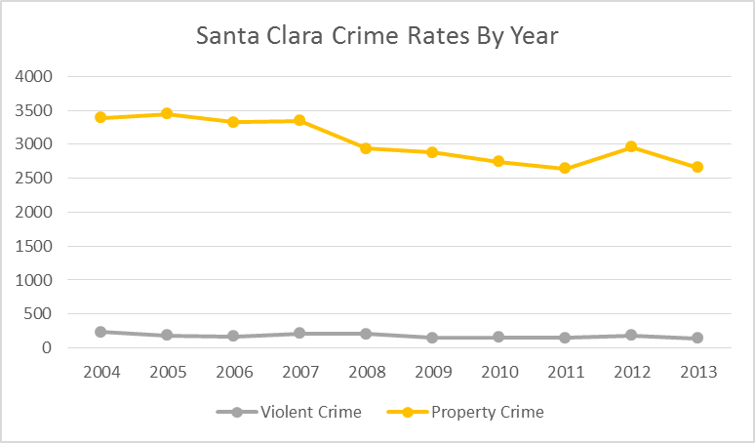

FIGURE 2-2: Reported Combined Crime Rates, Santa Clara and California, by Year
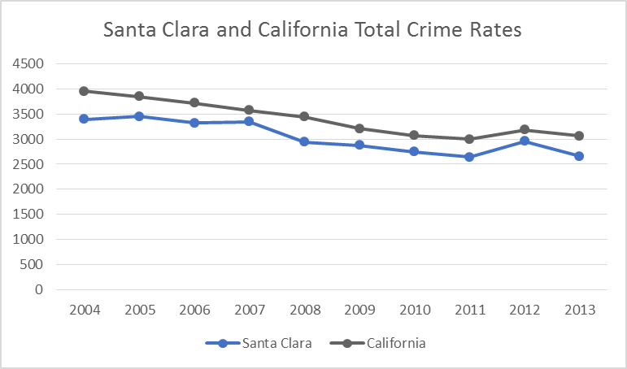

Section 3. Administration
The Santa Clara Police Department is led by the chief of police, who is elected by the citizenry of Santa Clara rather than appointed by the city manager. The chief serves a four-year term, and may seek reelection for an unlimited number of terms. This is a highly unusual methodology, though not unprecedented. It was reported that there has never been an elected police chief who was not an active member of the police department prior to election to the position.
Under the direction of the chief, assisted by an assistant chief of police, the department presently operates under four major divisions: (1) Field Operations, (2) Investigations, (3) Special Operations, and (4) Administrative Services. This four-division alignment was newly formed in
July 2015, when the functions of Homeland Security, Intelligence, and Special Events were separated from the Investigations Division and grouped within the newly created Special Operations Division. A primary reason for this reorganization was to address expanded activity associated with Levi’s Stadium and especially the upcoming NFL Super Bowl in February 2016.

Section 4. Field Operations Division

Patrol Division
The Santa Clara Police Department provides the community with a full range of police services, including responding to emergencies and calls for service (CFS), performing directed activities, and solving problems. The department is service-oriented, and thus provides a high level of service to the community. Essentially, every call for service from the public gets a police response and every criminal case gets investigated. The department embraces this approach and considers every request for service from the public important and deserving of a police response.

Demand
It was reported to the CPSM team that no call is considered too minor to warrant a response and no case is too small to warrant an investigation. The department has an expression “100% contact, 100% of the time.” The result of this policing philosophy is the delivery of comprehensive policing services to the Santa Clara community. The department has the hallmark of a small-town approach to policing, treating every citizen as a member of a community. Service is personalized, the police are part of the fabric of the community, and expectations for police service are high.
This approach is not without costs, however. Considerable resources are needed to maintain the small-town approach, since the patrol division must be staffed with sufficient officers to respond to the community’s needs and expectations.
When examining options for the department’s direction, the city and the department face the choices of: a) continuing to police the community as is done now, or b) take steps to restructure how to respond to demand, still promote order and safety, but free up additional time for officers to engage in proactive patrol. That is, the department must decide whether to sustain its comprehensive level of police service or take the steps necessary to manage public demand. Essentially, this is a political decision regarding the quantity of police services offered to the Santa Clara community. But quality doesn’t need to suffer. The recommendations offered regarding operations, if implemented, will permit the Santa Clara Police Department to continue its full-service model of policing yet run the agency more efficiently.
TABLE 4-1: Calls for Service
Category | Police-initiated |  |  | Other-initiated
Category | Calls | Units per Call | Minutes | Calls | Units per Call | Minutes
Accident | 170 | 1.7 | 28.1 | 1,889 | 1.9 | 40.5
Alarm | 32 | 1.9 | 15.3 | 3,437 | 2.6 | 14.1
Animal call | 8 | 1.4 | 15.0 | 438 | 1.4 | 23.0
Assist other agency | 17 | 2.3 | 31.0 | 996 | 2.5 | 34.6
Check/investigation | 5,633 | 1.1 | 16.5 | 3,079 | 2.3 | 30.5
Crime–persons | 34 | 2.1 | 53.7 | 1,466 | 2.6 | 68.4
Crime–property | 115 | 1.5 | 37.3 | 4,016 | 1.8 | 45.8
Disturbance | 105 | 2.2 | 30.2 | 5,732 | 2.6 | 30.9
Juvenile | 2 | 1.0 | 36.3 | 161 | 2.1 | 52.8
Miscellaneous | 1,473 | 1.2 | 23.7 | 3,212 | 1.6 | 27.3
Pedestrian/Traffic Stop | 14,469 | 1.4 | 18.3 | 833 | 1.5 | 23.7
Prisoner–arrest | 37 | 2.4 | 83.3 | 120 | 2.4 | 69.3
Suspicious person/vehicle | 919 | 1.9 | 18.5 | 3,227 | 2.6 | 28.2
Traffic/vehicle related | 637 | 1.2 | 24.6 | 2,866 | 1.4 | 30.2
Total | 23,651 | 1.3 | 18.8 | 31,472 | 2.2 | 32.6

Table 4-1 presents information on the main categories of calls for service received from the public and which the department handled between the period May 1, 2014 to April 30, 2015. In total, department officers were dispatched to just over 55,000 calls during that twelve-month period, or approximately 151 calls per day.
In general, CFS volume in Santa Clara is within acceptable bounds. To evaluate the workload demands placed on the department, it is useful to examine the number of CFS received from the public in relation to the population size. With a population estimated to be approximately 120,000, the total of 55,000 CFS translates to about 458 CFS per 1,000 residents. While there is no accepted standard ratio between calls for service and population, CPSM studies of other communities show a CFS-to-population ratio ranging between 400 and 1,000 CFS per 1,000 persons per year as an expected range. A lower ratio typically suggests a well-managed approach to CFS. The value of 458 CFS/per thousand/year would suggest an appropriate policy is in place for triaging nonemergency calls. A well-managed dispatch system includes a system where CFS are screened and nuisance calls eliminated before they are dispatched.
It also appears, however, that the Santa Clara Police Department should consider being more aggressive at triaging CFS. Certain types of calls do not necessarily require the response of a sworn police officer. These include responding to false alarms, and to motor vehicle accidents involving only property damage where the police role is largely administrative, that is, preparing and filing reports. The bottom line here is that a substantial number of CFS dispatches to officers could be eliminated. This would free officers’ time to address other conditions present in the community as opposed to spending time at CFS at which their services are not essential.

Alarm Reduction Program
False alarms are a source of inefficiency for police operations. The alarm industry is a strong advocate of developing ordinances and procedures to address police response to false alarms and will work closely with any agency exploring this issue. The 98 percent of alarm calls that are false are caused by user error, and this can be addressed by alarm management programs. During the study period the SCPD responded to more than 3,400 alarm calls, or 10.92 percent of all other-initiated CFS. The response to the overwhelming majority of these calls is undoubtedly unnecessary, and an inefficient use of police resources.
Currently, Santa Clare has a robust alarm reduction program. Section 8.40 of the Municipal Code regulates residential and commercial alarms in the city. According to this code, all alarms require a permit and alarm users require training from the alarm company in the proper use of the alarm. In addition, the code calls for monetary penalties for repeated false alarms. Each alarm user is allowed two false alarms in a 12-month period. The third false alarm within 12 months carries an $81 penalty, the fourth alarm carries a $126 penalty, and the fifth and successive false alarms carry a $131 penalty. In the last fiscal year the SCPD collected almost $100,000 in alarm application fees and penalties. Following the code’s inception, alarm calls in the city decreased dramatically, but the number of recorded alarms has remained relatively stable over the past 10 years. In 2004, the SCPD received 3,782 alarm CFS and in 2014 that figure was 3,564. Closer inspection of these data indicate that commercial alarms represent the overwhelming majority of CFS.
TABLE 4-2: Alarm History, 2013 and 2014
Year | Total | Commercial | Residential | Other | Valid
2014 | 3,564 | 2,634 | 881 | 49 | 27
2013 | 3,374 | 2,570 | 762 | 54 | 34
2-year Avg. | 3,469 | 2,602 | 822 | 52 | 31

Over the two-year period shown in Table 4-2, fewer than one percent of all recorded alarms were valid. This table also shows the large majority of alarms come from commercial establishments (about 75%).
The city and the SCPD should be commended for enacting this code and the administration of the program. However, false alarm calls still require a substantial commitment of resources by the SCPD and additional steps could be taken to further reduce unnecessary responses and strengthen an already sound program.
For example, a double-call verification protocol is becoming the norm across the country. Under such a program an alarm CFS is verified by the 911 dispatcher with the alarm company before an officer is dispatched to respond. Also, the city should consider making greater use of the data it collects on the false alarms already recorded. Analysis of the data could reveal certain companies that have a poor record of installation. High-frequency alarm violators could be identified and visited by sworn personnel to identify reasons behind the false alarms. In addition to requiring a permit for individual alarm users, permits for alarm companies could also be required to help ensure appropriate installation and maintenance. In addition, the city could consider raising fees associated with false commercial alarms. It appears that false commercial alarms might be viewed as a cost of doing business. If these costs are increased, commercial businesses might take them more seriously and the deployment of unnecessary police resources could be avoided. The SCPD has done an excellent job minimizing these unnecessary CFS and more focused attention to this area could have an even greater impact.

Automobile Accidents
Automobile accidents are another category of call for which the response by a sworn officer is questionable. In the period under observation the SCPD responded to 2,698 motor vehicle accidents. Many of these incidents (809) were investigated by the traffic safety section. As discussed in another section of the report, the use of specialized traffic safety personnel to investigate routine traffic accidents should be reconsidered. CPSM recommends that the policy of responding to and investigating routine traffic accidents (property damage only, no criminality) be minimized or discontinued altogether. Most accidents involve only property damage to vehicles and the role of an officer is simply report preparation. When injuries occur or vehicles are inoperable and blocking traffic, however, police response is important. Proper training of dispatchers and inquiries by dispatchers during the initial call-taking process can easily triage vehicle accident calls to determine which ones require a police response. Police departments around the country have discontinued assigning police officers to handle property damage-only accidents. CPSM supports this development and contends that dispatching police officers to all vehicle crashes is a policy that could be revisited. Dispatching specialized traffic safety officers to vehicle crashes is the least efficient use of their time and resources. The findings in our data analysis indicate that 6 percent of citizen initiated CFS during the study period were traffic accidents. Arguably, most of these calls were administrative in nature and did not necessarily warrant the response of a sworn police officer.
According to California law, if a motorist is involved in a motor vehicle accident in which a person is injured or there is property damage in excess of $750, the motorist must report the accident to the DMV within 10 days. Police departments across the state have interpreted this regulation as a mandate to respond to every traffic crash and prepare a report. This results in numerous hours spent by patrol officers responding to and documenting traffic crashes. CPSM contends that this approach is not an efficient use of patrol officer time. CPSM recommends that only a limited number of vehicle crashes require a police response. When a motor vehicle is disabled or blocking the roadway, or there is a dispute between motorists, or one motorist is intoxicated, or other criminal activity is alleged, a police response is required. When the crash is routine and none of those factors are present, the motorist should be advised to prepare the required California forms and submit them to the state: no response by the police is necessary. This process also spares the need for an officer to respond to the scene and keeps them free to perform other, more critical functions.
Consideration should be given to modifying the approach to vehicle traffic accidents in Santa Clara. The SCPD, similar to the alarm reduction program, should take a more aggressive stance towards responding to “property damage only” accidents. Currently, the SCPD CSOs handle traffic accidents in the community. However, when the CSOs are unavailable, the motor officers are expected to respond to accident scenes, and when both CSOs and motor officers are unavailable, this responsibility shifts to patrol officers. Adopting a more aggressive stance toward minor traffic accidents will minimize the number of accidents dispatched to patrol officers. The combination of these approaches will result in a more efficient use of personnel resources in Santa Clara.

Miscellaneous
Table 4-1 also shows that Santa Clara officers handled 3,212 “miscellaneous” CFS (10.2 percent of all CFS). This category of CFS is generally used to label calls that are not criminal in nature and have a limited relationship to police responsibilities. This category essentially becomes a catch-all for calls that are dispatched to patrol units, but that are not police-related. The data analysis section lists the sundry CFS categories labeled “miscellaneous,” but they include CFS such as phone message, meet with citizen, general information, courtesy service, garbage complaints, etc. Generally, CFS in this category are nonemergency.
Combined, three categories of CFS (1,890 automobile accidents, 3,437 alarms, and 3,212 miscellaneous calls) amount to more than 27.1 percent of all citizen-initiated CFS in the study period. Essentially, one-quarter of the CFS handled by the SCPD are nonemergency, and possibly not police-related activities. These categories of CFS must be examined carefully. It is recommended, therefore, that the SCPD establish a committee that includes all principal stakeholders in this process and which has the responsibility of evaluating the CFS workload, with an eye toward recommendations for ways to reduce response to nonemergency CFS. This committee should begin with these categories of CFS response and formulate additional protocols for these assignments.
CPSM recommends that from a policy perspective the responses to major categories of CFS be reduced, including responses to traffic accidents involving only property damage; that the alarm reduction program be continued and strengthened; and that 911 call takers and dispatchers be trained to trigger a police response in cases only when warranted. Again, the CPSM recommendations presented here do not call for an immediate cessation of responding to these types of CFS. However, best practices in American policing indicate that by working in collaboration with stakeholders in the community a dialogue can begin, and a critical evaluation of appropriate responses to these types of calls can be started. With community input and approval a decision can be made about the necessity of a police response to these CFS. If the community maintains that a police response is necessary, then the funds need to be committed to ensure sufficient police personnel are available. Good government and efficient management, however, require that scarce resources be committed only when and where they are absolutely necessary, and this is an area that is ripe for evaluation.

CFS Efficiency
Further examination of various elements of the CFS and patrol response data also warrants discussion. Data from various tables and charts in the data analysis section of this report provide a wealth of information about demand, workload, and deployment in Santa Clara. Several key pieces of information need to be highlighted to demonstrate the effective use of patrol resources in the city. These statistics are found in the data analysis section under Figure 9-2, Percentage Events per Day by Category; Table 9-6, Primary Unit’s Average Occupied Time; Table 9-7, Average Number of Responding Units by Initiator and Category; and Table 9-16, Average Response Time Components, by Category. Taken together these statistics provide an excellent lens through which to view the efficiency of patrol operations.
According to the data in Table 9-6, Santa Clara patrol units on average take 32.6 minutes to handle a call for service. This figure is higher than the benchmark time of about 28.7 minutes for a CFS, based on our experience. Also, the department, according to Table 9-7, dispatches 2.2 officers per CFS. The number of officers dispatched (like occupied time) varies by category of call, but is much higher in the SCPD than policing norms of about 1.6 officers per CFS. In other words, the SCPD uses more officers to handle a CFS, and it takes longer than the average police response of similar size agencies.
Looking at these data in the aggregate highlights the conclusion that the SCPD dedicates added resources to CFS responses compared to similar agencies studied by CPSM. With 31,495 other-initiated CFS handled in the study period, which consumed an average of 2.2 officers and 32.6 minutes per call, the SCPD committed 37,647 officer-hours to handle this demand (31,495x2.2x32.6/60). The average jurisdiction from the CPSM comparators would have used 24,104 officer-hours (31,495x1.6x28.7/60), or 36 percent fewer personnel resources.
One noticeable item from Table 4-3 is the amount of out-of-service time in Santa Clara; 34.1 percent of all workload is related to out-of-service activities. The department is generous in allowing for officers to exercise on department time. This undoubtedly contributes to the health and morale of the officers, but does cost the department in the terms of available personnel. Additionally, SCPD officers spend a substantial amount of time writing reports. Combined, these two categories make up more than two-thirds of the time dedicated to non-CFS activities.
Similarly, according to Table 9-16, response time for CFS in Santa Clara averages 12.7 minutes per call in the winter, and 13.1 minutes per call during the summer. This is slightly higher than many communities of similar size, but generally in the accepted target response time of fifteen minutes per call. Response time to “high-priority” CFS, 7.6 minutes, is higher in Santa Clara than the five-minute benchmark for this category of CFS. Part of these high response times are lengthy dispatch times. According to the data analysis section of this report, dispatch times to routine CFS exceed five minutes on average, and dispatch times to high-priority CFS exceed two minutes. Determining the reasons behind this lengthier response time to high-priority CFS is beyond the scope of this report; however, the department must examine this very closely with an eye toward reducing the time it takes to dispatch and respond to CFS. When this information was presented to the department, they did begin the process of identifying causative factors. One such factor discovered was in reclassification of lower priority calls to higher priority subsequent to the initial entry. More information is available in the reporting on the Communications Section.
TABLE 4-3: CFS Efficiency
Variable Description | Mean | Minimum | Maximum | Santa Clara | SCPD  vs. CPSM Comps
Population | 67,745.7 | 5,417.0 | 833,024.0 | 119,360
Officers per 100,000 Population | 201.2 | 35.3 | 465.1 | 123.2 | LOWER
Patrol, Percent of Total Sworn | 66.1 | 32.4 | 96.8 | 61.3 | LOWER
Index Crime Rate, per 100,000 | 3,235.1 | 405.0 | 9,418.8 | 2,659 | LOWER
VCR (Violent crime rate, per 100,000) | 349.3 | 12.5 | 1,415.4 | 143 | LOWER
PCR (Property crime rate, per 100,000) | 2,885.9 | 379.7 | 8,111.6 | 2,516 | LOWER
CFS Rate per 1,000 | 1,004.8 | 2.2 | 6,894.2 | 776 | LOWER
Avg. Service Time, Police CFS | 17.7 | 8.1 | 47.3 | 18.8 | HIGHER
Avg. Service Time, Public CFS | 28.7 | 16.0 | 42.9 | 32.6 | HIGHER
Avg. # of Responding Units, Police CFS | 1.2 | 1.0 | 1.6 | 1.3 | HIGHER
Avg. # of Responding Units, Public CFS | 1.6 | 1.2 | 2.2 | 2.2 | HIGHEST
Total Service Time, Police CFS (officer-min.) | 22.1 | 9.7 | 75.7 | 24.4 | HIGHER
Total Service Time, Public CFS (officer-min.) | 48.0 | 23.6 | 84.0 | 71.7 | HIGHER
Workload Percent Weekdays Winter | 26.6 | 5.0 | 65.0 | 49.0 | HIGHER
Workload Percent Weekends Winter | 28.4 | 4.0 | 68.0 | 54.0 | HIGHER
Workload Percent Weekdays Summer | 28.7 | 6.0 | 67.0 | 49.0 | HIGHER
Workload Percent Weekends Summer | 31.8 | 5.0 | 69.0 | 50.0 | HIGHER
Out-of-Service Time (percent) | 14.5 | 8.9 | 44.1 | 34.3 | HIGHER
Average Response Time Winter (min.) | 11.0 | 3.1 | 26.9 | 12.7 | HIGHER
Average Response Time Summer (min.) | 11.2 | 2.4 | 26.0 | 13.1 | HIGHER
High Priority Response Time (min) | 5.0 | 3.2 | 13.1 | 7.6 | HIGHER

Patrol Deployment
Uniformed patrol is considered the “backbone” of American policing. Bureau of Justice Statistics indicate that more than 95 percent of police departments in the U.S. in the same size category as the Santa Clara Police Department provide uniformed patrol. Officers assigned to this important function are the most visible members of the department and command the largest share of resources committed by the department. Proper allocation of these resources is critical in order to have officers available to respond to calls for service and provide law enforcement services to the public.

Deployment
Although some police administrators suggest that there are national standards for the number of officers per thousand residents that a department should employ, that is not the case. The International Association of Chiefs of Police (IACP) states that ready-made, universally applicable patrol staffing standards do not exist. Furthermore, ratios such as officers-per-thousand population are inappropriate to use as the basis for staffing decisions.
According to Public Management magazine, “A key resource is discretionary patrol time, or the time available for officers to make self-initiated stops, advise a victim in how to prevent the next crime, or call property owners, neighbors, or local agencies to report problems or request assistance. Understanding discretionary time, and how it is used, is vital. Yet most police departments do not compile such data effectively. To be sure, this is not easy to do and, in some departments may require improvements in management information systems.”
Essentially, “discretionary time” on patrol is the amount of time available each day where officers are not committed to handling CFS and workload demands from the public. It is “discretionary” and intended to be used at the discretion of the officer to address problems in the community and be available in the event of emergencies. When there is no discretionary time, officers are entirely committed to service demands, do not get the chance to address other community problems that do not arise through 911, and are not available in times of serious emergency. The lack of discretionary time indicates a department is understaffed. Conversely, when there is too much discretionary time officers are idle. This is an indication that the department is overstaffed.
Staffing decisions, particularly for patrol, must be based on actual workload. Once the actual workload is determined the amount of discretionary time is determined and then staffing decisions can be made consistent with the department’s policing philosophy and the community’s ability to fund it. The Santa Clara Police Department is a full-service police department, and its philosophy is to address essentially all requests for service in a community policing style. With this in mind it is necessary to look at workload to understand the impact of this style of policing in the context of community demand.
To understand actual workload (the time required to complete certain activities) it is critical to review total reported events within the context of how the events originated, such as through directed patrol, administrative tasks, officer-initiated activities, and citizen-initiated activities. Analysis of this type allows for identification of activities that are really “calls” from those activities that are some other type of event.
Understanding the difference between the various types of police department events and the resulting staffing implications is critical to determining deployment needs. This portion of the study looks at the total deployed hours of the police department with a comparison to current time spent to provide services.
From an organizational standpoint, it is important to have uniformed patrol resources available at all times of the day to deal with issues such as proactive enforcement and community policing. Patrol is generally the most visible and most available resource in policing and the ability to harness this resource is critical for successful operations.
From an officer’s standpoint, once a certain level of CFS activity is reached, the officer’s focus shifts to a CFS-based reactionary mode. Once a threshold is reached, the patrol officer’s mindset begins to shift from one that looks for ways to deal with crime and quality-of-life conditions in the community to one that continually prepares for the next call. After saturation, officers cease proactive policing and engage in a reactionary style of policing. The outlook becomes “Why act proactively when my actions are only going to be interrupted by a call?” Any uncommitted time is spent waiting for the next call. Sixty percent of time spent responding to calls for service is believed to be the saturation threshold.

Rule of 60 – Part 1
According to the department personnel data available at the time of the site visit (August 12, 2015), patrol is staffed by 87 sworn officers (including supervisors) with 10 additional sworn officers assigned to traffic. These 87 of the 143 sworn officers represent 60.9 percent of the sworn officers in the Santa Clara Police Department.
Accordingly, the department adheres to the first component of the “Rule of 60,” that is, about 60 percent of the total sworn force should be dedicated to patrol operations. The patrol function is balanced appropriately compared to the entire department, and the expected amount of resources is dedicated to patrol. The SCPD, however, also has officers assigned to the traffic unit who undoubtedly handle CFS. Including the 10 sworn officers assigned to traffic in this equation would result in 97 of 143 sworn officers in a position to respond to calls, or 67.9 percent of the sworn officers in the SCPD.

Rule of 60 – Part 2
The second part of the “Rule of 60” examines workload and discretionary time and suggests that no more than 60 percent of time should be committed to calls for service. In other words, CPSM suggests that no more than 60 percent of available patrol officer time be spent responding to the service demands of the community. The remaining 40 percent of the time is the “discretionary time” for officers to be available to address community problems and be available for serious emergencies. This Rule of 60 for patrol deployment does not mean the remaining 40 percent of time is downtime or break time. It is simply a reflection of the point at which patrol officer time is “saturated” by CFS.
This ratio of dedicated time compared to discretionary time is referred to as the “Saturation Index” (SI). It is CPSM’s contention that patrol staffing is optimally deployed when the SI is in the 60 percent range. An SI greater than 60 percent indicates that the patrol manpower is largely reactive, and overburdened with CFS and workload demands. An SI of somewhat less than 60 percent indicates that patrol manpower is optimally staffed. SI levels much lower than 60 percent, however, indicate patrol resources that are underutilized, and signals an opportunity for a reduction in patrol resources or reallocation of police personnel.
Departments must be cautious in interpreting the SI too narrowly. For example, one should not conclude that SI can never exceed 60 percent at any time during the day, or that in any given hour no more than 60 percent of any officer’s time be committed to CFS. The SI at 60 percent is intended to be a benchmark to evaluate overall service demands on patrol staffing. When SI levels exceed 60 percent for substantial periods of a given shift, or at isolated and specific times during the day, then decisions should be made to reallocate or realign personnel to reduce the SI to levels below 60. Lastly, this is not a hard-and-fast rule, but a benchmark to be used in evaluating staffing decisions.
The CPSM data analysis in the second part of this report provides a rich overview of CFS and staffing demands experienced by the Santa Clara department. The analysis here looks specifically at patrol deployment and how to maximize the personnel resources of the department to meet the demands of calls for service while also engaging in proactive policing to combat crime, disorder, and traffic issues in the community.
Figures 4-1 through 4-8 represent workload, staffing, and the “saturation” of patrol resources in the Santa Clara Police Department during the two months (seasons) on which we focused our workload analysis. By “saturation” we mean the amount of time officers spend on patrol handling service demands from the community. In other words, how much of the day is “saturated” with workload demands. This “saturation” is the comparison of workload with available manpower over the course of an average day during the months selected.
The figures represent the manpower and demand during weekdays and weekends during the months of August 2014 and February 2015. Examination of these figures permits exploration of the second part of the Rule of 60. Again, the Rule of 60 examines the relationship between total work and total patrol, and to comply with this rule, total work should be less than 60 percent of total patrol.
FIGURE 4-1: Deployment and Workload, Weekdays, Summer
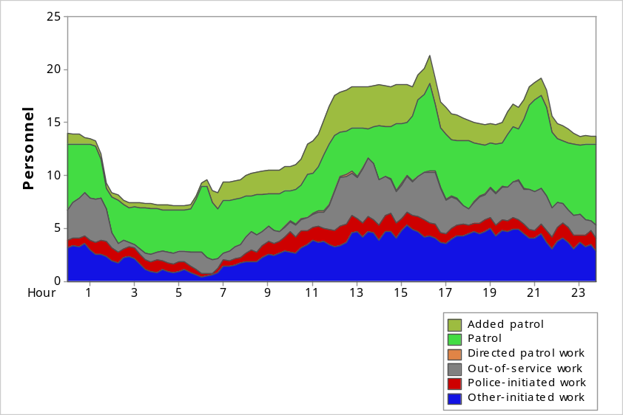
FIGURE 4-2: Workload Percentage by Hour, Weekdays, Summer
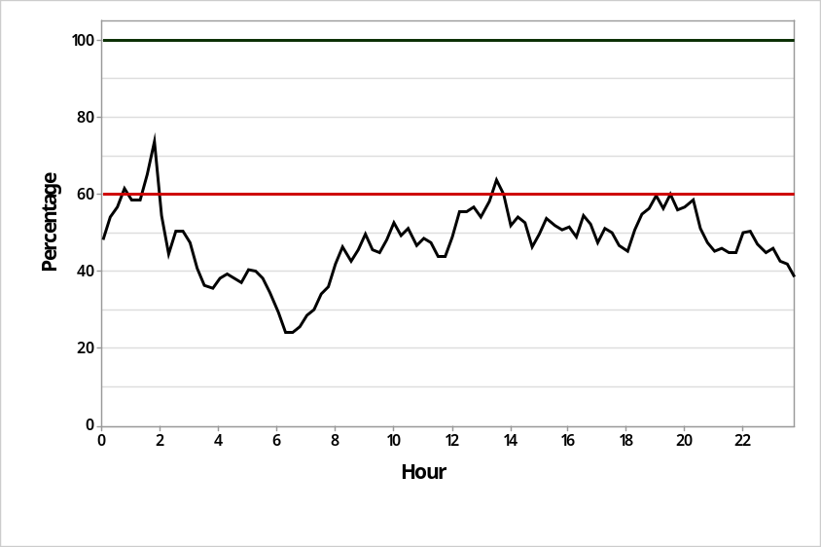
Workload v. Deployment – Weekdays, Summer
Avg. Workload: 6.6 officers per hour
Avg. % Deployed (SI): 49 percent
Peak SI: 73 percent
Peak SI Time: 1:45 a.m.
In Figures 4-2, 4-4, 4-6, and 4-8,the patrol resources available in Santa Clara are denoted by the dashed green line at the top. The 100 percent value indicates the total police officer hours available during the 24-hour period. This amount varies during the day consistent with the staffing of the shifts, but at any given hour the total amount of available manpower will equal 100.
The red dashed line fixed at the 60 percent level represents the saturation index (SI). As discussed above, this is the point at which patrol resources become largely reactive as CFS and workload demands consume a larger and larger portion of available time. The solid black line represents total workload experienced by the SCPD.
Looking at the comparisons of the green, red, and black lines in the SI figures, and comparing workload to available staffing, the data indicate that the SCPD struggles to meet the workload demands in Santa Clara with the resources available. It appears that the patrol function in the department is under stress numerous times throughout the day. Consideration should be given to implementing strategies to bring this workload and deployment relationship into better balance.
Figures 4-1 and 4-2 present the patrol workload demands and SI for weekdays in summer 2015. As the figures indicate, the SI exceeds the 60 percent threshold on several occasions. The SI ranges from a low of approximately 25 percent at 7:00 a.m. to a high of 73 percent at 1:45 a.m., with a daily average of 49 percent.
FIGURE 4-3: Deployment and Workload, Weekends, Summer
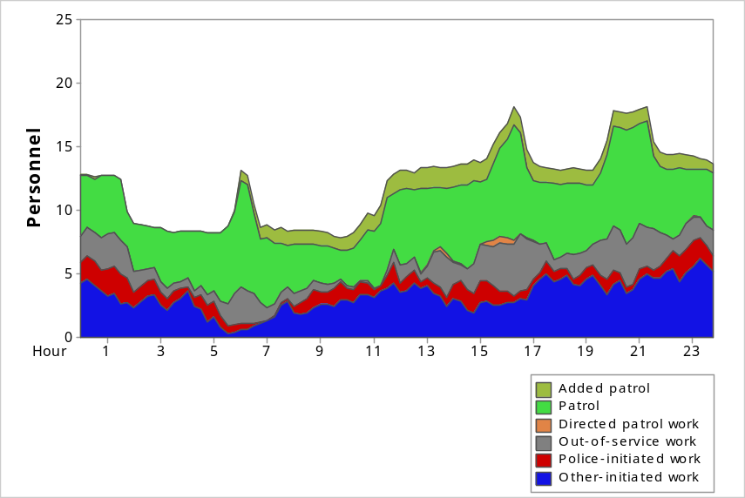
FIGURE 4-4: Workload Percentage by Hour, Weekends, Summer
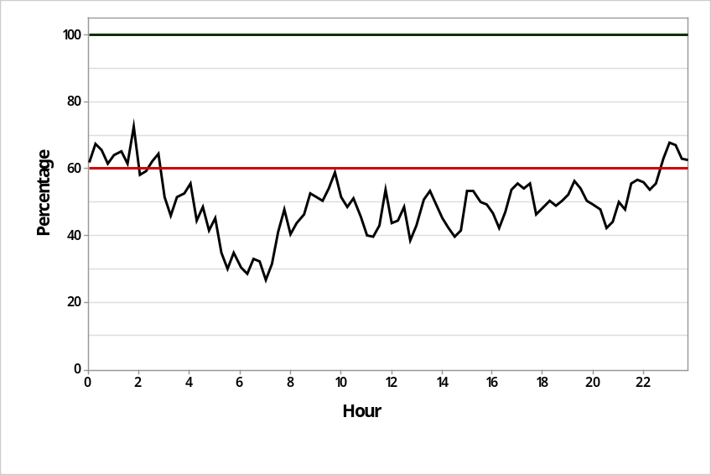
Workload v. Deployment – Weekends, Summer
Avg. Workload: 6.1 officers per hour
Avg. % Deployed (SI): 50 percent
Peak SI: 73 percent
Peak SI Time: 1:45 a.m.
Figures 4-3 and 4-4 present the patrol workload demands and SI for weekends in summer 2015. The workload exceeds the 60 percent threshold from approximately 11:00 p.m. until about 3:00 a.m.. The SI ranges from a low of just below 30 percent in the early morning hours to a high of 73 percent at 1:45 a.m. , with a daily average of 50 percent.
FIGURE 4-5: Deployment and Workload, Weekdays, Winter
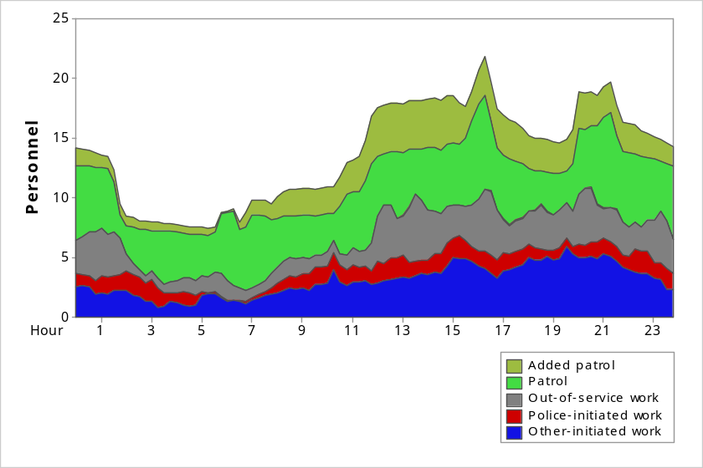
FIGURE 4-6: Workload Percentage by Hour, Weekdays, Winter
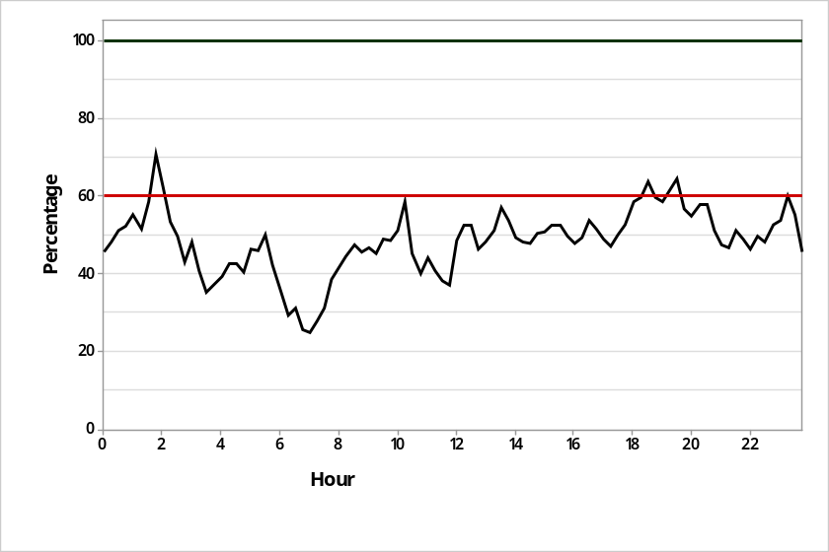
Workload vs. Deployment – Weekdays, Winter
Avg. Workload: 6.8 officers per hour
Avg. % Deployed (SI): 49 percent
Peak SI: 70 percent
Peak SI Time: 1:45 a.m.
FIGURE 4-7: Deployment and Workload, Weekends, Winter
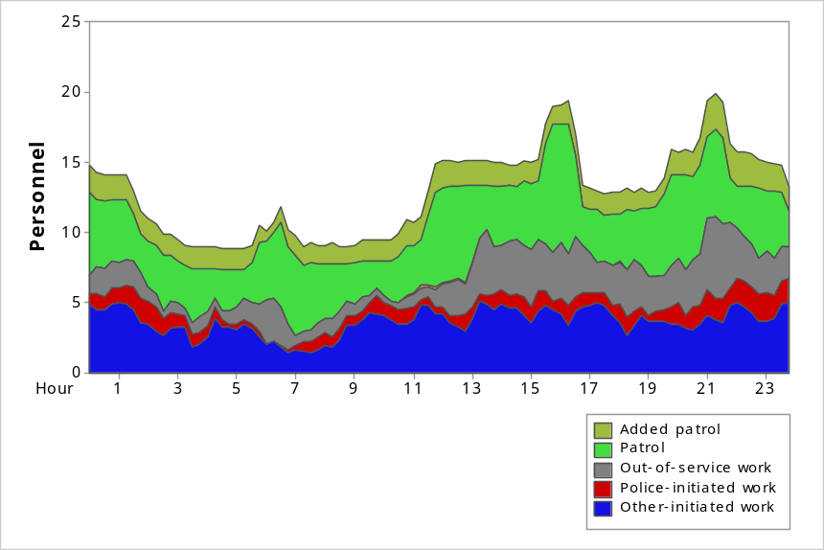
FIGURE 4-8: Workload Percentage by Hour, Weekends, Winter
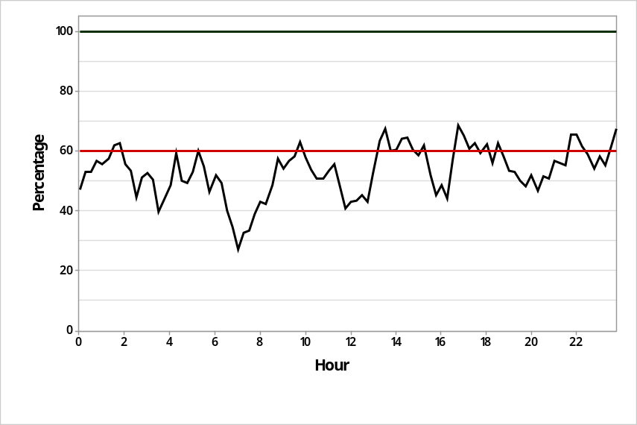
Workload v. Deployment – Weekends, Winter
Avg. Workload: 6.9 officers per hour
Avg. % Deployed (SI): 54 percent
Peak SI: 68 percent
Peak SI Time: 4:45 p.m.
Figures 4-5 and 4-6 present the patrol workload demands and SI for weekdays in winter 2015. As the figures indicate, the SI exceeds the 60 percent threshold on several occasions. The SI ranges from a low of approximately 25 percent at 7:00 a.m. to a high of 70 percent at 1:45 a.m., with a daily average of 49 percent.
Figure 4-5 depicts visually the manpower deployment during the 24-hour period during summer weekdays. From the figure, it can be seen there are two spikes in manpower deployment that coincide with the periods of time when the patrol teams overlap each other (as noted by the blue arrows). These overlaps occur numerous times throughout the day when the various shifts begin and end. The biggest spikes in personnel availability occur between 3:00 p.m. and 5:00 p.m. and again from 8:00 p.m. to 10:00 p.m. when three shifts are on duty at the same time. These overlaps are a natural product of the 11-hour shift configuration in the SCPD. It would be possible to make a minor adjustment in the shift start times to smooth out these spikes in staffing and provide a more balanced level of personnel throughout the day (see discussion below). The number of personnel available throughout the day varies from as few as 7 officers in the early morning hours, to as many as 20 officers at 4:00 p.m.
On the workload side, demand for service generally is very low for all periods during the early morning hours, and begins to rise after about 6:00 a.m. From 6:00 a.m., workload increases until about 9:00 a.m., where it remains relatively stable throughout the day until about 10:00 p.m., when workload begins to subside.
Additionally, consideration must be given to ensure there is ample time for officers to prepare reports and perform other administrative functions related to handling calls for service. Oftentimes officers build this time directly into the service time of the call. Other times officers take themselves out of service to perform this work, or remain available in the dispatch system and perform these functions as they are waiting for the next assignment. Regardless of the method used, it is important to have resources available to support this important role. The overlap of shifts provides this resource, as does providing enough officers on each shift so that administrative work can be accomplished while simultaneously providing enough officers to handle community demands.
Figures 4-7 and 4-8 present the patrol workload demands and SI for weekends in winter 2015. As the figures indicate, the SI exceeds the 60 percent threshold numerous times throughout the day. The SI ranges from a low of approximately 25 percent at 7:00 a.m. to a high of 68 percent at 4:45 p.m., with a daily average of 54 percent.

Schedule and Staffing
General patrol operations in the department are staffed using four patrol teams deployed as shown in Table 4-4.
TABLE 4-4: Patrol Shift Schedule/Staffing
Team | Lt. | Sgt. | PO | CSO | Shift | Days
1A | 1 | 1 | 11 | 2 | 0600x1700 | MON thru THU
1B |  | 1 | 8 | 1 | 0600x1700 | FRI thru MON
2A | 1 | 1 | 10 | 1 | 1100x2200 | MON thru THU
2B |  | 1 | 6 | 0 | 1100x2200 | FRI thru MON
3A | 1 | 1 | 9 | 0 | 1500x0200 | MON thru THU
3B |  | 1 | 7 | 0 | 1500x0200 | FRI thru MON
4A | 1 | 1 | 8 | 0 | 2000x0700 | MON thru THU
4B |  | 1 | 9 | 0 | 2000x0700 | FRI thru MON
TOTAL | 4 | 8 | 68 | 4

Patrol is divided into an A Side and B Side, each with 11-hour shifts. The A Side works Tuesday through Thursday and every other Monday. The B Side works Friday through Sunday and every other Monday.
The hours for the teams are as follows:
- Dayshift: 6:00 a.m. to 5:00 p.m.
- Midmorning shift: 11:00 a.m. to 10:00 p.m.
- Swing shift: 3:00 p.m. to 2:00 a.m.
- Grave shift: 8:00 p.m. to 7:00 a.m.
The design of the schedule, therefore, could be improved to better reflect the operational demands placed on the department. Consideration should be given to modifying this schedule in order to improve efficiency.
For example, if the SCPD changed the patrol schedule to 12-hour shifts, the result would be four equally staffed teams of two sergeants and 15 police officers. Under this schedule, 17 sworn officers would be assigned throughout the day. Days off could be rotated so that everyone would have every other weekend off (Friday, Saturday, and Sunday). This configuration would also provide the similar staffing coverage as the current work plan.
A 12-hour shift schedule offers both advantages and disadvantages. The advantages of the schedule is that it separates the patrol function into evenly staffed platoons. As the teams rotate in and out of their schedule, the department has a uniform and predictable deployment of officers on patrol at all times. The 12-hour configuration also works evenly into the 24-hour day and there are not excessive overlaps in staffing. This, however, is the extent of the advantages of the 12-hour shift as deployed by the department.
A disadvantage to the schedule is the uniform staffing level present throughout the day. Under the schedule, with each team equally staffed, there are equal numbers of officers assigned throughout the day. Demand for police services fluctuates during the 24-hour daily cycle, thus it is likely that there are parts of the day when not enough officers would be assigned to handle the workload and other times when there would be too many officers assigned. Staggering shifts to meet this demand is recommended, but often difficult to accomplish with available personnel.
Lastly, the four 12-hour shift configuration creates four separate patrol units that almost never interact. This can create a “silo” effect that inhibits communication and creates competition for scarce resources.
The 11-hour shift used in the SCPD could be improved to capitalize on the naturally occurring overlaps the shift plan provides. The major shortcoming of an 11-hour schedule is that is does not fit evenly into the 24-hour day, thus there will be times when more than one shift is working. The challenge is to create a schedule where these overlaps meet the increases in demand that naturally occur throughout the day. Without altering the A-side, B-side, days-off rotation, and using the same number of personnel, a shift schedule could be designed that meets the demand needs of the department in a more efficient manner. It would smooth out the available sources, cut down on excessive overlap of shifts, and cut down on the number of vehicles need to staff patrol.
The available literature on shift length provides no definitive conclusions on an appropriate shift length. A recent study published by the Police Foundation examined 8-hour, 10-hour, and 12-hour shifts and found positive and negative characteristics associated with all three options. A recent study of the Phoenix Police Departments 13:20-hour shift found it to be less than desirable on numerous levels. CPSM contends that the length of the shift is secondary to the application of that shift to meet service demands. Furthermore, CPSM does not recommend any particular shift length or rotation, except to advocate for the one that maximizes efficiency, effectiveness, and satisfaction of those working it.
In its totality, however, there is an opportunity to improve the patrol shift schedule without a major disruption of the current work plan.

Spatial Representation of CFS Demand
The workload-related figures presented previously (Figures 4-1 through 4-8) provide a thorough examination of the service demands placed on the Santa Clara Police Department during different times of the day and week. In addition to these “temporal” demands, it is also possible to illustrate the “spatial” demands on the SCPD. Examining the spatial demands permits the exploration of where incidents are occurring.
As can be seen in Figures 4-9 and 4-10, there are several distinct incident “hot spots” in Santa Clara. It is clear that retail, commercial, and traffic conditions along El Camino Real command a great deal of attention from the SCPD. There are numerous discernable hotspots in this area, as well as sizeable concentrations of CFS in other retail and commercial locations throughout the city. This comes as no surprise as these areas are vibrant and well-traveled part of the community and presumably would demand a large share of attention from the police department.
Each one of the actual “hot spots” in the community should be the focus of a specific and targeted strategy that aims to eliminate, or drastically reduce, the conditions present at those locations. Undoubtedly, these locations receive the lion’s share of attention from patrol officers in the department, and consideration should be given to formulating a deliberate plan to deal with these locations in a proactive fashion. For example, the SCPD could work with private security at the shopping centers to minimize theft, which would minimize the demand placed on patrol resources. Similarly, the department could work with the commercial establishments in the city to regulate activities more aggressively. Also, consideration should be given to deploying a dedicated “Camino Real” unit, or some other specified resource to deal specifically with CFS emanating from the commercial establishments, to provide a more consistent and long-term approach to dealing with the crime, quality-of-life, and service demand issues that originate from this area. This would expand upon the current deployment of patrol units and motors, and include the Nuisance Suppression Unit, and Community Service Officers, as well as detectives and any other resources the department chooses to deploy, in a coordinated approach to policing these areas.
Conversely, many areas of the community see low levels of CFS volume. Indeed, the areas of the community that are NOT along major arteries or part of the downtown or commercial locations show very low call volume. On the plus side, the argument can be made that there are no problems in these areas in general, thus a police presence is not required. On the other hand, officers are initiating a small amount of calls in these “other” areas, which compromises a community policing philosophy that should be central to the department’s approach to policing the community.

FIGURE 4-9: Spatial Representation of Other-Initiated CFS (Red=100 CFS)
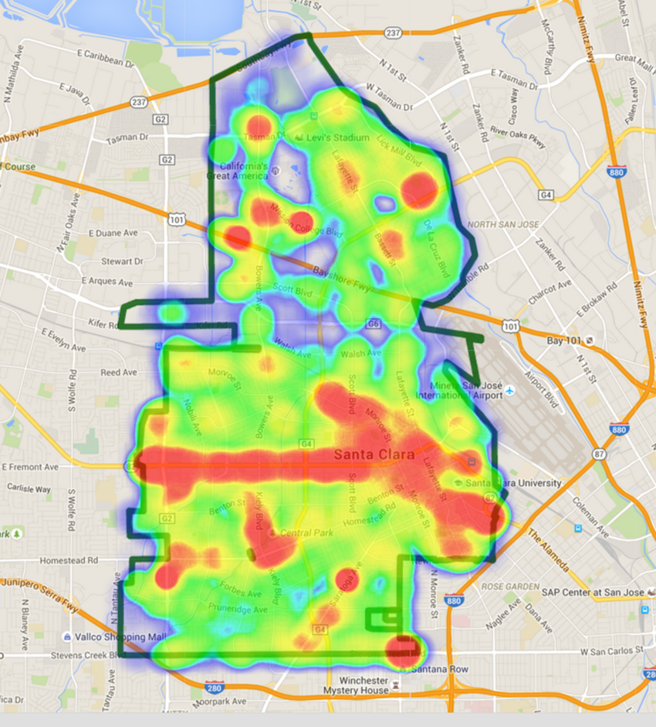

FIGURE 4-9: Continued, Other-initiated CFS
Count | Location
507 | 601 EL CAMINO REAL (Police HQ)
163 | 557 CHAPMAN CT (Private Residence)
133 | 3051 STEVENS CREEK (Westfield Vly)
127 | 909 KIELY BL (Central Park)
107 | 3111 MISSION COLLEGE (AMC Mercado)
107 | 700 LAWRENCE (Medical Ctr)
105 | 3550 EL CAMINO REAL (Belle Vista Inn)
96 | 2760 HOMESTEAD RD (Shopping Ctr)
94 | 3208 EL CAMINO REAL (Motel 6)
91 | 1500 WARBURTON AV (City Offices)
84 | 2605 THE ALAMEDA (Safeway)
82 | 3071 STEVENS CREEK BL (Safeway)
80 | 2401 AGNEW RD (Café area)
77 | 2250 EL CAMINO REAL (Western Motels)
76 | 444 SARATOGA AV (Pruneridge Apts)
75 | 1505 WARBURTON AV (Triton Museum)
70 | 3700 EL CAMINO REAL (Kohls)
69 | 5101 GREAT AMERICA PY (Hyatt)
68 | 3970 RIVERMARK PLAZA (Safeway)
67 | 2200 MONROE ST (Old Orchard Apts)

FIGURE 4-10: Spatial Representation of Crime-CFS (Red=100 Crime CFS)
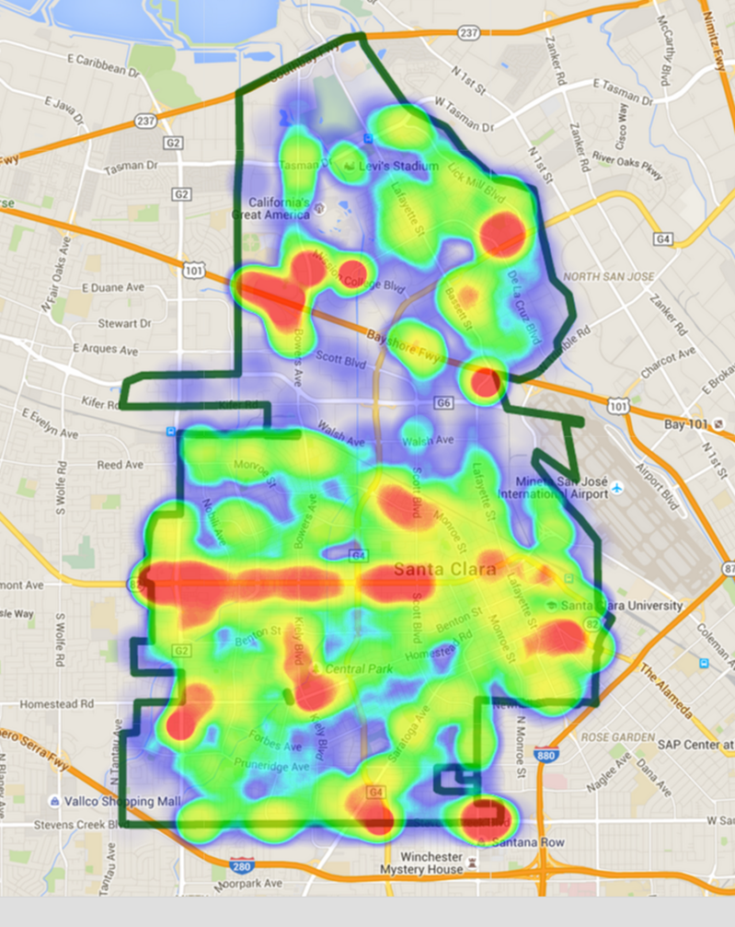

FIGURE 4-10: Continued, Spatial Representation of Crime (Crime-CFS)
Count | Location
95 | 3051 STEVENS CREEK BL (Westfield Vly)
57 | 3111 MISSION COLLEGE BL (AMC Mercado)
48 | 3700 EL CAMINO REAL (Kohls)
47 | 2760 HOMESTEAD RD (Shopping Ctr)
41 | 700 LAWRENCE EX (Medical Ctr)
39 | 4200 GREAT AMERICA PY (Hotel)
35 | HAMILTON&BASCOM AV, SJ (Starbucks)
34 | 2605 THE ALAMEDA (Safeway)
31 | 2401 AGNEW RD (Great America)
29 | 3001 MISSION COLLEGE BL (In-Out Brgr)
29 | 3041 STEVENS CREEK BL (Westfield Vly)
27 | 2004 EL CAMINO REAL (Target)
27 | 4150 GREAT AMERICA PY (Bennigan’s)
26 | 3970 RIVERMARK PLAZA (Safeway)
26 | 3071 STEVENS CREEK BL (Safeway)
23 | 2855 STEVENS CREEK BL (Westfield Vly)
22 | 3915 RIVERMARK PLAZA (Hyatt)
22 | 2950 LAKESIDE DR (El Torito)
21 | 3677 STEVENS CREEK BL (Guitar Ctr)
21 | 3033 LAFAYETTE ST (Storage)
21 | 3081 STEVENS CREEK BL (CVS)

TABLE 4-5: Calls and Work Hours per Day, by Year and Beat
 | Previous Year | Current Year
Beat | Calls per Day | Calls per Day | % +/-
PD01 | 19.2 | 23.4 | +21.9%
PD02 | 22.1 | 26.3 | +19.0%
PD03 | 33.8 | 31.5 | -6.8%
PD04 | 17.6 | 15.8 | -10.2%
PD05 | 22.8 | 20.5 | -10.1%
PD06 | 23.3 | 25.4 | +9.0%
Other | 6.5 | 8.9 | +36.9%
Total | 145.2 | 151.8 | +4.5%

According to Table 4-5, Beats 1, 2 and 6 showed an increase in call volume from one year to the next, with Beat 1 having the greatest increase in the number of calls. Beats 3, 4, and 5 showed a decrease in call volume. It appears that Beat 3 had the highest percentage of calls each year. Police headquarters is located in this beat, therefore, more calls would be expected than in other beats. With the development that is planned in the city, it is likely that calls logged in Beat 6 are likely to increase.
The current deployment of personnel across the six beats appears sound. While there are differences in the number of calls handled in each beat, the differences are not problematic and the small variation in call volume suggests the beat boundaries are drawn appropriately. To address the high demand placed on patrol from the El Camino Real corridor, additional resources as discussed above should be considered. Also, the SCPD could deploy a seventh beat car to act as an additional resource wherever is it needed. Instead of redrawing beat boundaries, a seventh patrol unit could be deployed each shift and act as a “roving unit” handling calls where necessary, and while not on assignment could back up other units, as well as concentrate on high-volume CFS areas, such as the commercial hot spots and the El Camino Real corridor. In addition to adding the extra personnel to handle the CFS in these locations, the SCPD should consider a strategic approach to dealing with these CFS. Instead of waiting for the CFS, plans should be put in place in order to address the underlying conditions that create the CFS in the first place. Proper planning, using the community policing S.A.R.A. (Scanning, Analysis, Response, and Evaluation) model, or a performance management approach such as Compstat or D.D.A.C.T.S., can diagnose and solve problems at these locations, thus avoiding the need for an emergency call to the police.
In totality, the workload demands faced by the patrol function in the SCPD are high. In fact, the data indicate the SCPD has one of the highest workload demands of all the police departments studied by CPSM. Daily saturation indexes in the mid-fifty percent range during the time periods under observation suggest that officers on patrol operate in an almost entirely reactive mode. Between the large out-of-service needs and the CFS, both police- and public-initiated, officers undoubtedly find themselves responding from one call to the next without ample time in between to engage in community policing activities or self-initiated enforcement. The nature of the community in Santa Clara, and the style of policing embraced by the SCPD, require adjustments to the patrol function to better accommodate the workload demands and supply of officers available to meet those demands. Typically, these adjustments take on one of two approaches: reduce demand or increase supply.
As discussed above, the SCPD responds to numerous CFS that could be called unnecessary. Alarms, noninjury motor vehicle accidents, and medical calls, for example, are all areas of workload demand that can be targeted for reduction. Minimizing police response to these types of CFS can free up a substantial amount of time for officers to engage in other more useful activities. It is understood that community expectations, to a large degree, shape the types of CFS that get a police response, and altering these expectations is not exclusively the responsibility of the police department. However, the potential does exist to shed a substantial amount of work from the patrol function. From discussions with personnel in the SCPD, it is also understood that restructuring community expectations and the demand to police services through 911 CFS would be challenging and that the community would be resistant to make wholesale changes in this area. Nonetheless, the potential is there and good-government and sound police management indicate this is an area worthy of exploration. If demand cannot be reduced the only other alternative is to increase supply.
Increasing the supply of officers available to meet workload demands can be accomplished in two ways: restructuring patrol shift schedules to better meet the temporal and spatial workload, and increasing the number of personnel assigned to patrol. Examination of the patrol shift schedule in the SCPD reveals some improvement opportunities. In general, however, the 11-hour shift model does a very good job of assigning officers to work during the times they are needed the most. Improving efficiency under the current model can be achieved by altering the start and end times of the shifts to create a smoother supply of officers throughout the day. As discussed below, this would entail eliminating the shift overlap at two times during the day.
Lastly, the SCPD should consider adding personnel to the patrol division. The current deployment plan calls for a minimum of six patrol officers per shift to be assigned to patrol. CPSM recommends this number be increased to seven. The seventh unit can be deployed in several ways, either creating a seventh beat, assigning the unit to El Camino Real area, or as a citywide unit available as needed. In addition, the SCPD should consider adding CSOs to patrol and ensure that these personnel are available during the peak demand hours to support operations.
Table 4-6 presents an example of an eleven-hour shift schedule that would be more efficient. The sample personnel schedule is consistent with the current patrol rotation. Other departments have created various day-off rotations that provide every other weekend off in addition to an overlap day for training each week. Under this model, the current A/B rotation is maintained.
TABLE 4-6: Sample 11-Hour Shift/Staffing Schedule
Shift | Hours | Lieutenant | Sergeants | Officers | CSO
1 | 0500x1600 | 1 | 2 | 10 | 2
2 | 0800x1900 |  | 1 | 9 | 1
3 | 1600x0300 |  | 1 | 9
4 | 1900x0600 | 1 | 2 | 10

The numbers in the table represent the staffing allocation for one-side of the A/B patrol rotation. In order to staff patrol, therefore, the personnel figures from this table should be doubled. This would conclude that the patrol function in the SCPD would require one captain, four lieutenants,
12 sergeants, 76 police officers, and six community service officers.

Traffic Unit
The mission of the Traffic Unit is to promote traffic safety in the city of Santa Clara. The unit relies on enforcement to accomplish this mission. The unit is responsible for responding to and investigating motor vehicle collisions involving injury, and motor vehicle accidents not investigated by CSOs.
The unit is comprised of one sergeant, eight police officers, one traffic investigator, and two CSOs assigned to parking enforcement. The Traffic Unit’s motor officers work 11-hour shifts. They are divided into day shift and night shift, and also are divided into an A and B schedule. The A schedule is Monday through Wednesday and every other Thursday; and the B schedule is Wednesday through Friday and every other Tuesday. The day shift runs from 6:00 a.m. to 5:00 p.m. and the night shift runs from 9:00 a.m. to 8:00 p.m. The traffic investigator works 10-hour shifts, Monday through Thursday. Personnel are not assigned to work on Saturdays and Sundays.
Between May 1, 2014, and April 30, 2015, the communications center recorded 4,907 events with call numbers assigned to traffic/motor units. Traffic units only work on weekdays, which comprised 263 days during the study period. When measured daily, the department reported an average of 18.7 events per day for the unit, approximately 2 percent of which (0.3 per day) had fewer than 30 seconds spent on the call. As noted, this average was over 263 days rather than the usual 365 calendar days in the same period.
During this period, the dispatch center recorded activities assigned to traffic units that were not assigned a call number. After excluding activities that lasted either less than 30 seconds and more than 8 hours, 1,079 noncall activities remained.
The discussion that follows gives an overview of the number of calls, noncall activities, deployment, and workload for the Traffic Unit.
TABLE 4-7: Traffic Unit Calls by Category
Category | Count | Percent
Accident | 809 | 16.5
Alarm | 85 | 1.7
Animal call | 4 | 0.1
Assist other agency | 29 | 0.6
Check/investigation | 96 | 2.0
Crime–persons | 51 | 1.0
Crime–property | 39 | 0.8
Disturbance | 103 | 2.1
Juvenile | 1 | 0.0
Miscellaneous | 122 | 2.5
Pedestrian/traffic stops | 3,387 | 69.0
Prisoner–arrest | 6 | 0.1
Suspicious person/vehicle | 91 | 1.9
Traffic/vehicle related | 84 | 1.7
Total | 4,907 | 100.0

TABLE 4-8: Traffic Unit Noncall Activities by Description
Description | Count | Percent
Coffee or meal | 26 | 2.4
Courtesy service | 1 | 0.1
Court | 235 | 21.8
En route to Code 7 / 10-18 | 37 | 3.4
En route County Jail | 2 | 0.2
En route Elmwood | 9 | 0.8
Equipment Maintenance | 18 | 1.7
En route (Other) | 72 | 6.7
En route to PD | 21 | 1.9
En route station for booking | 7 | 0.6
Follow-up | 28 | 2.6
Meeting | 99 | 9.2
Report writing at NSS, not available | 2 | 0.2
Report writing at station, available | 34 | 3.2
Report writing in field | 3 | 0.3
Report writing at station, not available | 65 | 6.0
Traffic control | 18 | 1.7
Traffic enforcement | 199 | 18.4
Training | 53 | 4.9
Vehicle maintenance | 149 | 13.8
Total | 1,079 | 100.0
Observations:
- Pedestrian/traffic stops accounted for 69 percent of calls.
- Accidents accounted for 17 percent of calls.
- The highest percentage of noncall activities involved court-related activities.
- Traffic control and traffic enforcement accounted for 20 percent of total noncall activities.
- Although not the safest practice, motorcycle officers often fail to notify dispatchers of traffic stops. Such activities cannot be captured for our data analysis.

FIGURE 4-11: Traffic Unit Deployment and Total Workload, Weekdays,
Summer 2014
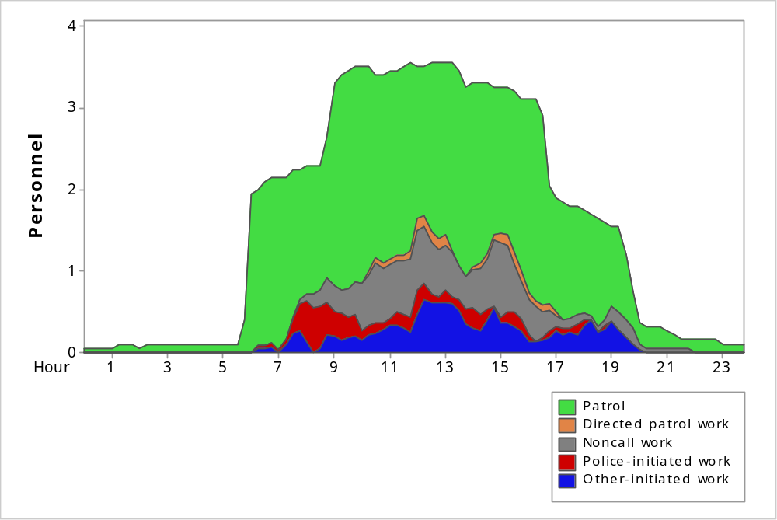

FIGURE 4-12: Traffic Unit Deployment and Total Workload, Weekdays,
Winter 2015
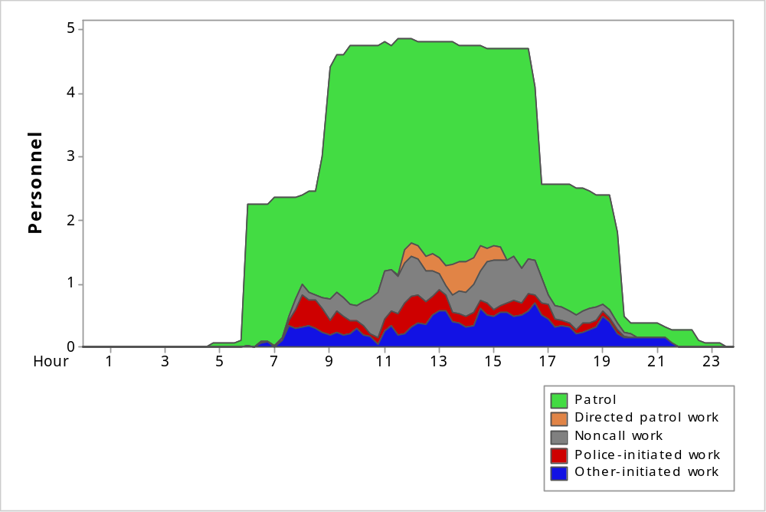
Observations:
- For summer weekdays between the hours of 6:00 a.m. and 8:00 p.m.:
- On average, 2.7 units per hour were deployed.
- Average total workload was 0.8 officers per hour. This was approximately 29 percent of the hourly deployment.
- Average total call-based workload was 0.4 officers per hour during the week. This was approximately 16 percent of the hourly deployment during the week.
- For winter weekdays between the hours of 6:00 a.m. and 8:00 p.m.:
- On average, 3.6 units per hour were deployed.
- Average total workload was 0.9 officers per hour. This was approximately 25 percent of the hourly deployment.
- Average total call-based workload was 0.6 officers per hour. This was approximately
16 percent of the hourly deployment.
Figures 4-11 and 4-12 indicate that there are a substantial number of traffic personnel available for the workload. Undoubtedly, the responsibilities of traffic section personnel are much greater than those captured exclusively by the CAD system. However, there does appear to be an overabundance of personnel working between the hours of 9:00 a.m. and 5:00 p.m.
Table 4-9 illustrates a three-year history of traffic accidents in Santa Clara. In a short time there has been a dramatic reduction in traffic accidents. The number of accidents in 2014 is 38 percent less than it was in 2012. Similarly, the average of 1.67 fatal traffic accidents over the three-year period, translates into a rate of 1.39 traffic fatalities per 100,000 population. This rate is about 75 percent lower than the overall California rate of 5.7 fatal crashes per 100,000 population. The Traffic Unit, as well as the entire department, should be commended for their contributions to traffic safety in Santa Clara.
TABLE 4-9: Total Traffic Accidents in Santa Clara, 2012-2014
Year | Total Accidents | Fatal | Injury | Alcohol Related
2012 | 1,290 | 2 | 343 | 79
2013 | 1,195 | 2 | 295 | 86
2014 | 801 | 1 | 147 | 63
3-Year Avg. | 1,095.33 | 1.67 | 261.67 | 76

In order to improve an already high-performing function, a more focused and proactive approach is recommended. The unit dedicates too much effort on non-focused enforcement and responding to post-accident investigations, and not enough time identifying and eliminating the causes of accidents in the first place. In general, traffic safety is improved by the rigorous application of the three “E’s”: enforcement, education, and engineering. The community would be better served if the traffic unit tracked accidents as the measure of its performance and leveraged enforcement, education, and engineering toward reducing those accidents. Responding to an accident after the fact is too late, and the time spent preparing an accident report (a report that can be done by CSOs if needed at all) could be spent on education programs or at focused enforcement in targeted locations. In addition, while unit members report having a good working relationship with the Santa Clara city engineer, a much greater emphasis should be given to examining problematic intersections in order to reengineer them for improved traffic safety.
An opportunity for improvement for the Traffic Unit could be to adopt a performance management approach (using traffic data to drive deployment and enforcement decisions) toward traffic accidents and injuries. This approach could be the focus of the unit as well as migrated to the rest of the patrol division. Adopting a strategic approach to traffic safety, and engaging the entire department in this effort, will magnify the current enforcement-centered approach and make the overall traffic safety plan of the SCPD more effective. The scope of this effort is beyond the unit itself and must be embraced by the patrol division commander. Under this approach, the patrol commander would become responsible for the overall traffic safety plan of the SCPD. The traffic unit would develop the plans necessary to focus the effort of the rest of the department. This approach would entail the creation of written traffic safety plans, monthly reports using traffic crash data to identify times/days/locations/causes of traffic crashes, and holding patrol shifts accountable for implementing this plan. It is recommended that the traffic investigator assigned to the section assist in the data analysis, plan preparation, and other administrative assignments associated with traffic safety management.
To support this effort, it is recommended that a reallocation of personnel be considered. The current shift schedules for the Traffic Unit do not cover weekends and do not go past 9:00 p.m. In order to provide greater coverage and to integrate traffic safety operations more seamlessly into patrol operations, it is recommended that two teams of traffic personnel be assigned to work the same shift rotation as general patrol operations (A/B sides with the same days off). Similarly, traffic personnel should have flexible hours and be prepared to alter their start and end times to address traffic conditions as needed. For example, during the weekends when drunk-driving might be an issue later in the evening, the traffic officers working the B side of the rotation could be deployed to work until 2:00 a.m. to address drunk driving. Or when schools reopen after summer vacation, all traffic officers working during the weekdays could alter their shifts to have everyone available at both the entry and dismissal of school.
Recommendations:
- Empanel a calls for service (CFS) committee to evaluate service demands and attempt to reduce and/or eliminate nonemergency responses.
- Adjust the start and end times of the patrol shifts.
- Increase minimum patrol staffing to 7 officers.
- Allocate one captain, four lieutenants, 12 sergeants, 76 police officers, and six community service officers to patrol.
- Address “hot spots” in the community with appropriate patrol and crime prevention plans.
- Adopt a strategic approach to traffic safety. Place the responsibility for traffic safety with the patrol commander and use the Traffic Unit as the research and planning arm to support this effort.
- Reconstitute the Traffic Unit into two teams that work in conjunction with patrol’s A/B-side rotation and with flexible hours of deployment.

Section 5. Investigations Division
The Investigations Division is led by a sworn police captain (presently acting) and is made up of the following sections, programs, and areas of responsibility: Detectives, Records, Special Enforcement Team, Forensics, and Crime Analysis. A team referred to as SCAT (Specialized Crime Action Team) was recently disbanded and its personnel were reassigned to other departmental duties. The decision to disband this team, which focused heavily upon narcotics activity, was based upon recent changes in California Health and Safety Code laws that largely minimize personal drug use as an offense that warrants incarceration. It is widely anticipated among law enforcement professionals that, due to this change, crime rates, especially property crimes, will rise significantly. This is because property crimes are often committed by drug offenders who now have less to fear from the criminal justice system. While some may question the wisdom of the state actions, the reaction by the Santa Clara Police Department to disband the unit and more effectively utilize its limited human resources is to be commended.
As noted previously, the SCPD underwent a reorganization shortly before the CPSM August site visit. A new division, the Special Operations Division, was created in anticipation of service needs related to the NFL Super Bowl and a myriad of other major events at Levi’s Stadium. Units from the Investigations Division, including Homeland Security, Special Events, Intelligence, and Special Operations, were transferred to and make up the new Special Operations Division. The former Investigations Division captain was transferred to the new division to direct it. This resulted in the Detective Section lieutenant being temporarily assigned as the Investigations Division acting captain. He presently serves the dual role of acting captain and detective lieutenant.

Detective Section
All of the above referenced Investigations Division areas of responsibility fall within the Detective Section with the exception of Records. The Detective Section is made up of sub-investigative units led by Sergeants. As well, the forensics unit coordinator and the crime/management analyst are civilian positions within the Detective Section; they report to the acting captain.
Sub-units of the Detective Section include Robbery / Assaults / Homicide; General Property Crimes; Financial Crimes / ID Theft; Misc. General Assaults / Domestic Violence; and Sex Crimes / Elder Abuse / Juvenile Crimes. As well, the Special Enforcement Team / AB 109, Forensics, Crime Analysis, and Subpoenas / Court Liaison are other functions that complete the Detective Section. Auto theft investigations are handled by the Special Enforcement Team.
CPSM examined the Detective Section’s investigative units collectively. Of initial interest is the staffing make-up of the units. The units are staffed, all told, with six sergeants and seven detectives. In one unit, there are two sergeants and one detective. This is a highly unusual supervisor-to-subordinate ratio. At the same time, sergeants carry caseloads at virtually the same level as detectives and routinely operate as peer investigators. In interviews, it was evident that sergeants, while they may be an experienced resource, do not supervise detectives. The seven detective positions are held by personnel who hold the rank of police officer and are assigned as detectives on a rotational schedule (which will be discussed later). The assignment of a police officer as a detective is generally considered important for training/development of personnel, and often comes with special assignment pay in the 5 percent range. No such pay rate increase is afforded in Santa Clara. It was reported that some officers have expressed a reluctance to accept this assignment when it results in a loss of pay if transferred from a Field Operations Division assignment where special assignment pay for duties such as FTO, traffic, etc. is afforded. This is obviously a collective bargaining issue, not appropriate for a recommendation on the part of the consultants, and is noted only to bring attention to this potential staffing issue.
It was explained that, in the past, virtually all detectives held the rank of sergeant. In recent years, the department began moving away from that model, and as attrition permits, more detectives and fewer sergeants will be assigned to the section. As that occurs, it will allow the sergeants to more formally supervise detectives rather than act, at least in part, as peers. CPSM agrees with this decision. As well, should the department choose to do so, this will allow for a reorganization of the Detective Section to better serve the community and organization. As an example, elder abuse, domestic violence, and juvenile crime may be investigated under the umbrella of a Family Crimes Unit. This is not intended to be a recommendation, but rather, an example of an opportunity that may exist as attrition allows for a reorganization to best meet the needs of the community and department.
A rotation schedule is in place as follows: sergeants are generally assigned to the detective assignment for a period of four years, with the option to extend that assignment to five years: officers are generally assigned to the detective assignment for a period of two years, with the option to extend that assignment to three years. This allows for a rotation of personnel through the section and provides the opportunity for personnel to gain valuable experience. When rotating out, they often return to patrol where they become a greater asset to that section.
There are, however, some specialized investigative functions which require a high degree of training and experience before fully mastering the skills necessary to thoroughly investigate select crimes. Computer crimes are but one example. The department must be cognizant of those positions and ensure that investigations are not compromised by inexperience. Such assignments may warrant a significantly longer assignment period, even indefinite.
As it pertains to case management, all cases with the exception of traffic-related matters (driving under the influence, driving on a suspended license, etc.) are reviewed daily by the detective lieutenant (Investigations Division acting captain). Priority is given to custody cases, which are immediately assigned to a detective. The daily arrest log is also reviewed to ensure that all custody case reports are received.
Following this action, all other reports are collected and reviewed by the detective lieutenant. They are reviewed for solvability factors and those with potentially workable leads are assigned to detectives for further action. Those without workable leads are closed and filed at the direction of the lieutenant. It was reported that there is no formal accounting of what constitutes a solvability factor. Rather, the decision as to whether a case has sufficient leads which could result in solving of the case is left up to the experience of whoever serves as the current lieutenant, regardless of their level of expertise.
Over a three-year period from 2012 to 2014, the Detective Section received 31,046 police reports. Of those 23,913 (77%) were assigned for investigation and 7,133 (23%) were determined to have no investigative leads and were filed without further action. Based upon existing staffing, this reflects a caseload of approximately three cases per investigator per day. That figure is based upon 184 work days per investigator per year (four days per week x 46 weeks [52 weeks minus 4 weeks of vacation, 1 week training, 1 week illness]). Investigations vary widely in complexity. One may require as little as submitting a fingerprint analysis request, and if no match is made, the case may be closed. Others may take weeks or months to complete. Because the department lacks an effective case management system (as will be addressed later in this section), it is difficult to determine what time commitment is required to complete the workload. Therefore, CPSM consultants draw upon their own experience in forming the conclusion that minor personnel staffing adjustments may be necessary.
A substantial number of custody cases are completed by patrol and only filing of the case with the district attorney is required. For example, an in-custody shoplifting or drug case originating from a Field Operations Division arrest requires preparation of the case documents for filing. This task is presently assigned to a detective(s). This does not require the expertise of a detective and could be easily handled by a CSO at a lower cost while freeing up the detectives’ time for more important duties. Most agencies do use civilians for these duties, an option strongly supported by CPSM.
While a software program (File Maker) exists to record which detective is assigned a particular case, cases are not meaningfully tracked after assignment. As an example, a detective may determine that an assigned case be closed without further supervisory review. That applies to both officers and sergeants serving as detectives. If an officer serving as a detective completes an investigation and prepares it for filing with the district attorney, the supervisor may review and approve the case for submittal for filing, but there is no indication that this is routinely done. Should a sergeant complete an investigation and seek to file the case, no further department review is conducted. This is extremely problematic, and stems from the organizational alignment where there is virtually no supervisory oversight due to the sergeant/detective peer status as previously referenced.
One of the measures of the effectiveness of a department and its detective function is its crime clearance rates. Annually, departments report clearance rates to the FBI for inclusion in the Uniform Crime Report. The UCR establishes a strict three-prong criteria for clearing of a case. There are clearances via exceptional means as well, but the exceptions are extremely limited and result in numbers that are not statistically sufficient to warrant consideration for our purposes here.
CPSM inquired of various Investigations Division staff, both in the Detective Section and Records, as to the section’s and department’s clearance rates. There did not appear to be a good understanding of the UCR criteria for clearing a case, and consistently, it was reported that clearance rates are not really utilized by the department. It was evident and reported to CPSM that any reported numbers to the FBI would be suspect.
CPSM found this to be problematic for a number of reasons. While preventing a crime is of utmost importance to any law enforcement agency, solving a crime should have parity. The solving of crimes which results in the prosecution of offenders not only prevents future crime, it provides much-needed closure to crime victims. Additionally, it is among the most important measures not only of a department’s effectiveness, but of that of individual officers who perform criminal investigations. To not meaningfully track clearance rates results in the inability to meaningfully assess the investigative capability of the department and its individual personnel. It is important to track the effectiveness of each detective to allow for remedial training or increased oversight where needed. In some cases, reassignment of a detective may be necessary and data supporting that decision is vital. Supervisors may suggest that they have a familiarity, but it cannot be supported by data. This is clearly the case here, as sergeants provide little to no supervisory oversight of detectives investigations. This deficiency creates difficulty in managing personnel. As well, it provides the opportunity for a legitimate challenge by any employee who may suffer a perceived adverse job action resulting from a poor performance review or transfer from the Detective Section outside that of the normal rotation schedule.
Table 5-1 reflects UCR clearance rate data collected for 2013. This is the latest year of available data. Based upon these numbers and these numbers alone, it is clear that the department lags behind the state and national averages for solving crimes in all categories. Again, these numbers are highly suspect, but this table illustrates the importance of accurately capturing UCR clearance rate data to allow the department to identify areas where opportunities for improvement exist.
TABLE 5-1: Reported Santa Clara PD Clearance Rates in 2013
Crime | Santa Clara PD |  |  | California |  |  | National
Crime | Crimes | Clearances | Rate | Crimes | Clearances | Rate | Crimes | Clearances | Rate
Murder & manslaughter | 0 | 0 | NA | 1,766 | 1,164 | 65.9% | 14,749 | 9,106 | 61.7%
Rape | 13 | 4 | 30.8% | 7,463 | 3,114 | 41.7% | 96,316 | 36,794 | 38.2%
Robbery | 55 | 9 | 16.4% | 53,632 | 15,419 | 28.7% | 341,538 | 95,591 | 28.0%
Aggravated assault | 104 | 57 | 54.8% | 89,010 | 49,632 | 55.8% | 713,479 | 395,145 | 55.4%
Burglary | 461 | 26 | 5.6% | 232,009 | 30,008 | 12.9% | 1,884,360 | 240,004 | 12.7%
Larceny | 2,169 | 319 | 14.7% | 621,430 | 94,181 | 15.2% | 5,882,210 | 1,272,290 | 21.6%
Vehicle Theft | 393 | 8 | 2.0% | 165,262 | 13,064 | 7.9% | 690,038 | 95,111 | 13.8%

CPSM wishes to point out that consultants did not review the thousands of investigative reports that would serve as the basis for the numbers reflected in the table. Therefore, CPSM draws no conclusion as to the effectiveness of the department in investigating crime. It is suggested however, that not measuring its effectiveness by accurately tracking and reporting of clearance rates may lessen the department’s ability to identify deficiencies and allow for corrective action where appropriate. We simply wish to use this information as the most effective illustration of the importance of tracking both the department’s and each detective’s success in solving crimes.
As it relates to technology in use, an inquiry was made as to the department’s audio/video recording capability in the department’s interview rooms. It was reported that while the rooms are equipped for this capability, the systems are dated and there have been failures of the systems in the past. At present, they are working, but with little confidence in reliability.
Another area of concern noted was that of cellular technology. The department does not issue “smart phones” to detectives, but rather telephones with calling capacity only. For a detective assignment, “smart phone” technology can be invaluable for “on-the-go” investigations. It was reported that most detectives, though assigned a “dumb phone,” use their personal phone for investigative purposes where necessary. This is problematic for a number of reasons. The department is paying for telephones that may never be used, but as important, phone records from a detective’s personal phones may be subpoenaed in cases where the phones were used in an investigation. It is understood that many agencies are reluctant to issue “smart phones” to personnel because of past abuses of the phones. However, with suitable policies and random inspection of records, abuse can be controlled.
While training of departmental personnel is covered in its own section later in this report, the expertise required of detectives often requires specialized training not needed by all department members. CPSM inquired about an assignment-specific training matrix for detectives and was told that while none exists today, the department is working on a draft matrix. CPSM supports this important action.
CPSM noted that auto theft and auto burglary crimes were not investigated by a dedicated detective from the Detective Section; rather, these crimes are assigned to the Special Enforcement Team (SET) for case management. CPSM found it unusual that a unit of this nature (see duties in the section that follows) would be tasked with the investigation of auto theft and auto burglary related crimes. These are duties more compatible with a dedicated detective position vs. a unit such as SET which, by necessity, should modify work schedules to match demands. It is recommended that these duties be transferred to a dedicated detective operating out of the Detective Section. This warrants the assignment of a full-time detective and CPSM recommends this as a new detective position. Consideration was given to transferring a position from the SET to handle the duties; however, SET’s workload makes this option wholly inappropriate as it would result in a reduction of staffing in a busy unit.
CPSM looked at the impact that Levi’s Stadium events will have on the Detective Section workload. Over the past year, it was reported that detectives handled 520 cases emanating from activities at Levi’s Stadium. Many of these involved arrests for public intoxication, and resulted in little more than data entry, another duty that could and should be performed by a civilian. It was reported that approximately 100 of the 520 cases required follow-up investigation by a detective and were assigned as such. While this number of cases does have an impact on the detectives’ workload, alone it does not warrant the need for an additional detective position. However, combining this added workload with the auto theft/burglary/larceny cases which should be transferred to Detectives from SET, as was recommended above, does appear to warrant the addition of a new detective position.
CPSM believes that the assignment of a new detective and a new CSO, along with the reorganization of the section as previously reported, would substantially improve the capacity of the section to investigate crimes. As has been mentioned, case management information does not exist in a format that allows for a detailed analysis of workload. Therefore, as it relates to staffing changes for the Detective Section, the recommendations are based upon the experience and expertise of the consultants.
Recommendations:
- The department should immediately take steps to utilize/acquire a suitable case management software program that would, at a minimum, allow for supervisor review of all open cases, establish a time schedule for submission of supplemental reports on these cases, include an automated notification of delinquent investigations, and record clearances as defined by the UCR. This software should allow for query by section, unit, and individual investigator.
- Efforts should be made to restructure the Detective Section into more appropriately managed functions such as crimes against persons, property crimes, and family crimes, each to be headed by a sergeant responsible for supervising a sufficient number of skilled detectives to manage the assigned caseload. This will result in a reduction of the number of sergeants assigned to the Section, while increasing the number of detectives. As well, additional detectives would be required to absorb the caseload vacated by the remaining sergeants. As an example, three sergeant positions would be downgraded to detective, and three additional detective positions would be required to absorb the caseload presently carried by the remaining three sergeants who would now provide supervision to the Section.
- A training matrix for each detective assignment should be completed to ensure that the detectives have sufficient training to allow for successful investigation of criminal activity specific to their areas of assignment. It is acknowledged that the department is presently taking action to accomplish this.
- Rotational schedules for detective assignments should be established based upon the complexity and expertise required to adequately investigate the specific crimes that fall within that assignment.
- Consideration should be given to providing “smart phone” technology— under tightly regulated conditions—to detectives for business use.
- Consideration should be given to increasing the authorized staffing in the Detective Section by one detective and transferring all auto theft and auto burglary related crimes from SET to this position.
- Consideration should be given to staffing the detective section with a CSO who would be responsible for completing the necessary paperwork for filing of cases with the District Attorney’s office and other clerical support as appropriate and necessary. This action would reduce the workload of virtually all detectives and allow for more thorough investigation of crimes.
- Training of appropriate department staff, including detective supervisors, should be provided on the FBI UCR criteria for “clearing” crimes to allow for those numbers to be used to improve the effectiveness of detectives and the department as a whole.

Special Enforcement Team / AB109
The Special Enforcement Team (SET) is a subunit of the Detective Section. It has myriad duties including fugitive apprehension, monitoring gang members and gang activity, addressing nuisance problems, surveillance duties in support of patrol and detectives, investigating all auto theft/auto burglary cases, and much more. Present staffing consists of one sergeant and four officers.
Consultants reviewed the activity level for this unit and found it to be a very active. Detailed records were kept of warrant activity, probation/parole searches, gang enforcement efforts, covert operations, and assistance provided to both detectives and patrol. Cases initiated by this team are handled to completion rather than transferring the investigative responsibility to a detective. For example, during the site visit, the team was involved in the arrest of an identity theft ring operating out of a local hotel. The ring was in the process of manufacturing counterfeit credit cards. These types of cases can be involved investigations and require expertise. The department/team will need to balance both the time commitment and skill sets required of such investigations against its broader mission. SET is to be commended, however, for its level of enthusiasm in “taking ownership” of its work.
The AB 109 assignment designation represents one detective assigned to the Santa Clara County Special Enforcement Team and whose duties include tracking persons released early under the AB 109 law so as to ensure compliance with release conditions.
Recommendation:
- Investigative responsibility for auto theft, vehicle burglary, and theft from vehicle cases should be transferred from SET to the investigative arm of the Detective Section. This should not result in a reduction of staffing to SET.

Forensic Services
Forensic investigations of crime scenes is a highly specialized duty. Successful identification and collection of evidence, especially trace and biological evidence, is of paramount importance in successfully solving crimes. Investigators must have a high degree of training, experience, skill, and commitment to master this art.
The collection, processing, and preserving of evidence is regulated by General Order 83.2. This order, eight pages in length, directs all aspects of evidence collection. The order includes cross reference to General Orders for the collection of items such as currency, drugs, and firearms.
Collection of evidence at crime scenes is generally conducted by the police officer assigned to the call. There is a team of 10 personnel (with two vacancies currently) referred to as Crime Scene Evidence Investigators (CSEI) who serve in this capacity as a collateral duty to their regular assignments, which generally is patrol. These CSEI personnel serve as both major case crime scene investigators as well as support for patrol officers.
Each member of the team undergoes monthly training (eight hours) in conjunction with the Santa Clara County Crime Lab. While they undergo regularly scheduled training, their regular assignments, generally in Field Operations, make it difficult if not impossible for them to master the art of crime scene investigation. One estimate indicated that each of the personnel assigned this duty spends an average of only two to four hours per week on duties associated with the identification and collection of forensic evidence at crime scenes.
CPSM staff requested data reports on the frequency of collection as well as the evidentiary value of that evidence which is collected. Other than the total number of DNA samples collected and submitted to the crime lab for classification/identification, no numbers are available. It is, therefore, not possible to quantitatively evaluate the efficiency and effectiveness of either the CSEI personnel or the patrol officers.
Previously addressed was the low clearance rates for several crime categories. With available data, it cannot be determined if there is a nexus between the effectiveness of crime scene investigations and solvability of crimes. However, best practices dictate that crime scene investigators be highly trained, experienced, and well supervised. Those qualities require a full-time commitment. As evidence collection duties are collateral to full-time assignments, this is not occurring in Santa Clara.
The department is fortunate to have a Forensics Coordinator with vast experience in the collection and processing of evidence. However, while she coordinates training for the CSEI team of personnel, she has no direct oversight responsibility for their work. Rather, that falls to the patrol sergeants who are responsible for review of the initial police report documenting a crime.
Forensic evidence collection from telephones, computers, and other electronic devices is a complicated and ever-changing science. Detectives serving on a rotational basis rarely develop the expertise required to accomplish this function, and should not be charged with that responsibility. This is a function better suited for forensics specialists.
The city of Santa Clara is a true cosmopolitan city with diverse neighborhoods, business, education, and recreational facilities. The size and complexity of the community justifies the creation of a dedicated professional forensics team, made up of civilians who specialize in the identification, collection, and preservation of physical evidence rather than collecting evidence as a collateral duty to their full time assignment.
Recommendations:
- The department should consider the development of a full-time forensics team, staffed by civilians and under the direction of the forensics coordinator. This team would be responsible for the identification, collection, and preservation of physical evidence at crime scenes and others as appropriate.
- A tracking mechanism should be put into place to record the efficiency and effectiveness of individual and group efforts in the collection of evidence. This would allow for the establishment of benchmarks that would assist in performance measurement and the identification of training needs.
- The forensics coordinator and or/forensics team (if implemented) should receive adequate and ongoing training to serve as a resource to detective personnel in retrieving data evidence from telephones, computers, and other electronic devices.

Crime Analysis
The crime analysis function falls under the responsibility of the Investigations Division management analyst. It is one of many duties that this position is called upon to handle. As a simple example, all data requested for the CPSM study was forwarded to the management analyst for input into a file sharing program established by CPSM. It is not uncommon for this position to be called upon to conduct research for a variety of projects and it is often a go-to person for any number of duties.
A wide variety of reports/maps are prepared during the course of a month, some weekly, some-biweekly, and some monthly. In addition, special reports and BOLOs are produced as necessary. The reports/maps reflect clustering of criminal activity by nature of crime, locale, time of day, and day of week. As is often the case with crime analysis units, the work product represents past criminal activity, but does not include a predictive analysis component.
While predictive policing software programs are available, the information is rarely specific enough to be of significant value for deployment purposes. For example, it may indicate that there is an 80 percent probability of a daytime burglary occurring in an identified three square-mile area of the city within the next two weeks. That limited information is of little use to officers assigned to patrol that area, nor supervisors responsible for deployment. A recent study conducted by a California city found that information supplied during the course of their contracted study was of limited value and not worth the expense or time involved to manage the program and thus terminated the contract.
No recommendations are offered.

Records Section
The Records Section is led by a civilian records manager. Organizationally, the manager has parity in terms of rank structure to that of a sworn lieutenant. Additional staffing, (though not fully funded due to budget restrictions and personnel reassignments) includes four records supervisors and fourteen records specialists, one office specialist, and a community service officer (CSO). Two police officers are also assigned to Records for seven days per week. The department reports vacancies at the position of records supervisor (position frozen), two vacancies at the position of records specialist (positions frozen), and one vacancy at the position of office specialist.
The section’s vacancies reflect a vacancy rate of nearly 20 percent. This is obviously disruptive to the timely completion of tasks, as will be discussed later, and should be addressed as soon as practical.
The police officers assigned to Records provide a variety of services, including answering phones, taking walk-in reports, and serving as a reference for police questions that civilian staff and walk-in customers may have. While there is some value to this service, it is rare that agencies of this size assign sworn officers to the front desk/Records. Walk-in reports often can be handled by a CSO rather than a police officer, and the CSO assigned to Records could assume those duties. The need and cost for a sworn police officer to be so assigned should be more closely examined. While at this point, the officers serve as a part of the working staff in Records, if Records were adequately staffed, CPSM recommends that these positions be considered for transfer to, for example, the needed detective positions referenced previously.
The Records Section is staffed 24 hours per day, 7 days per week. The public counter is open from 7:00 a.m. to 6:00 p.m., Monday through Friday, and 9:00 a.m. to 3:00 p.m. on Saturday. The public counter is closed Sundays. All employees in the Records Section work a 10-hour, four-day week. In addition to the Records staff, a police officer from the Field Operations Division is assigned to the front desk Monday through Thursday, a second officer works Fridays, and a reserve police officer covers this position on Saturdays.
Tiburon is the department’s records management system (RMS) platform. Staff reports no significant hardware/software interface issues in the transfer of data from the computer-aided dispatch (CAD) system to the RMS.
Contrary to the common perception that functions performed in law enforcement records units are as simple as filing reports and providing copies as needed, there is an exhaustive list of duties performed, as will be partially outlined in the following paragraph.
Among the general duties performed daily are: processing incoming police reports and citations including data input, conducting criminal history checks, responding to telephone inquiries, handling all walk-in customers at the front desk, preparing statistical reports including those for the state of California and the FBI, female prisoner searches as necessary, auditing of internal cash accounts, preparing files for delivery to prosecutors and the court for trials, entering court dispositions, processing animal impounds and releases, scheduling a receipt of payment for traffic school, bike licensing, preparing daily reports for the media, registering sex offenders, facilitating the release of impounded vehicles, updating a myriad of data bases, and more.
Ensuring staff is adequately trained for these complex duties is vital. CPSM consultants reviewed and were impressed with the training guide for new Records employees. This 318-page document provides step-by-step instructions to staff on each of these duties. The sheer volume of this document clearly defines the complexity of the responsibilities associated with running a professional records function.
As previously mentioned, among the duties of the Records Section is the compilation of statistical reports in the form of crime occurrence and case clearance rates. The FBI tracks this and other data and annually produces a Uniform Crime Report (UCR) on all reported crime in the United States. It is further broken down by region, state, and local agency. Specific guidelines are provided for reporting both crimes and clearances. A variety of other reporting criteria must be followed as well. This often requires that Records Section staff review each police report to ensure that the proper criteria for classification is met, another time-consuming, yet unavoidable duty. While officers are largely responsible for meeting this requirement when preparing their police reports, the complexity of the classifications can often lead to errors. For all Part 1 offenses, Records staff review the reports to ensure that the reports are accurate before UCR data is transmitted to the State and FBI.
In order to report that a case has been “cleared,” strict guidelines must be followed as reported on previously for the Detective Section. The Records Section prepares UCR reports and ultimately it is this Section’s responsibility to accurately report UCR data. As was suggested previously, attention to this matter is warranted.
In addition to the myriad daily, weekly, monthly, and quarterly duties, two other vitally important functions performed by the Records Section include the release of "public records" and ensuring that records are maintained in accordance with applicable statutes. United States Code (USC) 5 USC 552 and applicable California codes govern the release of "public records."
CPSM examined the mechanism for the release of records to the public and other governmental agencies. This includes items such as police reports and background check information, photographs, etc.
As it relates to the release of traffic collision reports, it is commendable that the department has joined with other agencies in making such reports available through an on-line vendor, LexisNexis, to facilitate the release of these reports to both insurance companies and citizens. This is a cost-effective way for the general public as well as insurance companies to obtain necessary reports without the inconvenience of responding to the police department. It is also beneficial to the department in reducing the public counter demands of an already busy Records Section staff. Since the use of LexisNexis is new, the department has not had the opportunity to fully evaluate its benefits, though they indicate that the numbers of reports released through Lexis/Nexus is not significant at this time. Nonetheless, it is beneficial to those who take advantage of it and the department can expect to recognize greater benefits as the program evolves.
While LexisNexis is presently limited to the release of traffic collision reports, FOIAView is a vendor that provides a similar service for crime reports, criminal history, and the like. With these technologies, the department maintains control over the release of documents. Some cases, such as homicides and sexual assaults, can be excluded from access altogether and those inquiring about such cases would need to contact the department to request documents, as occurs today. There is nothing to prevent a citizen from bypassing the use of these sites, it is simply a convenience that many would choose to take advantage of, and just as importantly, a benefit in reducing the workload in the Records Division. FOIAView does not charge the City for this service. The vendor receives a convenience charge from the customer, and again, the customer may still choose to visit Records if they prefer not to use such technologies. Upon fully evaluating the benefits of LexisNexis, the department may wish to evaluate expanding on-line access to public records. Based upon the report release numbers through Lexis/Nexus to date, it is suggested that no action yet be taken regarding FOIAView.
Additionally, with respect to ensuring that records are maintained in accordance with law, the Records Section maintains a retention schedule. This 12-page schedule includes 81 categories of reports/data/recordings; the current version of the schedule was adopted in August 2012. The retention period for these 81 categories varies greatly and ranges from three months to 50 years, with select files held indefinitely. Retention management is not a simple task. Records staff advised CPSM that they were not current in meeting the retention/destruction schedule, due to workload demands. CPSM staff explored other normal duties and found that Records staff is behind on citation and collision data input, input of data from field interview cards, and processing “pawn shop” slips. As noted previously, several authorized but unfunded positions exist in the Records Section, representing approximately 20% of staff. It is therefore logical that some work is not being performed in a timely fashion.
An area of concern noted was the handling of cash. Cash payments, as well as checks, credit/debit cards, and money orders are presently accepted for report copies, background services, fine payments, etc. Daily, a supervisor is charged with balancing the deposits. Cash transactions present an unnecessary risk to the city and the department. As just one of many examples, a few years ago, a records manager at a municipal police department in suburban Los Angeles pled guilty to grand theft. She was charged with stealing monies collected in the course of her duties over a period of many years. Though she agreed to reimburse the city $140,000, department estimates placed the loss at more than $340,000. These were cash transactions for collection of fines, vehicle releases payments, report copies, etc. They are of the same nature as those that take place at Santa Clara. Over a recent 12-month period, the Records Section took in $191,912 in payments, of which $41,880 was in cash. CPSM by no means infers that any suspicious activity has occurred at Santa Clara Police Department; to the contrary, the system in place serves to minimize the risk. However, CPSM does maintain that the present system presents an unnecessary risk to the department and staff.
Charges for release of documents run from $.20 per page to $3.00 for photos provided on a CD. Total annual revenue for documents was reported at $13,000 per year, with photos bringing in another $650. In many cases, report copies for items such as traffic collision reports include only a few pages, or less than $1.00. The time required to collect and financially account for a $.60 charge makes this an unreasonable action. Fees are waived for all government entities as well as schools. The fee structure does not begin to recover the cost of providing these services. Many agencies establish a flat rate such as $5.00 or $10.00 per report, and $20.00 for a photo CD, a very minimal charge. If the department were to charge rates allowable by law, it could recover costs that over the course of a year would return tens of thousands of dollars of incurred expenses to the general fund.
A 2010 workload analysis was conducted by the agency. It is reported that at that time, Records handled 60 walk-in customers and 160 telephone calls per day. While current numbers are not available, it is anticipated that those numbers have risen.
The Records Section is the answering point for calls from citizens wishing to contact an officer/employee. Records staff receiving such calls simply transfer the call to the voice mailbox of the officer/employee via a voice mail line - 408-261-//// (the individual employee’s four digit voice mail number). This results in an unnecessary disruption to Records staff workflow. Placement of this telephone number along with the officer’s four digit voice mail number on officers’ business cards would help to reduce those calls. Some concern was expressed that officers would not and do not check their voice mail. CPSM would point out that this is not an acceptable practice, and is a management issue to resolve. If officers do not check their voice mail, it only adds to the argument that Records staff should not be disrupted by the taking of these calls.
Finally, due to the sensitive nature of information maintained in a number of law enforcement data bases, the California Department of Justice (DOJ) periodically audits all law enforcement agencies for compliance with access regulations. In January 2012, the DOJ sent communication to Santa Clara Police Department requesting preliminary information to begin an audit. Additional information was requested and provided throughout the year. In December 2012 the DOJ notified the department that it was found to be “In Compliance” with all related requirements. The Records Section is to be commended for this finding. It must be noted, however, that DOJ conducts constant review of records and law enforcement agencies’ performance, and it is not uncommon for all agencies, as has occurred in Santa Clara, to receive notice to correct files/information that are required by DOJ. This requires additional work by the agency. In the case of Santa Clara, the Records Section has been responsive to DOJ requests, and this contributed to the “In Compliance” finding.
Recommendations:
- It is recommended that the three Records Section positions frozen in 2011 be reinstated. This would significantly aid in reducing if not eliminating the backlog of important work.
- If the three positions referenced above are filled, consideration should be given to reassigning the two police officers from Records to a more appropriate assignment, such as detectives or patrol
- The rate structure for the release of police reports, photos, etc., should be evaluated in order to ensure that the costs of providing such services are recovered as allowable by law. The side benefit of this reasonable action would likely result in sufficient new funding to support the addition of some or all of one FTE as needed and reflected in the prior recommendations.
- Consideration should be given to discontinuing the practice of accepting cash for report copies, vehicle releases, background services, fines, fees, etc., and moving to a system of accepting only credit/debit cards, checks, or money orders.
- In order to reduce the intake of nonessential calls into the Records Section, consideration should be given to creating a protocol whereby officers provide their direct voice mail number when handing out business cards or direct individuals to contact them via a police department telephone line.

Section 6. Special Operations Division
The Special Operations Division was created on July 5, 2015. The units within the division are long-standing units that were transferred to the new division from the Investigations Division. This action was taken as a result of increased workload at Levi’s Stadium, and specifically with an eye on the NFL Super Bowl scheduled for February 2016. Based upon their interconnectivity, the alignment of these functions within one division is highly desirable, especially for the Special Events Section, which must routinely evaluate staffing and deployment for such events based upon threat levels.
Planning for major events such as those held at Levi’s Stadium requires highly specialized skill sets. While security is always at the forefront of any such planning efforts, planners must also take into account that they are part of a team that is planning an event for the enjoyment of the customers who will attend. In preparation, they are called upon to work with a wide variety of partners including other city departments, the stadium’s management, event promotors, private security, parking operators, participating teams, entertainers, vendors, etc., all the while striving to ensure that the event will be both a safe and enjoyable experience for the customers who will attend. For each event, there are a host of essential planning meetings. The larger meetings include a security planning meeting, traffic/parking meeting, and production meeting. Representatives from all of the aforementioned interested parties must attend, and the meetings often last hours to ensure that all details are addressed. There are also a wide variety of subcategory meetings that are often needed.
In the case of Santa Clara, a moderately sized city, the police department by itself cannot adequately staff the large events that take place at Levi’s Stadium. The Special Events Section therefore has the added burden of working to bring in adequate staff from surrounding agencies and other sources. To supplement SCPD staffing, the department has made the decision to hire 150 reserve officers. At present, it has brought on board approximately 130. It is important to note that the California Commission on Peace Officer Standards and Training (POST) requires that Level 1 reserve officers undergo the same level of training as full-time police officers (six-month academy training), including preservice training and continuing professional training. Due to this requirement, many agencies struggle to acquire and retain reserve police officers.
Therefore, SCPD has reached out to full-time officers from other agencies as well as recently retired officers to supplement the reserve officer staffing. At present, officers representing 47 law enforcement agencies (referred to as “double badgers”) supplement the reserve officer program, but are hired specifically for these major events. Each of these personnel must undergo a background investigation and other normal hiring requirements, such as physicals and psychological evaluations. This puts a tremendous strain on the department, and it has retained private background services to help manage the workload. Nonetheless, the police department as well as Human Resources and the Finance Department have seen a significant increase in their workloads.
Many of these personnel are full-time peace officers at other agencies. For those, POST-mandated continuing professional training is handled by their agencies. But others, such as recently retired officers and regular SCPD reserves, must receive training through SCPD. This puts an added burden and expense on the training unit to ensure that all personnel are POST-compliant.
As well, the recruitment officer assigned to the Administrative Services Division continues her involvement in support of the double badgers program after they are hired. She is called upon by the Special Events Section to provide a listing of available (based upon event day/time) double badgers for all major events. Additional information on this role is presented in the section on her duties covered in the section on Administrative Services later in this document. While this may be necessary at present due to the staffing level of the Special Events Section, this is a role that, if adequately staffed, should be handled by Special Events. Transferring these duties to Special Events will allow the recruitment officer to more adequately perform her duties as intended.
The department provided a comprehensive listing of events at Levi’s Stadium for the period of August 2014 through December 2014. During that five-month period, there were 19 major events held at the stadium, with a total attendance that exceeded 900,000. There were nearly 2,000 calls for police service, 365 arrests, and 244 ejections recorded. To date, the information for 2015 has yet to be compiled in such a comprehensive fashion; however, the frequency and nature of such events appears to be consistent in terms of overall numbers. As well, the Homeland Security/Special Events Section staff plan a multitude of events at other locations including the Convention Center, parks, private venues, Santa Clara University, and the Great America Theme Park.
As it relates to Levi’s Stadium events, compounding policing efforts is the fact that the Great America Theme Park, located next door, operates on a normal schedule during many if not all stadium events’ excluding 49ers’ games. The simultaneous confluence of traffic and crowds into the area for both venues has a significant impact on traffic flow and the traffic management plan, and presents yet another challenge to a busy section.
As was mentioned above, planning for major events is a specialized and labor-intensive task. Not only must these events be planned in detail, but an after-action critique for each is vital to continuing efforts to improve performance at future events. Both crowd and traffic management should be critiqued after each event. The staffing model adopted by SCPD places even more demand on event planners as they must coordinate efforts with personnel from as many as 50 agencies and as far away as Southern California.
At present, the Special Events Section is staffed with a full-time lieutenant, two sergeants, and a police officer. The Special Events Section is supported, in a limited role, by a sergeant assigned to the Homeland Security Unit, also overseen by the lieutenant. An Office Specialist position remains unfilled as the Division seeks a suitable candidate. This position, when hired, will assist the unit with clerical matters not requiring a sworn officer. Two additional officers have been temporarily assigned to assist the Section leading up to the NFL Super Bowl. These officers have expertise in aviation and special weapons and tactics and are working largely with outside agencies such as the Federal Aviation Administration (FAA) that will be involved in assisting SCPD at the Super Bowl.
The SCPD does not appear to have received funding for new positions to staff the Special Operations Division as required to carry out their complex duties. Rather, the department made the decision that these positions were essential, and drew resources from other divisions. Examples of this include the two aforementioned officers. Another example is that of the office specialist. As was previously reported, this position was previously designated for the Records Section as a transfer from the Traffic Unit in order to handle the workload being absorbed by Records from Traffic. This left an already short-staffed Records Section with additional workload and no additional staff to handle it. This was previously addressed in the section on Records.
While CSPM supports the addition of temporary staffing, and some may be returned to their regular assignments at the conclusion of the Super Bowl, we suggest that the permanent staffing level is inadequate. We would recommend the addition of one FTE police officer. The recommendation for the addition of an additional FTE for the Special Events Section is based upon the workload demand at present. Should the number or size of the events the section plans for be expanded or reduced in the future, the recommended staffing could be modified based upon workload.
It must be noted that there will be brief periods when a lull in scheduled events exists and planning demands reduced. We emphasize that these will be short-term periods of not more than a couple of weeks based upon current event activities. Nonetheless, the department should be diligent in tracking those periods and take advantage of the opportunity to support other divisions/activities such as patrol or the Nuisance Suppression Unit through the temporary reassignment of some personnel during those windows.
If permanently staffed as recommended, the duties would be as follows:
LIEUTANANT – Responsible for overall event management and serving as liaison to venue management; participating teams/entertainers; promoters; trademark officials where appropriate; private security management; other city departments to include Fire, Public Works, Fleet, etc.; CHP; and the County Health Department as necessary.
SERGEANT – Assist with above duties and manage security planning and day of event security supervision inside the stadium.
SERGEANT – Assist with overall event management and manage traffic planning and day of event traffic supervision as well as security issues outside of the stadium to include parking lots, affected neighborhoods, and the public trails and recreation facilities in the immediate proximity of the stadium.
SERGEANT – Homeland security and criminal intelligence as presently assigned. This position serves only to support the Special Events unit as the primary duties involve Homeland Security.
OFFICER – Assist in the development of security plans and coordinate crowd control functions inside the stadium on days of events.
OFFICER – Assist in the development of operations plans and coordinate traffic management functions and other policing activities outside of the stadium on days of events.
OFFICE SPECIALIST – Serve as support staff for a variety of clerical functions in support of unit staff.
The net effect of this is the addition of one FTE police officer. All other positions are presently funded FTEs. These are duties that cannot be effectively assigned as a collateral duty to other division personnel for just special event days. Full-time staff as outlined above are critical to managing safe and successful events of the nature and frequency presently occurring.
CPSM consultants have extensive experience in policing major events including NFL Super Bowls, NCAA National Championship Football games, both Men’s and Women’s World Cup soccer events, and a multitude of concerts and other major events including the Tournament of Roses and Macy’s Day Parades. As part of this assessment, CPSM staff attended a major event at Levi’s Stadium with attendance in excess of 52,000. CPSM was highly impressed with the planning and organization of the policing operation, especially given the short operational period of the stadium. The department is to be commended for its efforts and outreach to a multitude of stadium venues, and the law enforcement partners that regularly police such events, to ensure that the department studied best practices and is well positioned to provide policing services that enable safe and enjoyable events in the city.
While mentioned under the section covering General Observations, the following point is worthy of mention again. Policing any major event is extremely costly, yet necessary. However, private security services can significantly reduce the need for sworn police officers, and dramatically reduce police staffing expenses at virtually every event. But, this is only possible where the company has a well-trained, experienced, and effectively supervised staff. For instance, police officers should rarely need to enter a seating area of a stadium, but rather, should be a visible presence on the concourse areas. Unruly behavior, including fights, should be handled by private security staff. That is not to suggest that officers never enter the seating area of a stadium, or that security never requires assistance, but generally, security should be capable of managing such incidents. If they are not capable of doing so, they have no business serving at such events. While there are a multitude of private security vendors available for hire, many lack the training, proper staffing, and supervision to work in the type of environments that exist at many major venues. CPSM did not conduct an assessment of the security firm(s) retained by the stadium, but we simply point out that policing costs are tied directly to the effectiveness of the private security vendor.
Secondly, without regard to the security vendor, the nature of events at any major venue, along with the projected attendance, dictate the staffing needs for both the police department and private security. The department must be diligent in ensuring that staffing meets demand. As an example, almost without exception, entertainers have been to other venues that would draw a similar crowd. Contact with law enforcement agencies serving those venues will provide good intelligence on what to expect in terms of crowd behavior. This information will allow for the department to make informed decisions on staffing not just based upon attendance, but projected crowd behavior, a far more important factor in determining staffing levels. As previously stated, policing these events is costly, yet necessary. The department must be diligent in controlling costs where appropriate.
Though mentioned earlier in the report, it is worth noting again that the Special Events Section has done an outstanding job in preparation for the hosting of the multitude of major events that the city will host for many years into the future.
Recommendations:
- The department should seek to increase permanent staffing of the Special Events Section by one FTE police officer.
- Once adequately staffed, the duties presently managed by the recruitment officer in managing available “double badgers” for various major events should be assumed by Special Events.
- The department should work closely with Levi’s Stadium management and its security companies to ensure that the security companies perform at a level appropriate for such venues.
- Police staffing at events can and should be adjusted based upon anticipated crowd behaviors and the capability of private security.

Temporary Holding Facility (THF) (Field Operations Division)
The police department operates a Temporary Holding Facility (THF) at police headquarters. The facility is utilized to pre-book prisoners prior to housing at the Santa Clara County Jail and for short-term (generally five hours or less) housing of prisoners who are eligible for release within that time period. Examples of short-term detainees include those arrested for DUI and those eligible for citation release. The capacity for the facility is 30 persons, though generally no more than five inmates would be held at any given time.
The facility operates under the direction of a police sergeant assigned to the Field Operations Division. Supervision of the THF is a collateral duty of the sergeant. He also serves as a patrol sergeant covering vacation periods of regularly assigned sergeants, manages cellular telephone contracts for the department (109 phones), and is responsible for facility maintenance and other related duties.
The THF was staffed with six jail service officers (civilian employees) until the economic downturn. This led to one JSO position being laid off and that position being eliminated. Due to this reduced staffing, the facility has insufficient staff to fully operate on a 24/7 basis. It is reported that it is in operation an average of 19 hours per day. That number will fluctuate based upon vacations, training, illness etc.
A second THF is operated at Levi’s Stadium during events. Staffing for these events is on an overtime basis and does not affect the department’s THF operation at the main station. The Levi’s Stadium THF is designed to hold up to 20 persons. Both facilities are approved by the state of California under Title 15 of the California Code of Regulations for the limited use of temporarily housing arrestees.
Santa Clara PD Operations Order 72.1 governs operations of the THF. This 40-page document, revised effective May 2014, was reviewed by CPSM staff and found to be very comprehensive. The document, required to be reviewed annually, provides step-by-step guidance and directives on all operational aspects for both the department and stadium temporary holding facilities.
Inmate processing includes medical screening, booking, prints, and photographs. Where appropriate, officers may conduct interviews at this facility as well. One area of note regarding the booking process is the fact that two medical screening documents must be completed for each arrestee, one required for the Santa Clara County Jail for those prisoners who are ultimately booked into that facility, and one required by the Santa Clara Police Department for those booked into its THFs. This redundant requirement appears unnecessary. However, there are differences in required information on the forms. CPSM staff reviewed both documents and found the city of Santa Clara’s was much more comprehensive.
Facilities utilized for incarceration or temporary holding of prisoners are strictly regulated by law. Biannually, the California Board of State and Community Corrections (BSCC) audits and inspects each prison, jail, and THF within the state. Additional inspections are conducted by the State Fire Marshal and county health officer.
The most recent inspection in Santa Clara occurred on October 15, 2013 and included review of policies and procedures, inspection of the two temporary holding facilities, and a verification of documented practices and procedures. It is a rigorous inspection process and the findings are detailed in compliance reports. On December 16, 2013, the BSCC published its report and indicated that the Santa Clara THFs were compliant in all categories. The Santa Clara Police Department is commended for its work in meeting all standards.
CPSM staff found the facilities to be well designed and maintained. Among the most significant liabilities faced in operating a jail, whether state or local, is the failure to medically screen, monitor inmates through visual inspections and video surveillance, and failure to train staff, including collateral duty supervisors. As previously noted, the medical screening form is comprehensive, log reports were current, and video surveillance systems appeared to meet operational needs. A request was made of the department to confirm that training was conducted as required. It was determined that the department was not in complete compliance. The department has immediately begun the process to train necessary personnel in order to become compliant. The THF is an asset to the SCPD and worthy of 24-hour operation. Periods of in-operation are disruptive to patrol operations and add additional time to the processing of prisoners, resulting in less availability of patrol officers in the field.
Recommendations:
- JSO staffing should be returned to the level required to operate the THF on a 24-hour basis.
- In order to reduce the redundancy created by completing both a Santa Clara County and an SCPD medical screening document as part of the booking process, an effort should be undertaken to standardize the medical screening document for all Santa Clara County law enforcement agencies.

Section 7. Administrative Services Division
The Administrative Services Division is led by a sworn police captain and consists of the following sections, units, programs, and areas of responsibility: Policies, Public Information, Communications, Community Services, DARE, Crime Prevention, Crossing Guards, Permits, Nuisance Suppression Unit, Training, Police Range, Evidence and Property, Police Activities League, Explorers, and Professional Standards and Recruiting. The only lieutenant in the Division oversees all units except Communications and Professional Standards. He also serves as public information officer and handles social media.
This review will include the Internal Affairs Unit. Though it is considered part of Professional Standards, the Unit reports directly to the assistant chief of police.
After identifying several areas for reform, CPSM learned that the department had already taken action to replace dated protocol and increase staffing, eliminating the need to include as many as six more recommendations. This highlights the foresight and commitment of the department to strive for greater effectiveness.

Administrative Services Lieutenant
The lieutenant supervises the NSU, Training, Evidence and Property, Police Activities League, and Community Services Unit. Other duties include serving as the department’s public information officer and handling the department’s social media, such as Twitter, Facebook, and Nixle. A volunteer occasionally helps with Facebook, but it is primarily the lieutenant’s responsibility. CPSM reviewed the department’s Twitter and Facebook accounts. Both are attractive, up-to-date, and informative.
The Administrative Services lieutenant is a two-year assignment with an option for a one-year extension. Social media updates are more appropriately delegated to line staff, considering the lieutenant’s workload. CPSM recommends that the department consider reassigning social media duties to the staff analyst assigned to the chief’s office. The position is permanent and will not require the retraining needed when a lieutenant rotates into the Administrative Services position. The staff analyst is knowledgeable in social media and her assignment in the chief’s office is a desirable alignment.
Recommendation:
- Reassign social media responsibility to the staff analyst in the chief’s office.

Information Technology
During the site visit CPSM heard repeated concerns at every level of the department about the need for a dedicated IT Unit. This was one of the two most frequent issues that arose. Though the city contracts with Unisys to provide technical support, two-day service delays occur and adversely affect operations and service delivery. The city’s contract with Unisys is effective for some issues, but is incompatible for a 24/7 emergency services organization when immediate help is needed. Most police departments Santa Clara’s size have a dedicated IT Unit. The current model does not meet the needs of the organization. The department should create an internal IT Unit staffed with two technicians.
Recommendation:
- CPSM recommends that the department create an IT Unit staffed with two technicians.

Internal Affairs Unit
One sergeant staffs Internal Affairs (IA) and reports directly to the assistant chief of police. The unit is responsible for managing investigations of alleged personnel misconduct. Though IA is part of Professional Standards, the alignment with the assistant chief is appropriate due to the sensitive nature of its investigations and is consistent with other similarly sized and structured organizations.
General Order 52-1 describes the function and responsibilities of the Internal Affairs process. Personnel complaints are received in person, by telephone, online, or by mail. The department’s website contains a thorough explanation of the citizen’s complaint process from initial complaint through notification of findings. The printed citizen’s complaint form, available at the PD front desk, consists of a brief message encouraging citizen input for commendations and complaints and a short complaint form. The form describes how to make a complaint or inquiry, but does not include a description of the online option.
Complaints involving allegations of unnecessary use of force or criminal conduct are referred to Internal Affairs. Watch commanders or supervisors receiving complaints directly from the public have discretion to resolve minor procedural complaints. The “Resolved” complaints are not recorded nor is there a higher level review; therefore, it is unknown how many resolved complaints are received yearly or whether they have increased, decreased, or remained the same.
The department’s website distinguishes complaints from inquiries. A citizen’s inquiry is described as follows:
A Citizen’s Inquiry is any contact with a citizen in reference to an issue of concern that does not require a formal investigation. The Citizen’s Inquiry process seeks to resolve the issue at an informal level, to the satisfaction of the citizen, by means of discussion, explanation or clarification. Citizens Inquiries are generally handled by an on-duty supervisor. A Citizen’s Inquiry that is not resolved can become a Citizen’s Complaint.
The practice of informally resolving complaints from the public is appropriate. It is beneficial for police supervisors to personally meet with complainants both to be more informed about facts surrounding an incident and to offer an explanation for an officer’s conduct. Many times complainants are satisfied and choose not to file a formal complaint. Other times supervisors may elicit more information that was omitted from a complaint form, forming the basis for a more thorough investigation. When a member of the public submits a written complaint that is subsequently resolved through this informal method, it is the practice of the department to maintain the written complaint in accordance with state law.
All other complaints are forwarded to the chief’s office through the appropriate division captain. The assistant chief reviews the initial complaints and determines a course of action for each case. Cases are either assigned to a division captain for investigation, or the complaint can be determined not to be a violation and rendered resolved. Cases are assigned a number based upon the year received and the order received in that year. For example, 15-1 would designate the first formal investigation initiated in 2015.
CPSM reviewed internal affairs investigations from 2012 through 2014. The total of both internal- and public-initiated numbers appears in Table 7-1.
TABLE 7-1: Internal Affairs Investigations, 2012-2014
Year | Total | Internal | Public | # Officers Involved
2012 | 2 | 2 | 0 | 1
2013 | 8 | 6 | 2 | 17
2014 | 12 | 8 | 4 | 14

The number of formal personnel investigations is remarkably low, especially in 2012, for a department the size of Santa Clara. Further inquiry revealed that the two investigations in 2012 involved the same employee. It is common for the public to generate complaints for lawful police activity that may appear inappropriate due to the public’s unfamiliarity with police training and experience. These cases often result in a finding of “Exonerated.” That aside, it is unusual that so few public-initiated investigations occurred in 2013 and 2014. Individual IA investigations were not reviewed by CPSM due to privacy regulations.
Each allegation in a completed investigation has one of four possible findings:
- Unfounded – The investigation proved that the act or acts complained of did not occur.
- Exonerated – The acts that were the basis for the complaint occurred, but the investigation revealed they were justified, lawful and proper.
- Not Sustained – The investigation failed to provide sufficient evidence to prove or disprove the allegation.
- Sustained – The investigation disclosed sufficient evidence to prove the allegations made in the complaint.
A summary of findings from allegations for the three-year period of 2012 to 2014 are shown in Table 7-2.
TABLE 7-2: Internal Affairs Allegations and Findings, 2012-2014
Findings | Dept./City Policy Violations | Conduct Unbecoming | Violation of Law | Use of Force
Unfounded | 3 | 1 | 0 | 1
Sustained | 13 | 10 | 2 | 0
Not Sustained | 1 | 0 | 0 | 0
Exonerated | 9 | 0 | 0 | 15
Total | 26 | 11 | 2 | 16

It is command staff’s responsibility to ensure that investigations and findings are appropriate. Files on completed investigations are secured and retained for five years, then purged in accordance with policy and state law.
Internal investigations data are valuable as a risk-management tool to identify training needs, patterns of misconduct, or performance deficiencies. CPSM asked for further breakdowns of public-generated vs. internally initiated complaint data. It was not immediately retrievable in a customized format. To the department’s credit, it recently acquired internal affairs management software from LEA Data Technologies. The program contains an internal affairs administrative suite to instantly produce reports and track use of force, officer-involved accidents, complaints, awards, and personnel documents. It features an “early warning” alert should an officer exceed a pre-determined number of citizen complaints, use of force incidents, or misconduct allegations. Data from 2015 forward will now be tracked. The LEA system is an excellent addition to internal affairs management, and is consistent with best practices. CPSM commends the department for its choice.
The department’s internal affairs policies and procedures appear to be compliant with legal mandates and with a few minor opportunities for improvement.
Recommendation:
- A monthly IA report should be presented to the chief and command staff for review during a regularly scheduled command meeting. The report should list all cases initiated in the month, nature of complaint, involved personnel, case status, open cases carried over from prior months, and cases closed, including disposition. This report can now be easily created through the LEA IA management software.

Professional Standards
Professional Standards consists of Recruitment, Preemployment investigations, and Internal Affairs. Internal Affairs is staffed with one sergeant who reports directly to the assistant chief of police and is addressed in the preceding section. Professional Standards is staffed with a sergeant, and one police officer is assigned to Recruitment.

Recruitment Unit
One sworn police officer staffs Recruitment. Responsibilities include all department hiring, coordinating with Human Resources, pre-employment investigations, setting up and often participating in oral boards, and new employee orientation. At the time of the CPSM visit, nine positions were vacant.
A significant impact on Recruitment was last year’s creation of “double badger” positions to augment the staffing of Levi’s Stadium events. “Double badger” is the term the department uses to refer to full-time California police officers hired part-time to staff stadium events. California law requires departments to conduct preemployment investigations for all sworn positions, including full-time peace officers hired to work part-time for other departments. The hiring of double badgers tremendously increased the investigation workload in Recruitment.
The Recruitment officer also serves as the point of contact for the nearly 140 double badger positions for questions regarding pay, assignments, sick calls, etc. Responsibilities also include managing overtime scheduling software for game day staffing, notifying 400 employees of game event sign-ups and assigning staff, and working with the ‘49ers on their internal management software system. All stadium-related duties have significantly increased the workload for Recruitment. These post-hiring duties should be transferred to the Special Event Section. Once the Special Events Section is fully staffed, Recruitment should not be tasked with these duties. These peripheral duties are more closely aligned with Special Operations and Event Planning.
Until recently the Recruitment Unit supervisor delegated sworn officer background investigations to sworn sergeants and lieutenants throughout the department, while police officers were assigned civilian investigations. This practice has been in place for years and is inconsistent with best practices. Investigators are required to complete a POST-certified background investigators course and should be assigned exclusively to investigations. Conducting thorough investigations to identify the best candidates for police work is critically important and requires consistency and expertise.
The department recently took steps to relieve the workload and hired a private firm to conduct double badger investigations. The department also contracted with a retired SCPD sergeant to handle all other investigations. CPSM commends the department for these decisions that will relieve collateral duties for sergeants and lieutenants. If the need arises, CPSM recommends hiring additional retired officers part-time to do investigations, using salary savings to fund their positions. This has become a common practice that benefits departments by retaining experienced investigators at a reduced cost.
For the past ten years the same police officer has been assigned to Recruitment. It is evident that the officer is highly competent, enthusiastic, and committed to the job. The duties have increased considerably since Levi’s Stadium opened. There is no job description for the officer assigned to Recruitment. CPSM recommends that one be created.
Recruitment and retention have long been issues for law enforcement agencies across the country. To address the issues, in 2006 the California Commission on Peace Officer Standards and Training released a 240-page best practices article on how to compete for and retain police officers. The article is available online. Cited among those things most effective in recruiting police officers are: pay and benefits, a robust advertising effort, and department employees involved in aiding in the recruitment effort by strongly endorsing the agency as a desirable place to work. Some agencies went so far as to pay recruitment bonuses to personnel who successfully recruited an officer.
According to the Recruitment officer, the most common approach to recruiting police officers in Santa Clara is posting jobs online and sending out e-mail notices. The department may want to consider creating a more robust recruiting effort. A recruitment team could aid in attracting prospective employees and as well as serve on oral boards. SCPD has excellent pay and benefits and many attributes that make it a highly desirable place to work. This is underscored by the low number of officers who leave the department for another agency.
Recommendations:
- Consider alternatives to the current Recruitment Unit duties for a more effective use of resources. One option is to reassign the current Recruitment officer to the Special Operations Division, Event Planning, and replace the position with another officer. Another choice would be to reassign the double badger and event-related duties to Special Events and leave the Recruitment officer in place, which would significantly reduce her workload.
- Develop a job description for the Recruitment officer.
- Consider hiring retired police officers to perform preemployment investigations, using salary savings to fund the officers’ positions.
- Consider creating a recruitment team to attract employees and serve on interview boards.

Civilianization Career Development
The number of civilian employees has increased in positions throughout police departments across the country. This has resulted in greater opportunities for lateral movement and advancement for civilian employees in police organizations. In California, civilians represent one-third to one-half of full-time positions in police departments. Civilians in police work have attended courses previously limited to sworn personnel, such as POST’s Command College and POST’s Management certification courses. The rapid growth of civilians in police departments has outpaced many departments’ ability to allow progression from one classification to the next or to supervisory or managerial positions.
At present, the SCPD affords limited movement for civilian employees. SCPD has 149 authorized sworn staff, and 67 authorized civilian staff; this civilian staff represents 45 percent of the positions in the department. The only supervisory positions are the communications supervisor and manager, records manager, and four records supervisors. This represents limited opportunities for a significant part of the department. Creating a civilian career ladder would provide greater lateral and vertical opportunities.
Implementation of a civilian career development program provides several benefits:
- It provides civilians the challenge and stimulation of working in assignments throughout the department while gaining a broader knowledge and understanding of the organization.
- Restructuring allows managers and supervisors greater flexibility to transfer employees within the department.
- Civilian salary costs are lower.
- Civilian representation in the management level often brings new and valuable perspectives.
The planning and implementation of a civilian career ladder project requires extensive planning and collaboration with labor and management groups. CPSM spoke to several civilian SCPD employees, all of whom embraced the idea of greater civilian opportunities.
Recommendation:
- Consider appointing a committee to develop a structure for civilian career development.

Policy
The department’s general orders are currently undergoing revision. The general orders are on the department’s shared drive, accessible to all employees. Many agencies have switched management of policy updates to Lexipol, a provider of online policy management resources and daily training. The department considered Lexipol and opted to review and update its own policies. CPSM recommended that the Training Unit identify high-risk policies (use of force, pursuits, dealing with mental illness, etc.) and ensure that these are regularly reviewed and documented as training for employees. A review of several critical general orders revealed that they were updated and consistent with contemporary legal and industry standards. Several policies that CPSM reviewed in conjunction with the site study were outdated and inaccurate, mostly addressing organizational units and their functions.
No additional recommendations.

Use of Force
General Order 1.3 Use of Force (UOF), was amended in December 2014. It is thorough and consistent with best practices in UOF policies. The department tracks UOF incidents in the LEA software system, which is designed to create an alert should an officer’s instances of UOF exceed the norm. CPSM examined a 40-page use of force report. Many officers and supervisors completed individual reports describing detailed circumstances leading to the use of force and officers’ state of mind before taking action. The reports also contained witness statements and efforts to find additional witnesses, and recordings of the incident. If the report was consistent with the standard of UOF reports, the department does a superior job of UOF documentation. The report would serve as an excellent training resource.
Use of force is a critically important policy to review periodically with all patrol personnel. This should be done at a minimum, every two months at shift rotation in roll-call briefings. This recommendation addressed under Training. CPSM has no other recommendations.

Communications
The Communication Unit is a vital component of an effective police department. Its interaction with callers plays a significant role in setting the tone for the community’s attitude toward the department. As well, the efficiency with which they collect information from callers and relay that information to responding units significantly impacts the chances of apprehending criminals in high-priority and in-progress crimes.
The Communications Unit operates within the Administrative Services Division under the direction of the division captain. The unit is headed by a communications manager who oversees three communications supervisors, three lead dispatchers, and 13 dispatchers. Communications supervisor positions are “working supervisors;” they answer phones regularly and are part of the shift deployment. There is presently one dispatcher vacancy. All Communications Unit positions are staffed by civilian employees who work a 4/10 schedule on day, night, and morning shifts.
The Communications Unit is understaffed. This is partly due to actual vacancies, and in part due to the impact of collective bargaining agreements that grant generous time off to employees. This in no way is meant as a criticism, it is simply a variable that affects staffing. Three emergency dispatchers and a supervisor are insufficient staffing to handle peak calls for service. Staffing shortages have affected the ability of the communications manager to send supervisors to training and to grant time off. As a result, two years lapsed until supervisors could attended a mandated communications supervisor training course in January 2015. The department’s minimum staffing is three dispatchers. Their assignments are as follows:
Police | 1 dispatcher
Fire | 1 dispatcher
911 call taker | 1 + police dispatch capability

Each of three shifts are staffed with the three primary dispatchers, one call taker, and a supervisor. The call takers are all dispatchers, but serve exclusively as call takers as staffing requires. In CPSM’s experience it is highly unusual to have only one call taker for a city the size of Santa Clara. The number of call takers handling general information and transferred calls was unavailable, though from May 2014-2015, 61,390 calls were received that resulted in the dispatching of a SCPD unit (sworn or civilian), and 49,013 (911) calls were received. Incoming call averages in a 24-hour period in July 2015 reflected peak call time at 2:00 p.m. with 30 calls. A rise in the number of calls began at 8:00 a.m. and continues through 11:00 p.m.
CPSM recommends that the department create two new dispatcher positions. The additional dispatchers are needed to perform either dispatcher or call-taker functions. Though supervisors help by answering calls, this duty is not their primary function as they have administrative tasks to perform. One call taker is insufficient to handle multiple calls for service, questions, and requests to be transferred at peak times without placing callers on hold. Staffing is also adversely impacted by extensive sick time usage, which always requires overtime and results in fatigue. According to the communications manager, dispatchers cannot take meal breaks during busy times because there is no relief. As mentioned earlier, staffing was so tight for two years that communications supervisors did not attend the POST-mandated supervisor course. Even when the one vacant dispatcher position is filled, it will not be enough to meet the Communications Unit’s needs.
The police dispatcher and the 911 call taker are able to broadcast directly on the police radio. The fire dispatcher can answer 911 calls, but cannot broadcast on the police radio. Instead, the fire dispatcher must type all calls on a keyboard and transmit it to the police dispatcher for broadcasting. Dispatch supervisors and the communications manager can, and do, take calls when necessary. This explanation may be helpful in understanding a forthcoming patrol response time delay issue.
CPSM inquired about a communications operations manual. The operations manual should be a guide for dispatchers and anyone working in Communications. No updated manual exists. Completion of the manual should be a goal with a realistic deadline. The communications manager is currently rewriting all of the Communications Unit general orders.
Average dispatch, travel, and response times are shown in Table 7-3 by call priority. Priority 1 calls are the most critical in progress incidents, such as major injury collisions, shootings, robberies in progress, etc. A priority code is assigned to calls by the department, with 1 as the highest priority. The table shows average response times, separated by priority. These averages include nonzero-time-on-scene, other-initiated calls throughout the year from May 1, 2014, to April 28, 2015. There were 27,950 other-initiated calls with valid response times.
TABLE 7-3: Average Dispatch, Travel, and Response Times, by Call Priority
Priority | Dispatch | Travel | Response | Total Calls
1 | 2.7 | 4.9 | 7.6 | 1,582
2 | 3.5 | 6.0 | 9.5 | 7,060
3 | 5.7 | 7.9 | 13.6 | 10,336
4 | 8.8 | 9.6 | 18.5 | 6,541
5 | 6.8 | 9.0 | 15.9 | 1,615
6 | 7.5 | 11.2 | 18.7 | 686
7 | 17.3 | 8.3 | 25.6 | 1
8 | 19.2 | 13.3 | 32.5 | 84
9 | 18.3 | 11.0 | 29.3 | 47
All | 5.9 | 7.8 | 13.7 | 27,952
Note: The total average is weighted according to the number of calls within each priority level. The priorities shown are associated with each call’s final description. In a significant percentage of calls, a description was changed from one of low priority at time of dispatch, to a higher priority description upon arrival. Priority 1 calls were reviewed in February, and those whose priorities remained identical throughout the dispatch process had a shorter dispatch delay of 2.2 minutes.

Data calculations are based on what is commonly practiced at police departments —a call taker typing a priority call on the keyboard before broadcasting it, and sending it to the police dispatcher, who broadcasts the call. The measured response time in the data report is based on the delay between the first stroke of the keyboard and the broadcast transmission. The 2.7 minute delay in response time to Priority 1 calls should serve as an opportunity to identify factors affecting the delay and as a motivation to work to reduce the response time. In discussions with the communications manager, it was pointed out that communications’ practice is for the 911 call taker to immediately broadcast Priority 1 calls over the radio instead of first generating a keyboard record of the call and then sending it to the police dispatcher for broadcasting. Though the 911 operator has the ability to broadcast on the police radio, the fire dispatcher, who also handles 911 calls, cannot broadcast Priority 1 calls, and must type them in on a keyboard and send them to the police dispatcher for broadcasting, resulting in an increased delay. The overall response time for Priority 1 calls is 7.6 minutes.
It was also pointed out that some calls, initially taken as Priority 2 or higher, were changed to Priority 1 as more information became available. The data in the charts listing “Priority” are “Final Priorities” and not necessarily the values assigned upon dispatch. Call reclassification impacts response time and affects calculations, making it difficult to correctly assess the response times. For example, a call may be taken and broadcast as a theft, a Priority 2 call. As a call taker gets more information the caller sees that the suspect is armed, which raises the call to Priority 1. The same may occur in the field when an officer solicits more information and changes the call classification from a lower priority to Priority 1.
As a rule, Santa Clara is somewhat unique in that its business practice is to minimize delay in dispatching priority 1 calls by virtue of immediate broadcasts, as described earlier; the exception being when a fire dispatcher takes the call and relies on keyboard transmission of the call. This affects the calculations in measurement of response times. In addition, the communications manager reviewed 120 calls to 911 in a select month and found that about 15 percent were captured as Priority 2 or lower, then changed to Priority 1 as more information became available. This would also help explain some of the delay in response time.
It appears that the Communications Unit is well managed and operates efficiently despite its staffing shortages. Policies and protocols need to be updated to ensure that the unit provides the optimal level of service to the community. Detailed records are kept on call volumes and delay times in dispatching units. Quality control checks are conducted by supervisors on a regular basis.
The Communications Center is housed off the main lobby or police headquarters in a large, attractive room with plenty of windows. The facility is secure, modern, and spacious, and includes a training room, an employee lounge, and patio.
A communications technician II serves as the radio technician handling all police radios and those throughout the city of Santa Clara. The technician maintains two radio systems, approximately 900 radios, radio antennas and all required infrastructure, two radio towers, approximately 20 radio consoles, and maintains all ten fire stations. He is also responsible for all physical repairs for anything radio-related within the city. The department uses Motorola CAD Premiere 1 as its CAD/RMS platform.
Recommendations:
- Create two new dispatcher positions.
- CPSM recommends that a team from Communications look for ways to reduce the 2.7 minute response time between the receipt of a Priority1 call and dispatch of the call to field units.
- Complete the communications manual.

Nuisance Suppression Unit
The NSU reports to the Administrative Services lieutenant. The unit is staffed with a sergeant and three officers, one of whom was transferred to the unit as an added position in July 2015. The sergeant also supervises the CSO in the Alarms Unit and the CSO assigned to staff the Northside substation at Rivermark Village. He is also in charge of the department’s Mentoring Program for new and existing employees.
General Orders 21.5.17 reads: The NSU Officer is responsible for investigating and resolving various reported and discovered quality of life issues and concerns that cannot be easily addressed with a routine response. These can range from criminal complaints, to code violations, to neighborhood disputes.
The actual workload of the NSU greatly exceeds this description.
CPSM was impressed with the wide array of accomplishments that the NSU has achieved. The unit takes a long-term strategic approach to problem solving and works effectively with property owners, and city and community resources. The sergeant summarized many of their cases involving neighborhood blight, chronic drug houses, code violations, criminal activity, and neighborhood disputes. The tenacity and thoroughness of the NSU is commendable. A considerable number of complaint locations the NSU addressed resulted in eviction of the problem tenants, property sales, and renovated homes and yards that positively impacted neighborhoods. One case involved 23 arrests in 10 months.
The quantity of cases and complaints the NSU handles is difficult to measure as they are not all captured electronically. The NSU sergeant provided an estimate of the unit’s yearly average productivity:
- NSU cases (recurring issues/high CFS): 250-300.
- Arrests/citations: 250.
- Administrative citation penalties total: $50,000.
- Police reports: 575.
NSU is also responsible for the following duties:
- Assisting patrol and detectives with investigations.
- Santa Clara University’s point of contact
- Managing school year’s “Team 200” enforcement schedule (officers staff the campus on weekend nights).
- Developing strategies to reduce and prevent campus crime.
- Intake of all SCU-related disturbance reports with weekly follow-up with offenders and issuance of citations.
- Department. of Alcoholic Beverage Control’s primary point of contact
- Primary investigators of problems at ABC-licensed premises.
- Management of ABC grant and operations.
- Investigations of recurring incidents involving mental health issues
- Primary point of contact with Santa Clara County Mental Health Dept.
- Employs long-term approach to working with problematic mentally ill population.
- Crimes against animals
- Primary point of contact with Animal Control.
- General Welfare investigations involving children, elderly, and disabled.
- Massage establishment regulations.
- Taxi regulations.
- Alarm regulations.
- Bingo establishment regulations.
- Management of SCPD’s Northside substation at Rivermark Plaza.
The NSU should work to better quantify the amount of work it performs and capture this information electronically. The sergeant was able to share the unit’s success stories in every duty listed above, including letters from grateful residents. While impressive, the downside is that the NSU has expanded the scope of its responsibilities beyond the capability of a sergeant and three officers. It is rare that a service request is turned down. To the department’s credit, an additional officer was recently transferred from Community Services to the NSU.
The Northside substation at Rivermark Plaza falls under the NSU sergeant’s responsibilities. One CSO is assigned to staff the substation Tuesday through Friday from 7:00 a.m. to 4:00 p.m. Rivermark is a mixed use development of a shopping center and residential communities. It is adjacent to apartments, condos, and single family homes that reach the northern city boundaries. The substation building is new and is provided at no cost. CPSM learned that only an average of two to three people come to the substation during the days it is staffed. Assigning a CSO to staff the substation is an inefficient use of resources. CPSM recommends that the NSU move to the substation. The department should consider transferring the CSO assigned to the substation to split responsibilities between Permits and Evidence and Property. Both units need assistance due to backlogged files and cases. When the city’s northern residential development is completed, staffing of the North substation can be reevaluated.
The NSU should narrow its focus as well as identify realistic goals. The supervisor and two officers are energetic and motivated, but their work level and pace of activities could easily lead to burnout. The sergeant accepts NSU calls 24 hours a day. The mental health services the NSU addresses should be handled by a dedicated mental health team, which is addressed in the next section. Though patrol officers handle mental health calls, they call the NSU for assistance and the unit takes on chronic long-term mentally ill complaints. The department should consider adding an additional officer to the NSU if it is to continue handling permit enforcement and ABC operations, or else delegate those responsibilities to another team. Patrol should handle animal complaints and relieve the NSU of that responsibility.
Recommendations:
- Limit the mission of the Nuisance Suppression Unit to an achievable level and reassign other duties. The NSU is a high-performing unit, but has taken on far too many ancillary tasks for a three-member team. Some tasks, such as mental health outreach, should be handled by a specially trained team, patrol should handle animal complaints, and detectives and patrol should handle family abuse cases
- Create a method for NSU to accurately capture information about its workload and productivity.
- Transfer the CSO position from the North substation to split assignments between Permits and Evidence and Property. The walk-in activity at the substation does not justify full-time staffing.

Mental Health Issues
There are ample anecdotal examples of violent and tragic encounters between the mentally ill and police officers which polarize relationships between the community and police and can create substantial liability to a jurisdiction. It is commendable that the SCPD has trained some of its field personnel in crisis intervention training (CIT), designed to help officers recognize signs of mental illness and respond effectively to defuse crisis situations. This training is important and CPSM recommends that the department provide an abbreviated CIT to officers who have not received it unless they are scheduled for CIT in the next few months.
Increasingly, larger departments are creating mental health teams to provide effective and compassionate response to mental health and law enforcement issues. This is achieved by assisting those in need of mental health services and reducing the impact on patrol officers’ time. These teams have met with great success in addressing repeated calls for service involving the homeless and mentally ill populations.
A study in one Southern California city involving only one mentally ill individual revealed that dozens of CFS involving repeated response from police, fire, and paramedics, and emergency room admissions, resulted in an expense of nearly $900,000 to the city. The cost of “revolving door” treatment for the mentally ill can become prohibitively expensive unless alternative methods are employed.
Furthermore, a 2009 Bureau of Justice Statistics study revealed that 13 percent of inmates were being treated for mental health issues through a combination of counseling and/or medication. Of that population, nearly 50 percent were incarcerated for crimes of violence. Countless others were untreated. In Los Angeles County, as of August 2015, it is estimated that 20 percent of the inmate population suffers from mental illness.
CPSM recommends that the department create a mental health team comprised of police officers. If feasible, the department could reach out to Santa Clara County Health Department for additional support. Some police departments have paired police officers with licensed clinical social workers at no expense to the police agency, though it is more common for police officers to staff the teams.
A mental health team could handle homeless or mental health calls by assessing the client and determining an appropriate resolution. The team would also assist officers in defusing potentially violent situations through crisis intervention. Additionally, the team could identify chronic problem areas and individuals and provide long-term solutions to reduce homelessness. These efforts reduce CFS for patrol. Finally, as the team develops expertise, they could provide training to personnel on homeless and mental health issues.
The creation of a mental health team would relieve the NSU and patrol from handling calls involving the homeless and mentally ill. CPSM recommends that the department consider creating a mental health team.
Recommendations:
- Officers who have not yet participated in the full critical intervention training should receive abbreviated training in recognizing signs of mental illness and techniques to de-escalate crises.
- Consider creating a mental health team to proactively handle homelessness and problems associated with mentally ill people.

Evidence and Property Unit
Two full-time CSOs staff the Evidence & Property (E&P) room and report directly to the Administrative Services Division lieutenant. The unit is appropriately placed in an “accountability neutral” division to preserve the integrity of the operation. E&P is open to the public by appointment only, Monday through Friday, from 8:00 a.m. to 4:00 p.m.
CPSM reviewed the following documents: Property Evidence Procedural Manual; General Order 83.2 Collection and Preservation of Evidence: Operations; General Order 83.3, Collection and Preservation of Evidence: Evidence handling; General Order 84.1 Property and Evidence Control: Administration and Operations; and General Order 84.1.6. The Property Evidence Procedural Manual was updated and comprehensive, containing many depictions of evidence and property items with clear instructions on packaging and storage. The general orders were clear, concise, and in accordance with best practices, according to state and national property and evidence association standards.
The E&P room’s public access is off the main police department lobby. It features a closable public window for retrieval of property. The adjacent door into the E&P room is accessible only with an authorized security card key. The two CSOs assigned to E&P have card keys as does at least one member of command staff. The interior E&P room is windowless and has secured doors. The storage shelves and work areas were neat and orderly. Guns, cash, and narcotics are stored securely in separate locked rooms.
E&P has several storage facilities for items. They include:
- Bike garage.
- Chemical locker.
- Drug lockers.
- Drug room.
- Evidence lab.
- Freezer.
- Gun room.
- Refrigerator.
- Safe.
- Shelves.
- Temporary evidence cabinet.
CPSM visited the storage area and found each to be neatly organized with every visible item properly stored with identifying barcodes on the envelope or tag.
Officers package evidence and property in a room adjacent to E&P and place the items in self-locking wall-mounted storage lockers that open to E&P. CPSM noticed the lack of cameras in the storage area for guns, money, and drugs. Cameras serve as a deterrent for internal control and externally to discourage unauthorized entry. All doors into storage areas where guns, money, and drugs are stored should be equipped with cameras. Digital technology allows data storage based on motion detection to limit the amount of data saved. The digital data should be saved for at least three to four years so it is available to investigators should it be discovered that evidence is missing.
E&P uses VeriPic’s digital evidence manager software for its digital media storage and houses its server. The department uses VieVu body cameras, which were recently issued to patrol officers. The digital recordings are automatically transferred to the server located in E&P. The department uses Filemaker Pro software for recording and tracking evidence and property booked into the unit.
With the assistance of the E&P custodians, CPSM reviewed three randomly selected cases with stored evidence or property from Filemaker Pro. The CSO walked to each storage location and promptly retrieved the stored folder containing the evidence. CPSM inspected each folder and confirmed that the case number, crime, tag number, and evidence description matched the random computer query. The three cases are listed in Table 7-4.

TABLE 7-4: Evidence & Property Inspection
Year | Case | Crime | Tag # | Evidence
2015 | 15-366 | Burglary | 214698 | Visa Vanilla gift card
2014 | 14-1501 | Petty Theft | 207216 | CDR w/video surveillance of theft
2013 | 13-1398 | Burglary | 200190 | Oral buccal swab H. Thompson

The department participates in a pharmaceutical disposal program. A receptacle is located in a recessed niche off the lobby adjacent to the E&P door. The program accepts unused or expired medications. Per department policy, one CSO unlocks the receptacle at the end of each shift and empties its contents. A CSO empties pill boxes into pharmaceutical containers and documents the weight of containers once full and sealed.
General Order 84.1.6 describes inspections and audits. The Administrative Services captain or designee is responsible for conducting quarterly inspections of E&P. At the time of CPSM’s visit the inspection was overdue. Once a year the chief of police designates a supervisor not associated with the property control process to conduct an inventory. Every two years an outside agency audits E&P. These audits and inspections are consistent with best practices.
Recommendations:
- Install cameras in the Evidence and Property booking areas, and the gun, jewelry, and narcotics storage rooms. Cameras are valuable as a deterrent to theft and a tool in investigations, where they have been instrumental in both clearing and identifying staff involved in misconduct.

Training
The Training Unit reports directly to the Administrative Services Division lieutenant. The unit is staffed with one full-time sergeant who serves as the training manager, and an office specialist II as of July 2015. The training sergeant supervises the K9 Unit, as well as the range master, a sworn police officer who works off-site at the police firing range and also serves as the department’s armorer.
The Training manager is responsible for coordination and recordation of all department training. Training assistance is provided from subject matter experts in areas such as firearms and defensive tactics through teams made up of in-house experts in these fields. In addition, the manager buys and disperses tactical equipment (gas masks, helmets, rubber boots, goggles), attends monthly county and homeland security Urban Area Security Initiative (UASI) grant meetings with the management analyst, attends county training officers’ meetings, supervises the four K9 officers, plans training cycles for perishable skills and legislatively mandated training, and secures training sites.
Santa Clara is fortunate to have an indoor range in the city. It includes a training shoot house designed for use with Simunitions ammunition (nonlethal cartridges). Simunitions training is provided during perishable skills training every two years. The range is rented to local agencies, which helps offset costs. It is equipped with a 50 yard backstop able to withstand .50 cal. rounds. Officers qualify every four months.
The office specialist handles data entry into the department’s training management system (TMS). Once training is approved, the specialist handles travel arrangements, data entry, POST EDI access, and internal TMS. The unit maintains POST training files and hard-copy files of training providers and course outlines. This course material is also entered into TMS. Prior to the appointment of the specialist, the training sergeant worked without clerical support. For several months the department contracted with Sunnyvale PD for part-time clerical staff to input data into the TMS. The lack of full-time support created a backlog of data, and impacted the ability of the training sergeant to manage his duties.
The office specialist does not share an office with her supervisor, though a desk is available. Rather, the specialist is assigned to staff the Administrative Services Division office specialist desk to answer phones in the absence of that Division’s office specialist, even though these calls could easily be transferred to the Training Section. CPSM recommends that the Training Unit office specialist work in the same office as her supervisor to allow discussion of training issues.
Some units in the department keep separate training files. SWAT maintains its own computerized training and deployment records in a stand-alone system. The K9 officers use a system called KANINE. While software programs may be tailored to specific assignments, the training sergeant should have immediate access to external programs to ensure that records are entered into TMS. The Training Unit uses Filemaker software system to record guns issued to officers, shooting records, personnel info, and watch commander reports. Filemaker shooting records are currently being transferred to the TMS.
The training sergeant should develop a comprehensive training matrix that identifies training classes for every position in the department. CPSM learned that such a project has been in the works for years. The training sergeant and the recruitment officer work on it in their spare time.
CPSM recommends that the training sergeant develop a two-year master training calendar. The calendar designates specific dates each month for scheduled classes in perishable skills and mandated in-house training. These include range training, defensive tactics, use of force, dealing with the mentally ill, racial profiling, etc. The calendar is an important document to ensure that necessary and appropriate cyclical training is provided. As training priorities shift, it is easy to neglect to include vital training without such a document. The calendar should be flexible so that changes can be made as needed. CPSM recommends that the department consider assigning the training matrix and the master training calendar as goals with a completion date.
Currently, patrol roll-call training is not presented uniformly across shifts. To patrol supervisors’ credit, some fill out training documentation cards that are forwarded to Training for entry into the TMS. The cards include the type of training, date, time, and names of officers receiving training. The training sergeant, with input from patrol and management, should be responsible for coordinating and delivering roll-call training topics. These should include high-risk policies such as pursuits, use of force, mental health encounters, race-based policing, etc., which should be offered on a frequent, rotating basis. These examples refer to patrol, but training also needs to be directed throughout the department as appropriate, including for detectives, supervisors, managers, and civilians.
Department personnel have access to excellent training resources such as Point of View from the Alameda District Attorney’s Office, the Peace Officers Legal Sourcebook, and POST-certified training DVDs. While these resources are valuable aids, the Training manager should be forward-thinking and proactive in identifying training beyond department policies and legal briefs. For example, this could include examining trends in litigation and complaints at the city attorney’s office and from internal affairs; following national news coverage on recurring policing topics; reading PERF, Cal Chiefs, and IAPC websites for emerging issues; reading professional journals; and reviewing relevant case law decisions to garner ideas and direction for training topics.
The department should consider training officers in how to recognize symptoms of mental illness and how to respond appropriately. Deescalation skills training is scheduled for March 2016. All members of the hostage negotiation team have been through crisis intervention training. Less than twenty percent of officers have attended CIT. The remaining eighty percent will be scheduled as soon as training courses are available. CPSM recommends that abbreviated crisis intervention training be provided as soon as possible to the 80 percent officers awaiting the CIT course.
CPSM noted that some patrol officers have not met their mandated training in human trafficking because they did not watch DVD courses. The department should identify the reason and take appropriate steps to ensure that training mandates are met.
Recommendations:
- Move the office specialist assigned to Training from the Administrative Services Division’s clerical desk to training sergeant’s office. The training manager and office specialist need to work in proximity to conduct business efficiently. The phone calls the specialist takes at the Administrative Services desk could be forwarded to the Training office.
- Develop a training curriculum, with input from local mental health professionals, for dealing with the mentally ill. The training should be included in the two-year master training calendar at appropriate intervals.
- CPSM recommends that a two-year training calendar be created and that it include additional specificity throughout the document. As an example, firearms training should reflect the schedule for duty weapons, shotguns, patrol rifles, and less lethal munitions. Defensive tactics training should reflect if the training provided includes batons, pain compliance techniques, etc. This document should be subject to revision at any time, at the discretion of management, and available for review by all employees.
- Address the reason for patrol officers’ noncompliance with the mandated DVD-based training courses to ensure completion of training.
- Roll-call training should present the most critical policies — pursuits, use of force, dealing with mental illness, etc. — at least every two months, perhaps at patrol shift rotation.

Police Activities League
The Police Activities League (PAL) is supervised by one police officer who serves as PAL director and by one as-needed clerk funded by PAL. They are responsible for developing and implementing youth sports programs and other recreational activities. The activities include softball, BMX, soccer, judo, wrestling, etc. CPSM commends the department for participating in PAL. CPSM recommends that the department exercise a similar level of oversight with PAL as described under the section on Police Explorers.

Police Explorers
Two sworn officers serve as Police Explorer Post coordinators as a collateral duty. The coordinators supervise fourteen Police Explorers. The Explorers hold bimonthly meetings except for June, when the Explorer Academy takes place, and in July and August. From 2012 to 2014 the Explorer Post was active throughout the year with an average of two events a month, and three during the summer months. The Post appears to be well-managed.
CPSM has one recommendation. The Explorer coordinators should be carefully selected and limited to a one- to two-year assignment, with appropriate oversight. It is important that a supervisor oversee the sworn officer and Explorer activities. A lack of oversight in other police departments has led to significant misconduct involving police and Explorers, warranting a close level of oversight. Careful selection and close oversight of the Explorer Post by supervision is essential and should be included in the General Orders.

Community Services Unit
A sergeant supervises the CSU and oversees Crime Prevention, DARE, School Services, Crossing Guards, and the Permits Unit. The sergeant also reviews planning permits for crime prevention through environmental design and works with business and building planners. He also works on the MDC in the patrol cars and interfaces with the city’s IT on some department software programs.

Crime Prevention Unit
One CSO is assigned to Crime Prevention. Duties include handling Neighborhood Watch presentations and planning, coordinating, and evaluating crime prevention activities.
The unit is understaffed. Crime prevention is the core of community policing and should be its primary emphasis. One CSO is insufficient to handle crime prevention programs and outreach for a city with a resident population of 120,000 and a daytime population spike of 43,500. CPSM recommends that an additional CSO be assigned to Crime Prevention. As the city’s northern residential development nears completion, the need for additional staffing and resources should be reviewed.
The crime prevention events handled from 2012-2015 YTD are as follows:
Year | Events
2012 | 117
2013 | 120
2014 | 124
2015 YTD July 15 | 68

Nearly all of the events are Neighborhood Watch presentations. Business Watch should be revitalized along with home and business safety inspections. Volunteers, ideally Citizen’s Police Academy graduates, may be suitable for assisting in crime prevention. When staffing allows, patrol officers should conduct Neighborhood Watch presentations, especially in their assigned beats. Officers benefit by improving their public speaking, developing relationships with residents in their beat, and enhancing officers’ understanding of the importance of crime prevention.
Recommendations:
- Assign a second CSO to Crime Prevention.
- Consider recruiting Citizen’s Police Academy graduates to volunteer in crime prevention.
- When patrol staffing allows, use patrol officers to speak at Neighborhood Watch presentations.

Drug Abuse Resistance Education (DARE)
Three police officers are assigned to DARE. One officer was assigned as a school officer until July 2015, when the officer was transferred to the Nuisance Suppression Unit. The position was not filled. The school officer responded to many school CFS, which DARE officers will now be called upon to handle at 26 schools, including two public high schools and one private high school. Each DARE officer has a workload of six to seven schools to instruct a 10-week DARE course to fifth grade students. DARE officers are also responsible for the high school antidrinking and driving program Every 15 Minutes. During summer break DARE officers are assigned to patrol, and help the NSU with permit enforcement. One DARE officer does crime prevention public safety announcements on local television.
The philosophy in the unit is to respond to all school-related calls for service. For example, officers respond to calls for help from parents whose children refuse to go to school. The department may want to reconsider the policy of sending officers to such calls that arguably, are the responsibility of parents, not police. This consideration is timely given the reduction in staffing and the increased workload for the remaining DARE officers.
DARE programs have been offered in schools nationwide since the 1980s. Over the past two decades critics have asserted that DARE has no lasting impact on youth. Other criticize the difficulty of defining measurable outcomes. Consequently, many police departments have discontinued the DARE program. A benefit of DARE is the relationships that form between police and kids, their parents, and school staff. Last year Scientific American published research findings suggesting that a new methodology increases the program’s effectiveness. The continuation of the DARE program is a decision for the department to make and it should be reevaluated periodically.
Recommendation:
- The department should reevaluate the policy of sending DARE officers to nonessential calls for service, such as truancy, given the reduction in staffing and subsequent increase in workload.

Crossing Guard Supervisor
One CSO is assigned as crossing guard supervisor. The CSO supervises 39 adult crossing guards and an American Automobile Association (AAA) safety program for 575 fourth and fifth grade kids who perform as school safety patrollers. The crossing guard supervisor is responsible for hiring and terminating crossing guards. CPSM has no recommendations.

Permits Unit
One CSO staffs the Permits Unit. Responsibilities include oversight of businesses regulated by city, state, and federal laws. This includes regulating and maintaining records of 87 different businesses in the city and approximately 500 individual permit holders. The Unit relies on the Nuisance Suppression Unit and DARE officers during summer break for permit enforcement. This involves inspections of businesses and permittees to ensure compliance with permit regulations. On Thursday afternoons the CSO is reassigned to take fingerprints for two hours.
The businesses that come under the scrutiny of the unit include: licensed bingo organizations, taxicab drivers, massage establishments, firearm dealers, second-hand dealers, pawnshops, contracted tow companies, funeral escorts, solicitors and peddlers, mobile food trucks, fortune tellers, curb painters, charitable solicitors, tattoo parlors, adult bookstores, private patrol operators, funeral escort services, and closing-out sales.
The Permits Unit has a considerable backlog of cards for filing. It is recommended that the card system be replaced with online record keeping. Until then, the CSO needs assistance in managing a backlog. If the department staffs an additional CSO in Crime Prevention, that CSO should assist a half-day in Permits to address the backlog. No one else is cross-trained for the CSO’s job in Permits. This will ensure that at least one other employee is trained in the Permit Unit duties. If this is not feasible, a volunteer should be assigned to help at least one day a week.
Recommendation:
- Identify a CSO to cross train and assist in Permits.

Section 8. Departmentwide Issues
The following four areas pertain to departmentwide issues and are therefore reported upon separately from a specific division.

Workers’ Compensation
Injuries and exposure to health hazards resulting in workers’ compensation claims are inherent in policing. While workplace safety training is necessary and helpful in some circumstances, the unpredictable and volatile nature of policing makes it impossible to prevent injuries/claims. Santa Clara P.D. is not alone in coping with this disruptive and costly reality. As well, the state of the law in California as it relates to occupational injuries results in significant cost exposure.
When a worker is injured, California law establishes a timetable for reporting and treatment for injuries. Santa Clara P.D. appears to be in compliance with the law. Once reported, the employee may be treated at one of three city-contracted facilities: Kaiser Occupational Health, US HealthWorks, or Alliance Occupational Medicine. If the employee predesignates a treating physician, the employee is entitled to see his or her physician in lieu of receiving treatment at a city-contracted facility. The department estimates that 20 percent of staff have predesignated a treating physician.
All Santa Clara occupational injury claims are submitted to the Department of Human Resources. Staff from the HR department log and track those claims. The city of Santa Clara, like many agencies, contracts with a third-party administrator (TPA) to manage the handling of claims. Sedgwick is the contracted TPA. Many claims do not involve “lost time” or medical expense. These are generally very minor injuries or exposures to hazardous substances where the reporting employee chooses not to seek medical attention and incurs no “lost time” due to temporary or total disability, but does file the first report of injury to memorialize the incident. In these cases, the Human Resources Department maintains the records and the file is not forwarded to Sedgwick for claim management.
Records of claims from 2012 through 2014 were reviewed for lost time, costs, and a determination of patterns of injuries. Overall, the total number of claims appeared consistent with rates of claims for similarly sized agencies.
Additionally, CPSM examined the nature of injuries reported. CPSM spoke with staff at Sedgwick. It was the opinion of Sedgwick, and CPSM concurs, that there are currently no patterns of injuries that require specific training or policy revisions to reduce the incidence of occurrence. Sedgwick did note that in the past, defensive tactics training involving the “Red Man” seemed to produce a higher rate of injuries, but that seems to have subsided.
The following tables reflect claims resulting in “lost time” and/or incurrence of medical treatment costs for 2012 through 2014. These are cases managed by Sedgwick and do not include first reports of injury which did not incur “lost time” or medical treatment costs. As a point of reference, the total number of claims was 97 for 2012, 69 in 2013 and 71 in 2014. Again, the figures in the following tables reflect only those incidents with “lost time” and/or medical treatment costs.
TABLE 8-1: Workers’ Compensation Claims, 2012-2014
 | 2012 | 2013 | 2014
Total number of claims* | 40 | 47 | 44
Number of "no lost time" claims (medical only)* | 22 | 25 | 23
Number of "lost time" claims* | 18 | 22 | 21
Average number of days for lost time claims** | 11 | 14 | 25
Average cost of lost time claims (salary**) | $19,950 | $17,475 | $41,500
Total cost of lost time claims (salary**) | $359,100 | $384,450 | $871,500
Average cost "lost time claim" (medical***) | $7,511 | $13,312 | $22,567
Total cost "lost time claims" (medical) | $133,424 | $288,330 | $463,988
Average cost "no lost time" claim (medical only***) | $558 | $415 | $576
Total cost "no lost time" claim (medical) | $12,273 | $10,373 | $13,237
Total cost | $504,797 | $683,153 | $1,348,725
* Source: Sedgwick TPA Claims Administrator
** Source: Police Department
***Average Cost @Senior Police Officer Hourly Rate
It should be noted that any overtime costs associated with backfill of a vacated position are not reflected.

TABLE 8-2: Nature of Injury, Workers’ Compensation Claims, 2012-2014
 | 2012 | 2013 | 2014
Leg (knee, foot) injuries | 30% | 15% | 30%
Back injuries | 25% | 15% | 10%
Shoulder injuries | 20% | 15% | 15%
Hand/arm injuries | 15% | 35% | 15%
Miscellaneous (including exposures) | 10% | 20% | 30%
Total | 100% | 100% | 100%
Source : Police Department

While workers’ compensation claims are inevitable, and present laws and medical standards add to the complexity of efforts to reduce lost time and costs, there are things that can be done to reduce costs associated with claims as well as the disruptive nature of lost time. The importance of this issue is reflected in the total cost of “lost time claims” vs. “no lost time claims.” In 2014, though the number of “lost time claims” and “no lost time claims” was about the same (21 vs. 23), the total cost of “lost time claims” at $1,335,488 dwarfed that of “no lost time claims,” which totaled only $13,327. And as is reflected in the treatment costs, when employees lose time, the costs for medical treatment skyrocket. For 2014, “lost time claims” averaged $22,567 per claim in medical treatment costs whereas “no lost time” claims cost only $576 on average. Also clear is that the costs are escalating over the three-year period CPSM reviewed. CPSM did not review individual claims, but questioned the steep escalation in costs, especially for 2014. In response, staff indicated that one or more officers were on extended leave during that period, for as long as one year. That was believed to have been the cause of the 2014 cost spike.
While “lost time claims” frequently reflect incidents involving more serious injuries, there is ample anecdotal evidence to suggest abuse of the system in some incidents. Workers’ compensation fraud leads to “lost time claims” at an unnecessary cost and disruption to the work environment. This invariably includes additional medical expense.
To reduce the incidence of “lost time claims”, it is imperative that treating physicians fully understand that TEMPORARY, SHORT-TERM (of 30 to 90 days) modified duty, outside of the normal duty demands, may be available to an injured worker. As work restrictions oftentimes include lifting of not more than 5lbs., standing and or sitting restrictions, etc., it is important for the treating physician to be aware that such assignments MAY be available and are a desired option to “temporary total disability.” There are vital steps to be taken to ensure this familiarity. The recommendations to follow outline suggestions to accomplish this.
Recommendations:
- Temporary modified duty assignments (30 to 90 days) should be identified and a detailed written description of the duties of each assignment be developed, including the environmental conditions where the work is to be performed. This will assist a treating physician in determining if the medical condition of an injured employee would allow for such assignment. Once the descriptions are completed, outreach to treating facilities should be conducted on an annual basis to affirm the availability and desirability of these temporary assignments.
- Supervisors should accompany employees seeking initial medical treatment/evaluation to the treating facility when such treatment is provided at a city-contracted facility. The supervisor should consult with the treating physician and discuss with them the availability of temporary modified duty assignments as defined above to assist in determining if such work can be performed where available.
- In the event that an injured worker is found to be temporarily disabled and will be on a lost-time status, his or her first line supervisor should be in weekly contact with the employee to ensure that his or her needs are being met, as well as provide encouragement for a speedy recovery.
- If an injured worker has a predesignated physician and seeks treatment with that provider, information on available temporary modified duty should be provided to that physician without delay, so as to inform the physician about the availability and desirability of temporary modified duty assignments.

Performance Evaluation Instrument
The annual evaluation of employees is a tremendous opportunity to help guide their development, enhance their opportunity for a successful career, and increase their value to the organization. In many organizations, supervisors fail to take advantage of this opportunity to the detriment of both the employee and the organization. While the performance evaluation instrument in and of itself will not ensure that the annual review takes full advantage of this opportunity, it does contribute to the process. As well, senior management review of the evaluations provides insight as to which supervisors are putting forth worthwhile effort in reviewing and developing their personnel.
The performance instrument presently in use by the Santa Clara Police Department is inadequate to accomplish the opportunities afforded by the process. It neither challenges the rating supervisor to thoughtfully assess the employees performance, nor challenges the employee to identify his or her own strengths, weaknesses, and opportunities for improvement.
The performance appraisal form utilized for police officers calls for a simple numerical rating of performance on up to 40 categories of behaviors in areas such as work habits, judgement, communication skills, initiative, investigations, etc. A rating scale from 1 to 7 is used, with 1 being not acceptable and 7 being superior. Comments are required only for ratings of 1, 2, or 7. While this numbering scale is adequate, more definition of the numbering system with additional required comments is desirable.
There is a section for an individual development plan; however, it need only be completed for ratings of 1. Additionally, there is an optional section for a narrative or general comments, though there is no indication on the form, except as stated above, that comments are required. This allows for the rater, in most cases, to simply circle a number without further comment. In agencies where this type of rating instrument is utilized, ratings are often toward the top of the scale, but short of superior so as to both avoid triggering the need to provide written justification, and leaving the employee with an overall above average rating, thus avoiding conflict.
During the course of this assessment, CPSM staff learned that a new evaluation instrument is being developed or pending approval. We strongly support this action and offer a few suggestions for formatting.
The following rating definitions represent only a slight, but significant, variation from the present model: Superior (7), Exceeds Standards (6), Meets Standards (3,4,5), Needs Improvement (2) Not Acceptable (1), and NR (Not Rated). This numbering allows supervisors to suggest that the "Meet Standards" employee, with a 5 rating, can easily improve to an Exceeds Standards, but more importantly, puts an employee with a 3 rating on notice that his or her performance is bordering on subpar. Supervisor comments should be required for ratings of Superior, Exceeds Standards, Needs Improvement, and Not Acceptable.
An evaluation form should include sections on self-assessment and goals to be completed by the employee. The self-assessment component not only aides the employee in reflecting upon his or her strengths, weaknesses, and career objectives, but allows supervisors to assess the employee’s thought processes as well. Where appropriate, supervisors can utilize this information to facilitate training or mentorship opportunities to assist the employee in meeting his or her goals.
Recommendation:
- CPSM supports the department’s efforts to create a meaningful performance rating instrument and encourages it to move forward with this effort.

Fleet
The department operates with a fleet of 146 motor vehicles. Maintenance and replacement of the fleet is coordinated by the city’s Automotive Services Division and is budgeted as an Interfund Service. The FY2014/15 budget amounted to $1.8 million. The maintenance budget is determined by the Automotive Services Division based upon an average of the three (plus) most recent years’ actual rate experience. The replacement budget is based upon projected costs of replacement prorated over the planned life cycle of the vehicle. Patrol vehicles and motorcycles have shorter life cycles, while those vehicles utilized by administration and detectives as well as specialty vehicles have a longer useful life. Patrol vehicles are generally scheduled for replacement at 90,000 miles. Other use vehicles may be held for a longer period. In addition, the fleet department considers repair costs as part of its decision-making process when identifying those vehicles that require replacement.
Vehicles are classified in three categories:
- Replacement Fund (RF) – As mentioned above, replacement funds for these vehicles are budgeted on a pro-rata formula based upon the life expectancy of the vehicle. These funds are budgeted annually and held in a replacement account to ensure adequate funding when replacement is due. This is a prudent budgeting strategy that CPSM supports. There are presently 129 RF vehicles spread throughout the organization, including motorcycles. For an organization this size, that number appears reasonable.
- Unfunded-Retained (UR) – Unfunded-retained are vehicles that were formally RF vehicles whose lifespan has ended, but the department chooses to retain in its fleet. While no replacement funds are budgeted for these vehicles, maintenance/fuel costs do apply and ultimately affect the budget. There are presently 16 vehicles in this category. Several of the vehicles are assigned to Homeland Security/Special Events and are reported to be held for anticipated need during the upcoming Super Bowl and related activities. UR vehicles are routinely held by various city departments for legitimate reasons. They serve as economical pool and training vehicles, and are commonly found during CPSM assessments. Nonetheless, departments must be prudent is their retention/use.
- Non-Amortized (NA) – Non-amortized vehicles are generally purchased with special funding, often grant related. As is the case with UR vehicles, there is no funding for replacement, but maintenance/fuel costs are a factor. Santa Clara PD only has one such motor vehicle.
CPSM staff interviewed appropriate police department and Automotive Services Division staff and reviewed fleet records. CPSM found that the number of vehicles, replacement cycles, preventative maintenance schedules, and the budgeting system for the fleet to be appropriate and well managed.
Recommendation:
- Subsequent to the Super Bowl, staff should examine the level of need for UR vehicles and retain only those as necessary and appropriate.

Litigation / grievances
CPSM staff requested information from the city attorney’s office on litigation for the past three years and reviewed all data provided. Only one lawsuit filed went to trial. This case involved a dog bite of an innocent person who was thought to be a suspect in a crime that had just occurred. The case resulted in a jury award of approximately $100,000. While lawsuits are inherent in police work, this relatively low level of litigation activity reflects that the department does not operate in a manner which needlessly places the city and its personnel in undue jeopardy. CPSM was impressed with the timeliness, detail, and organization of the information received from the City Attorney’s office and would like to commend them on both the quality of information as well as cooperation with CPSM staff.
At the time of the inquiry concerning grievances, the department reported that none were pending.
No recommendations are offered.

Section 9. Data Analysis
As was mentioned previously, this data analysis is an integral part of the operational assessment. Portions of the data report were utilized in the above reporting. Nonetheless, the data report is provided here in its entirety as it contains valuable information not specifically referenced above. Again, the data report applies primarily to patrol-related activities, and the source of the data is the SCPD’s CAD system.

Introduction
This data analysis on police patrol operations for the Santa Clara, California, Police Department, focuses on three main areas: workload, deployment, and response times. These three areas are related almost exclusively to patrol operations, which constitute a significant portion of the police department’s personnel and financial commitment.
All information in this report was developed directly from the data collected by the Santa Clara Police Department.
The majority of the first section of the report, concluding with Table 9-9, uses call data for the period of one year from May 1, 2014, to April 30, 2015. For the detailed workload analysis and the response-time analysis, we use two four-week sample periods. The first period is from August 1 through August 28, 2014, or summer, and the second period is from February 1 through
February 28, 2015, or winter. The section on variation by year uses the previous year’s call data from May 1, 2013, to April 30, 2014. The section on event day variation uses the call data collected on the days when major events were held in Levi’s Stadium in Santa Clara. The deployment, call, and workload data for traffic/motor units for the period of one year, from May 1, 2014, to April 30, 2015 are analyzed in the Traffic Units section of the report.

Workload Analysis
When CPSM analyzes dispatch records, we go through a series of steps to refine the data:
- We first process the data to improve accuracy. For example, we remove duplicate patrol units recorded on a single event and records that do not indicate an actual activity. We also remove incomplete data, as found in situations where there is not enough time-stamp information to evaluate the record.
- At this point, we have a series of records that we call "events." We identify these events in three ways:
- We distinguish between patrol and nonpatrol units.
- We assign a category to each event based upon its description.
- We indicate whether the call is "zero time on scene" (i.e., patrol units spent less than 30 seconds on scene), "police-initiated," or "other-initiated."
- We then remove all records that do not involve a patrol unit to get a total number of patrol-related events.
- At important points during our analysis, we focus on a smaller group of events designed to represent actual calls for service. This excludes noncall activities and events with no officer time spent on scene.
In this way, we first identify a total number of records, then limit ourselves to patrol events, and finally focus on calls for service.
As with similar cases around the country, we encountered a number of issues when analyzing the dispatch data from Santa Clara. We made assumptions and decisions to address these issues.
- About 635 events (1 percent) involved patrol units spending zero time on scene.
- The computer-aided dispatch (CAD) system uses more than 250 event descriptions, which we condensed to 15 categories for presentation in this report’s Tables and 9 categories for presentation in this report’s Figures (shown in Chart 9-1). Table 9-26 in Appendix A shows how each call description was categorized.
- Officer deployment data were not readily available so we used the recorded log-on and log-off times to estimate the hours spent on duty.
- The records for 12 percent of the units dispatched for calls were missing dispatch times. In these cases, we filled in the dispatch time from the primary unit dispatch time.
Between May 1, 2014, and April 30, 2015, the communications center recorded 56,029 events that were assigned call numbers and which included an adequate record of a responding patrol unit as either the primary or secondary unit. This translates to an average of 153.5 patrol-related events per day, approximately 1 percent of which (1.7 per day) had fewer than 30 seconds spent on the call.
In the following pages we show two types of data: activity and workload. The activity levels are measured by the average number of calls per day, broken down by the type and origin of the calls and categorized by the nature of the calls (crime, traffic, etc.). Workloads are measured in average work-hours per day.
CHART 9-1: Event Descriptions for Tables and Figures
Table Category | Figure Category
Prisoner–arrest | Arrest
Assist other agency | Assist
Crime–persons | Crime
Crime–property | Crime
Directed patrol | Directed patrol
Animal calls | General noncriminal
Juvenile | General noncriminal
Miscellaneous | General noncriminal
Alarm | Investigations
Check/investigation | Investigations
Pedestrian/traffic stops | Pedestrian/traffic stops
Disturbance | Suspicious incident
Suspicious person/vehicle | Suspicious incident
Accidents | Traffic
Traffic/vehicle related | Traffic

FIGURE 9-1: Percentage Events per Day, by Initiator
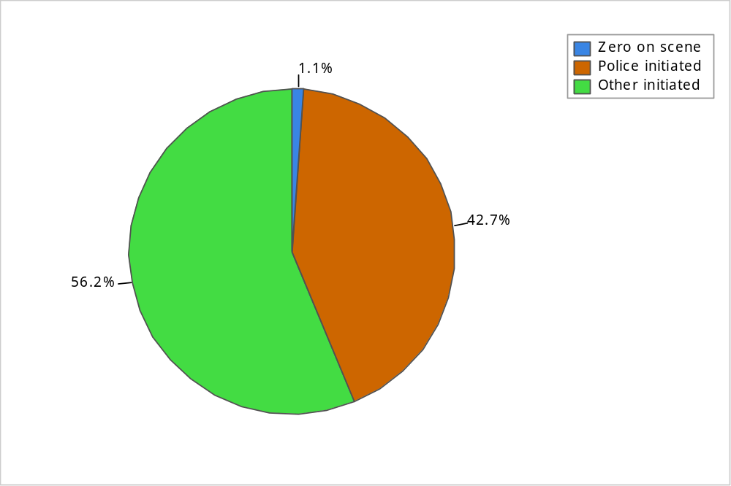
Note: Percentages are based on a total of 56,029 events.

TABLE 9-1: Events per Day, by Initiator
Initiator | Total Events | Events per Day
Zero on-scene | 635 | 1.7
Police-initiated | 23,899 | 65.5
Other-initiated | 31,495 | 86.3
Total | 56,029 | 153.5
Observations:
- 1 percent of the events had zero time on scene.
- 43 percent of all events were police-initiated.
- 56 percent of all events were other-initiated.
- On average, there were 154 events per day, or 6.4 per hour.
FIGURE 9-2: Percentage Events per Day, by Category
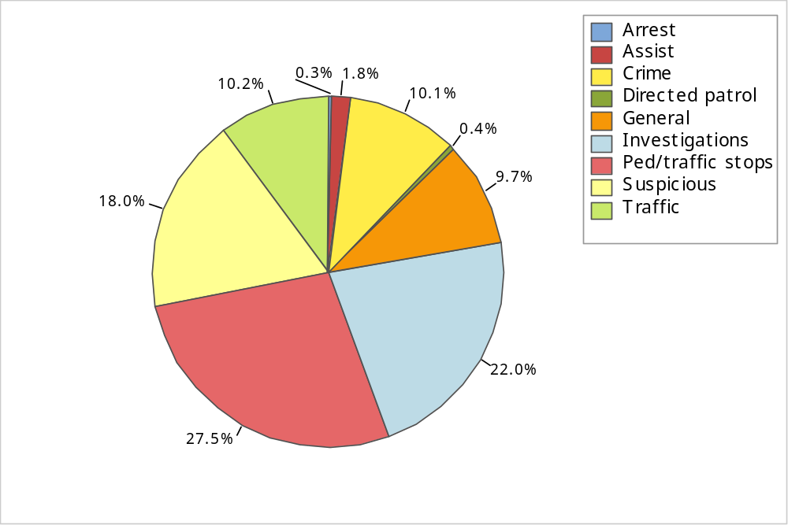
Note: The figure combines categories in the following table according to the description in Chart 9-1.
TABLE 9-2: Events per Day, by Category
Category | Total Events | Events per Day
Accidents | 2,083 | 5.7
Alarm | 3,523 | 9.7
Animal calls | 456 | 1.2
Assist other agency | 1,020 | 2.8
Check/investigation | 8,804 | 24.1
Crime–persons | 1,518 | 4.2
Crime–property | 4,160 | 11.4
Directed patrol | 246 | 0.7
Disturbance | 5,892 | 16.1
Juvenile | 165 | 0.5
Miscellaneous | 4,810 | 13.2
Pedestrian/traffic stops | 15,380 | 42.1
Prisoner–arrest | 158 | 0.4
Suspicious person/vehicle | 4,174 | 11.4
Traffic/vehicle related | 3,640 | 10.0
Total | 56,029 | 153.5
Observations:
- The top three categories (pedestrian/traffic stops, investigations, and suspicious incident) accounted for 67 percent of events.
- 27 percent of events were pedestrian/traffic stops.
- 22 percent of events were investigations.
- 18 percent of events were suspicious incidents.
- 10 percent of events were crimes.
FIGURE 9-3: Percentage Calls per Day, by Category
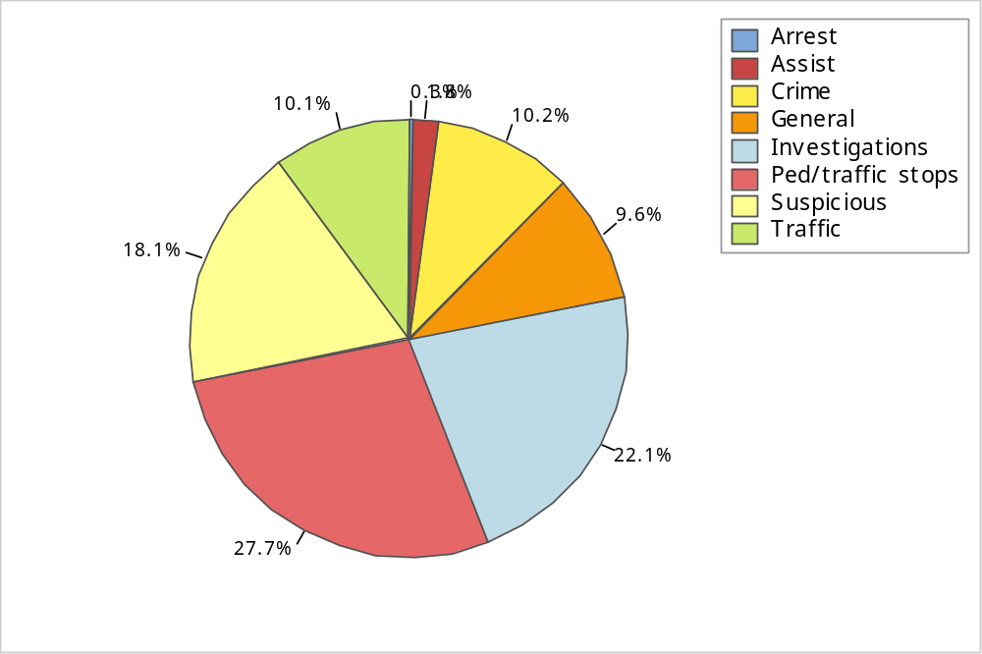
Note: The figure combines categories in the following table according to the description in Chart 9-1.
TABLE 9-3: Calls per Day, by Category
Category | Total Calls | Calls per Day
Accidents | 2,060 | 5.6
Alarm | 3,469 | 9.5
Animal calls | 446 | 1.2
Assist other agency | 1,013 | 2.8
Check/investigation | 8,718 | 23.9
Crime–persons | 1,509 | 4.1
Crime–property | 4,136 | 11.3
Disturbance | 5,839 | 16.0
Juvenile | 164 | 0.4
Miscellaneous | 4,686 | 12.8
Pedestrian/traffic stops | 15,305 | 41.9
Prisoner–arrest | 158 | 0.4
Suspicious person/vehicle | 4,147 | 11.4
Traffic/vehicle related | 3,504 | 9.6
Total | 55,154 | 151.1
Note: The focus here is on recorded calls rather than recorded events. We removed events with zero time on scene, and directed patrol activities.
Observations:
- On average, there were 151.1 calls per day, or 6.3 per hour.
- The top three categories accounted for 68 percent of calls:
- 28 percent of calls were pedestrian/traffic stops.
- 22 percent of calls were investigations.
- 18 percent of calls were suspicious incidents.
- 10 percent of calls were crimes.

FIGURE 9-4: Calls per Day, by Initiator and Months
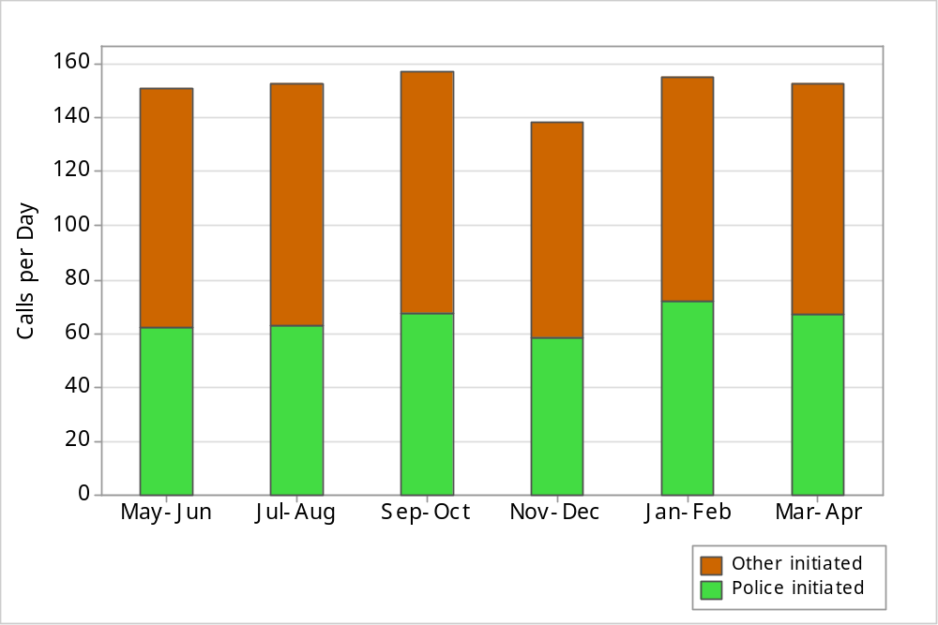

TABLE 9-4: Calls per Day, by Initiator and Months
Initiator | May-Jun | Jul-Aug | Sep-Oct | Nov-Dec | Jan-Feb | Mar-Apr
Police-initiated | 62.1 | 62.9 | 67.3 | 58.4 | 71.8 | 66.7
Other-initiated | 89.0 | 89.6 | 89.8 | 79.7 | 83.2 | 86.2
Total | 151.1 | 152.5 | 157.1 | 138.1 | 155.0 | 152.9

Observations:
- The number of calls per day was lowest in November-December.
- The number of calls per day was highest in September-October.
- The months with the most calls had 14 percent more calls than the months with the fewest calls.
- January-February had the most police-initiated calls, with 23 percent more than the period of November-December, which had the fewest.
- Three of the periods, May-June, July-August, and September-October had between 89 and 90 other-initiated calls per day, which were 13 percent more than the period of November-December, which had the fewest.
FIGURE 9-5: Calls per Day, by Category and Months
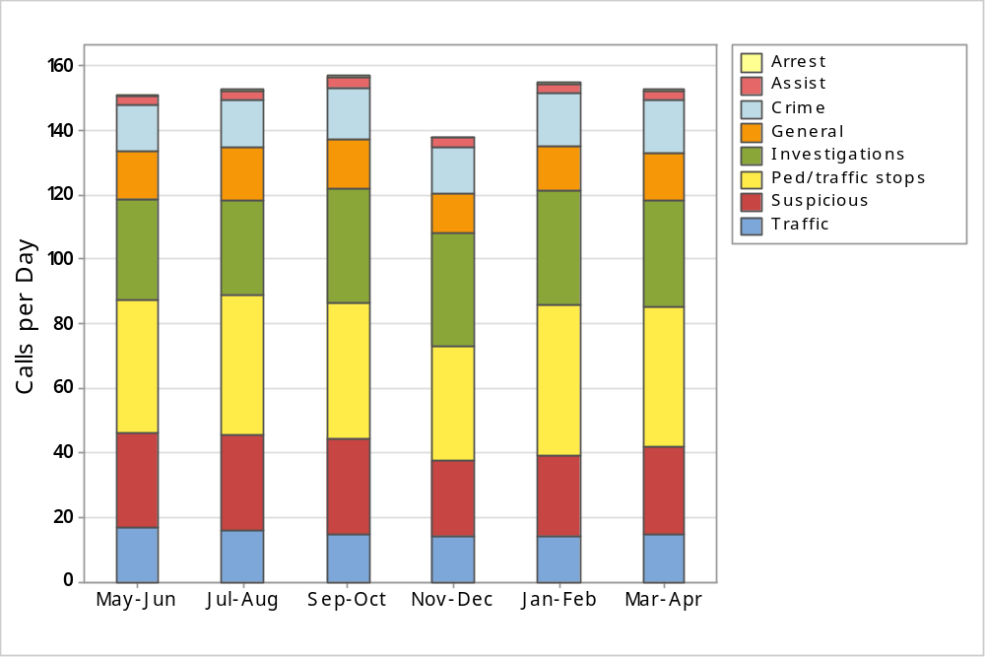
Note: The figure combines categories in the following table according to the description in Chart 9-1.
TABLE 9-5: Calls per Day, by Category and Months
Category | May-Jun | Jul-Aug | Sep-Oct | Nov-Dec | Jan-Feb | Mar-Apr
Accidents | 6.0 | 5.2 | 5.6 | 6.5 | 5.6 | 5.0
Alarm | 9.7 | 9.8 | 9.2 | 10.5 | 9.0 | 8.9
Animal calls | 1.1 | 1.5 | 1.5 | 1.1 | 1.0 | 1.0
Assist other agency | 2.9 | 2.3 | 3.1 | 2.8 | 2.6 | 2.9
Check/investigation | 21.9 | 19.8 | 26.2 | 24.6 | 26.7 | 24.2
Crime–persons | 4.0 | 4.1 | 4.9 | 3.6 | 3.8 | 4.4
Crime–property | 10.1 | 11.0 | 11.3 | 10.6 | 13.1 | 11.9
Directed patrol | 0.0 | 0.0 | 0.0 | 0.0 | 0.0 | 0.0
Disturbance | 18.1 | 17.6 | 17.2 | 13.2 | 13.7 | 16.0
Juvenile | 0.5 | 0.5 | 0.5 | 0.5 | 0.3 | 0.4
Miscellaneous | 13.2 | 14.0 | 13.4 | 10.7 | 12.5 | 13.2
Pedestrian/traffic stops | 41.4 | 43.4 | 42.0 | 35.3 | 46.3 | 43.4
Prisoner–arrest | 0.3 | 0.5 | 0.5 | 0.4 | 0.4 | 0.4
Suspicious person/vehicle | 11.2 | 12.0 | 12.3 | 10.5 | 11.1 | 11.1
Traffic/vehicle related | 10.7 | 10.8 | 9.4 | 7.8 | 8.9 | 9.9
Total | 151.1 | 152.5 | 157.1 | 138.1 | 155.0 | 152.9
Note: Calculations were limited to calls rather than events.
Observations:
- The top three categories (pedestrian/traffic stops, investigations, and suspicious incidents) averaged between 67 and 69 percent of calls throughout the year.
- Pedestrian/traffic stops averaged between 35.3 and 46.3 calls per day throughout the year.
- Investigations averaged between 29.5 and 35.7 calls per day throughout the year.
- Suspicious incidents averaged between 23.7 and 29.6 calls per day throughout the year.
- Crimes averaged between 14.1 and 16.8 calls per day throughout the year.
- Crimes accounted for 9 to 11 percent of total calls.

FIGURE 9-6: Average Occupied Times, by Category and Initiator
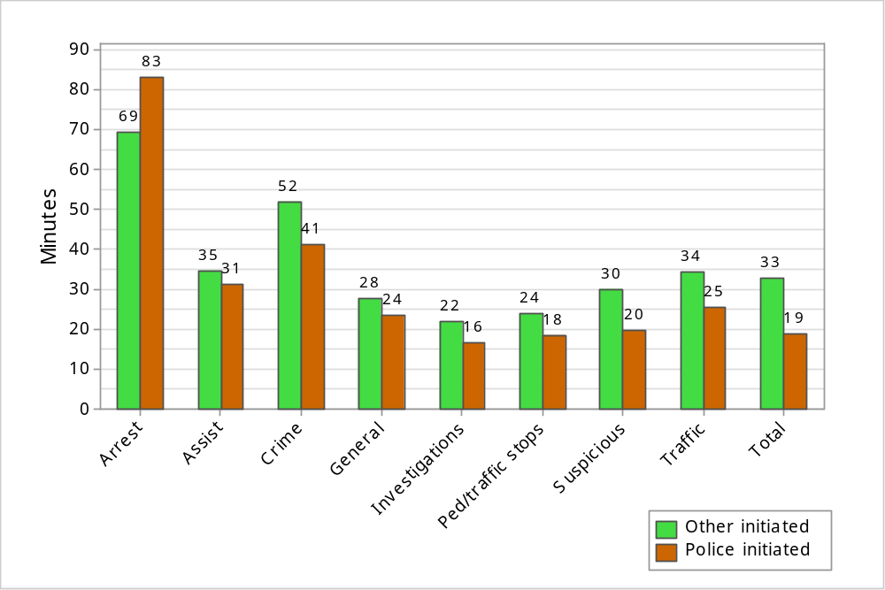
Note: The figure combines categories using weighted averages from the following table according to the description in Chart 9-1. For this graph, we removed 31 calls with inaccurate busy times.
TABLE 9-6: Primary Unit’s Average Occupied Times, by Category and Initiator
Category | Police-Initiated |  | Other-Initiated
Category | Total Calls | Minutes | Total Calls | Minutes
Accidents | 170 | 28.1 | 1,889 | 40.5
Alarm | 32 | 15.3 | 3,437 | 14.1
Animal calls | 8 | 15.0 | 438 | 23.0
Assist other agency | 17 | 31.0 | 996 | 34.6
Check/investigation | 5,633 | 16.5 | 3,079 | 30.5
Crime–persons | 34 | 53.7 | 1,466 | 68.4
Crime–property | 115 | 37.3 | 4,016 | 45.8
Disturbance | 105 | 30.2 | 5,732 | 30.9
Juvenile | 2 | 36.3 | 161 | 52.8
Miscellaneous | 1,473 | 23.7 | 3,212 | 27.3
Pedestrian/traffic stops | 14,469 | 18.3 | 833 | 23.7
Prisoner–arrest | 37 | 83.3 | 120 | 69.3
Suspicious person/vehicle | 919 | 18.5 | 3,227 | 28.2
Traffic/vehicle related | 637 | 24.6 | 2,866 | 30.2
Weighted Average/ Total Calls | 23,651 | 18.8 | 31,472 | 32.6
Note: The information in Figure 9-6 and Table 9-6 is limited to calls and excludes all events that show zero time on scene. A unit’s occupied time is measured as the time from when the call was received until the unit becomes available again. The times shown are the average occupied minutes per call for the primary unit, rather than the total occupied minutes for all units assigned to a call. Observations below refer to times shown within the figure rather than the table.
Observations:
- A unit's average time spent on a call ranged from 16 to 83 minutes overall.
- The longest average times were for police-initiated arrest calls.
- The average time spent on crime calls was 52 minutes for other-initiated calls and
41 minutes for police-initiated calls.
FIGURE 9-7: Number of Responding Units, by Initiator and Category
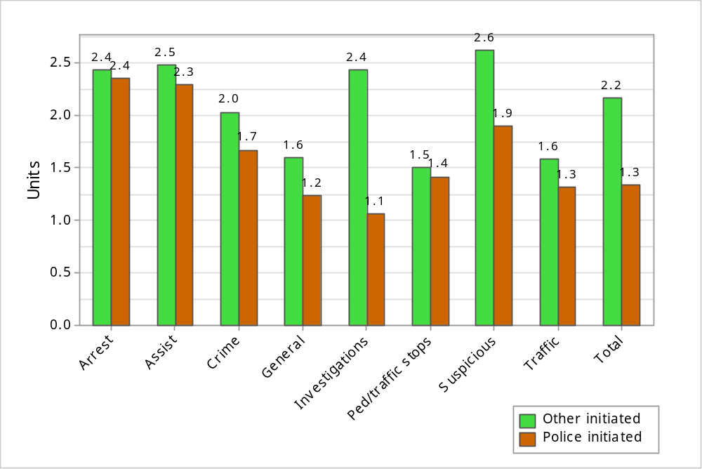
Note: The figure combines categories using weighted averages from the following table according to the description in Chart 9-1.
TABLE 9-7: Average Number of Responding Units, by Initiator and Category
Category | Police-Initiated |  | Other-Initiated
Category | Average | Total Calls | Average | Total Calls
Accidents | 1.7 | 170 | 1.9 | 1,890
Alarm | 1.9 | 32 | 2.6 | 3,437
Animal calls | 1.4 | 8 | 1.4 | 438
Assist other agency | 2.3 | 17 | 2.5 | 996
Check/investigation | 1.1 | 5,637 | 2.3 | 3,081
Crime–persons | 2.1 | 34 | 2.6 | 1,475
Crime–property | 1.5 | 115 | 1.8 | 4,021
Disturbance | 2.2 | 105 | 2.6 | 5,734
Juvenile | 1.0 | 2 | 2.1 | 162
Miscellaneous | 1.2 | 1,474 | 1.6 | 3,212
Pedestrian/traffic stops | 1.4 | 14,471 | 1.5 | 834
Prisoner–arrest | 2.4 | 37 | 2.4 | 121
Suspicious person/vehicle | 1.9 | 919 | 2.6 | 3,228
Traffic/vehicle related | 1.2 | 638 | 1.4 | 2,866
Total | 1.3 | 23,659 | 2.2 | 31,495
FIGURE 9-8: Number of Responding Units, by Category, Other-initiated Calls
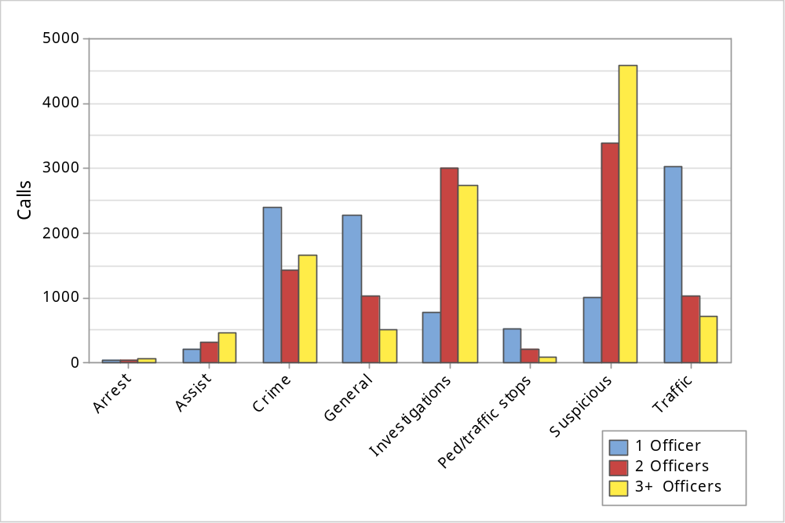
Note: The figure combines categories using weighted averages from the following table according to the description in Chart 9-1.
TABLE 9-8: Number of Responding Units, by Category, Other-initiated Calls
Category | Responding units
Category | One | Two | Three or more
Accidents | 939 | 448 | 503
Alarm | 128 | 1,734 | 1,575
Animal calls | 295 | 104 | 39
Assist other agency | 216 | 308 | 472
Check/investigation | 656 | 1,271 | 1,154
Crime–persons | 381 | 362 | 732
Crime–property | 2,009 | 1,074 | 938
Disturbance | 685 | 2,110 | 2,939
Juvenile | 59 | 50 | 53
Miscellaneous | 1,912 | 881 | 419
Pedestrian/traffic stops | 532 | 213 | 89
Prisoner–arrest | 34 | 32 | 55
Suspicious person/vehicle | 321 | 1,268 | 1,639
Traffic/vehicle related | 2,079 | 584 | 203
Total | 10,246 | 10,439 | 10,810
Observations:
- The overall mean number of responding units was 1.3 for police-initiated calls and 2.2 for other-initiated calls.
- The mean number of responding units was as high as 2.6 for suspicious incidents that were other-initiated.
- 33 percent of other-initiated calls involved one responding unit.
- 33 percent of other-initiated calls involved two responding units.
- 34 percent of other-initiated calls involved three or more responding units.
- The largest group of calls with three or more responding units involved suspicious incidents.
FIGURE 9-9: Percentage Calls and Work Hours, by Beat
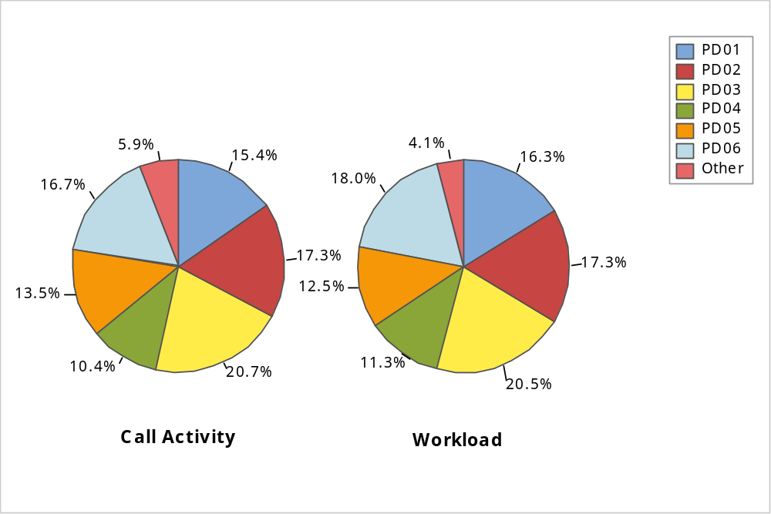
Note: Calls without a recorded area are included in “Other” category.
TABLE 9-9: Calls and Work Hours by Beat, per Day
Patrol Area | Per Day
Patrol Area | Calls | Work Hours
PD01 | 23.4 | 17.0
PD02 | 26.3 | 18.1
PD03 | 31.5 | 21.3
PD04 | 15.8 | 11.8
PD05 | 20.5 | 13.0
PD06 | 25.4 | 18.7
Other | 8.9 | 4.3
Total | 151.8 | 104.3
Observations:
- Beat PD03 had the most calls and highest workload. It accounted for 21 percent of total calls and 21 percent of total workload.
- Beat PD04 had the fewest calls and lowest workload. It accounted for 10 percent of calls and
11 percent of workload.
FIGURE 9-10: Percentage Calls and Work Hours, by Category, Summer 2014
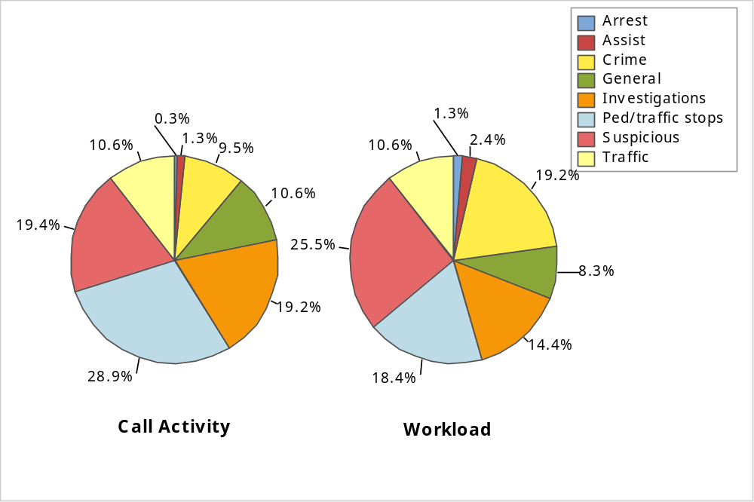

TABLE 9-10: Calls and Work Hours per Day, by Category, Summer 2014
Category | Per Day
Category | Calls | Work Hours
Arrest | 0.5 | 1.3
Assist | 2.0 | 2.4
Crime | 13.9 | 19.5
General noncriminal | 15.6 | 8.4
Investigations | 28.1 | 14.7
Pedestrian/traffic stops | 42.2 | 18.7
Suspicious Incident | 28.4 | 25.9
Traffic | 15.5 | 10.8
Total | 146.2 | 101.8

Observations:
- Total calls averaged 146 per day, or 6.1 per hour.
- Total workload averaged 102 hours per day, meaning that on average 4.2 officers per hour were busy responding to calls.
- Pedestrian/traffic stops constituted 29 percent of calls and 18 percent of workload.
- Investigations constituted 19 percent of calls and 14 percent of workload.
- Suspicious incidents constituted 19 percent of calls and 25 percent of workload.
- Crimes constituted 10 percent of calls and 19 percent of workload.
- These top four categories constituted 77 percent of calls and 77 percent of workload.

FIGURE 9-11: Percentage Calls and Work Hours, by Category, Winter 2015
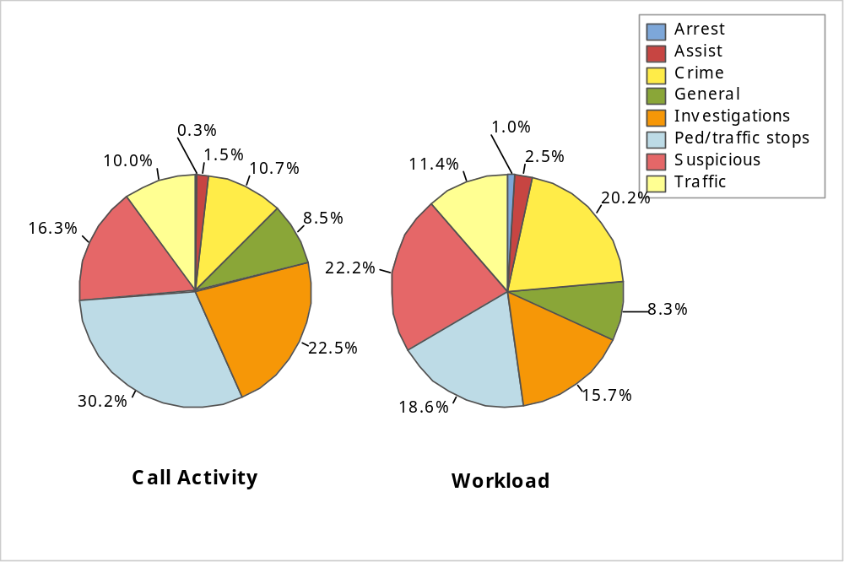
TABLE 9-11: Calls and Work Hours per Day, by Category, Winter 2015
Category | Per Day
Category | Calls | Work Hours
Arrest | 0.4 | 1.0
Assist | 2.4 | 2.6
Crime | 16.6 | 21.2
General noncriminal | 13.3 | 8.7
Investigations | 34.9 | 16.5
Pedestrian/traffic stops | 47.0 | 19.6
Suspicious Incident | 25.4 | 23.3
Traffic | 15.5 | 12.0
Total | 155.6 | 105.1
Note: Workload calculations focused on calls rather than events.
Observations:
- The average number of calls per day was higher in February than in August.
- The average daily workload was higher in February than in August.
- Total calls averaged 156 per day, or 6.5 per hour.
- Total workload averaged 105 hours per day, meaning that on average 4.4 officers per hour were busy responding to calls.
- Pedestrian/traffic stops constituted 30 percent of calls and 19 percent of workload.
- Investigations constituted 22 percent of calls and 16 percent of workload.
- Suspicious incidents constituted 16 percent of calls and 22 percent of workload.
- Crimes constituted 11 percent of calls and 20 percent of workload.
- These top four categories constituted 80 percent of calls and 77 percent of workload.

Noncall Activities
In the period from May 2014 to April 2015, the dispatch center also recorded activities that were not assigned a call number. We focused on those activities that involved a patrol unit. We also limited our analysis to noncall activities that occurred during shifts where the same patrol unit was also responding to calls for service. Each record only indicates one unit per activity.
There were a few problems with the data provided and we made assumptions and decisions to address these issues:
- We excluded activities that lasted less than 30 seconds. These are irrelevant and contribute little to the overall workload.
- Another portion of activities lasted more than 8 hours. As an activity is unlikely to last more than 8 hours, we assumed that these records were inaccurate.
- After these exclusions, 28,446 activities remained.
- The start and end times for the activities were not always clearly delineated. We estimated the end times based on the start of the next call or activity or a code indicating that the unit was either back in service or logged off for the day.
- The included activities had 32 different activity codes that were classified into 7 different activity types.
- Occasionally, dispatch descriptions indicated a specific patrol activity such as a bicycle patrol or traffic control. While not technically administrative, these were too rare (less than one percent of activities and associated workload) to classify separately and were folded into the administrative category.
In this section, we describe an activity’s average duration, and report on the variation of noncall activities by month, day of week, and time of day. In the next section, we include these activities in the overall workload when comparing the total workload against available personnel in February and August.
FIGURE 9-12: Percentage Activities and Work Hours by Category
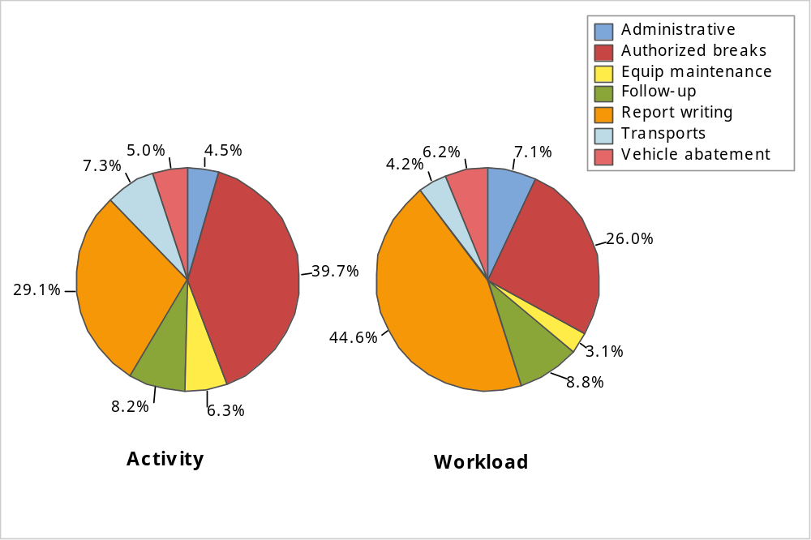
TABLE 9-12: Average Noncall Occupied Times, by Category
Category | Per Day
Category | Activities | Work Hours
Administrative | 3.5 | 3.9
Authorized breaks | 30.9 | 14.1
Follow-up investigation | 6.4 | 4.8
Report writing | 22.6 | 24.3
Transports | 5.7 | 2.3
Vehicle abatement | 3.9 | 3.3
Vehicle/equipment maintenance | 4.9 | 1.7
Total | 77.9 | 54.4
Observations:
- Report writing constituted 29 percent of noncall activities and 45 percent of the workload.
- Authorized breaks constituted 40 percent of noncall activities and 26 percent of the workload.
FIGURE 9-13: Activities per Day, by Month
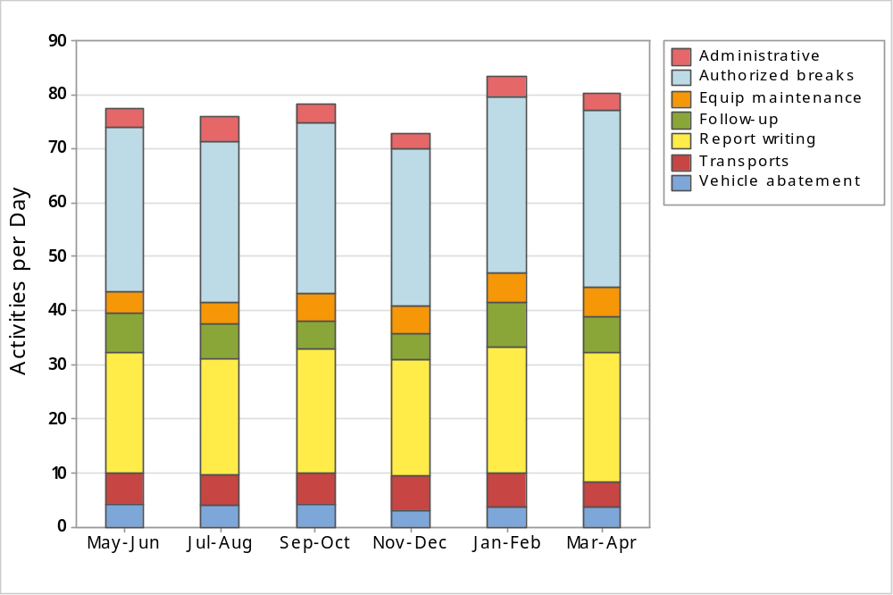
TABLE 9-13: Activities per Day, by Month
Activity Type | May-Jun | Jul-Aug | Sep-Oct | Nov-Dec | Jan-Feb | Mar-Apr | Yearly Average
Administrative | 3.5 | 4.6 | 3.4 | 2.9 | 3.7 | 3.0 | 3.5
Authorized breaks | 30.4 | 29.6 | 31.4 | 29.0 | 32.6 | 32.6 | 30.9
Follow-up investigation | 7.1 | 6.3 | 5.2 | 4.8 | 8.4 | 6.5 | 6.4
Report writing | 22.4 | 21.6 | 23.0 | 21.6 | 23.4 | 24.0 | 22.6
Transports | 5.7 | 5.6 | 5.8 | 6.2 | 6.3 | 4.6 | 5.7
Vehicle abatement | 4.2 | 4.1 | 4.2 | 3.3 | 3.7 | 3.8 | 3.9
Vehicle/equipment maintenance | 4.1 | 4.1 | 5.2 | 5.0 | 5.3 | 5.6 | 4.9
Total | 77.5 | 75.9 | 78.2 | 72.8 | 83.3 | 80.1 | 77.9
Observations:
- The number of noncall activities per day ranged between 73 and 83 throughout the year.
- Report writing and authorized breaks constituted between 67 and 71 percent of noncall activities throughout the year.
FIGURE 9-14: Activities per Day, by Day of Week
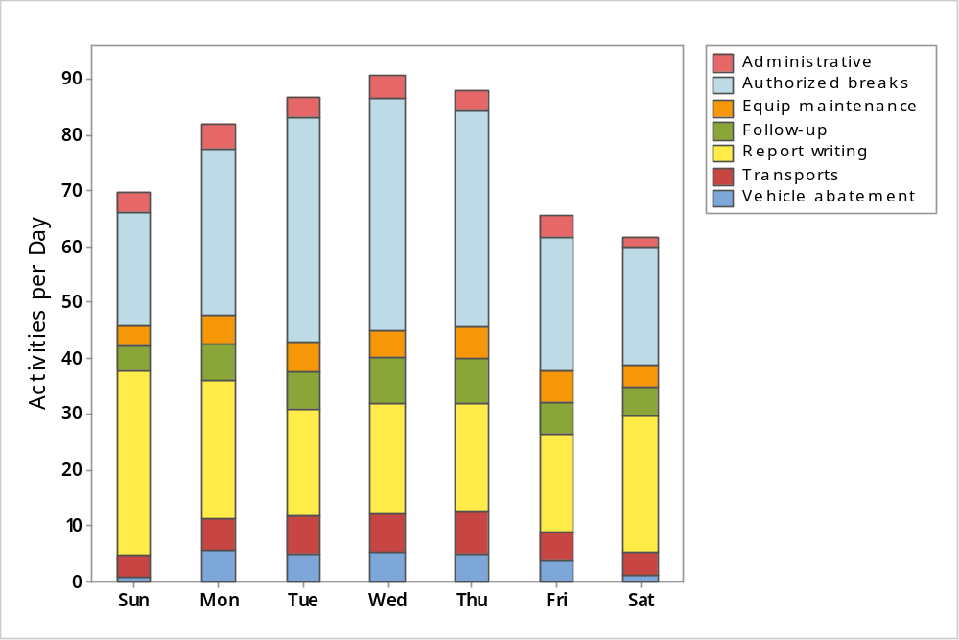

TABLE 9-14: Activities per Day, by Day of Week
Activity Type | Sun | Mon | Tue | Wed | Thu | Fri | Sat | Weekly Average
Administrative | 3.5 | 4.5 | 3.6 | 4.1 | 3.4 | 3.8 | 1.8 | 3.5
Authorized breaks | 20.4 | 29.9 | 40.4 | 41.4 | 39.0 | 23.9 | 21.3 | 30.9
Equipment maintenance | 3.5 | 5.2 | 5.6 | 5.0 | 5.6 | 5.6 | 3.8 | 4.9
Follow-up investigation | 4.4 | 6.5 | 6.5 | 8.3 | 7.9 | 5.9 | 5.1 | 6.4
Report writing | 33.3 | 24.8 | 19.2 | 19.7 | 19.6 | 17.5 | 24.5 | 22.7
Transports | 3.8 | 5.8 | 6.7 | 7.0 | 7.4 | 5.1 | 4.0 | 5.7
Vehicle abatement | 0.9 | 5.6 | 5.2 | 5.3 | 5.1 | 3.9 | 1.3 | 3.9
Total | 69.8 | 82.2 | 87.0 | 90.7 | 88.1 | 65.7 | 61.8 | 77.9
Observations:
- Report writing and authorized breaks made up, on average, about 66 percent of total activities on weekdays and 76 percent on weekends.
- The number of authorized breaks was highest mid-week, from Tuesdays to Thursdays.
- The number of report writing activities was highest on Sundays.
FIGURE 9-15: Activities per Hour, by Hour of Day
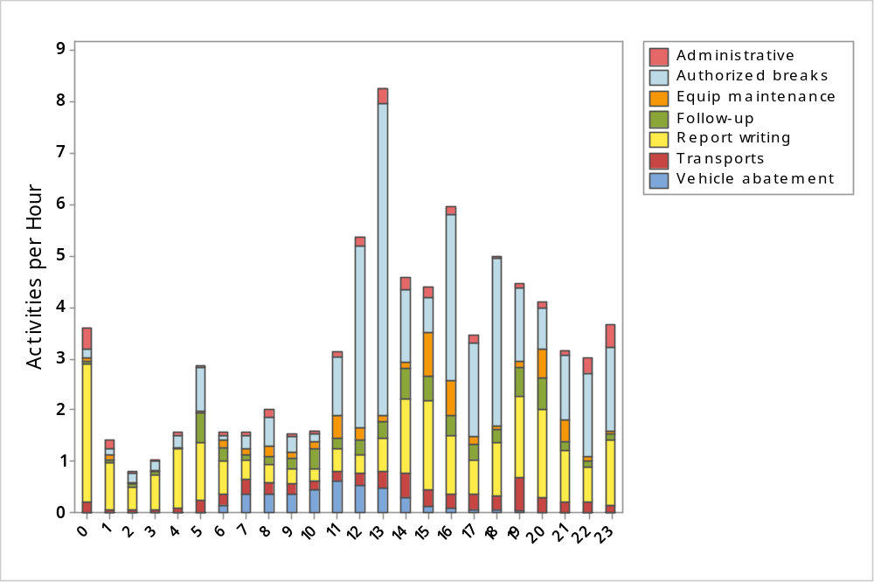

TABLE 9-15: Activities per Hour, by Hour of Day
Hour | Activity Type
Hour | Admin. | Auth. breaks | Equip. maint. | Follow-up | Report writing | Transports | Vehicle abatement | Total
0 | 0.4 | 0.2 | 0.0 | 0.1 | 2.7 | 0.2 | 0.0 | 3.6
1 | 0.2 | 0.1 | 0.1 | 0.1 | 0.9 | 0.1 | 0.0 | 1.4
2 | 0.0 | 0.2 | 0.1 | 0.0 | 0.4 | 0.1 | 0.0 | 0.8
3 | 0.0 | 0.2 | 0.0 | 0.0 | 0.7 | 0.0 | 0.0 | 1.0
4 | 0.1 | 0.2 | 0.0 | 0.0 | 1.1 | 0.1 | 0.0 | 1.6
5 | 0.0 | 0.8 | 0.0 | 0.6 | 1.1 | 0.2 | 0.0 | 2.9
6 | 0.1 | 0.1 | 0.2 | 0.2 | 0.7 | 0.2 | 0.1 | 1.6
7 | 0.1 | 0.3 | 0.1 | 0.1 | 0.4 | 0.3 | 0.4 | 1.6
8 | 0.1 | 0.6 | 0.2 | 0.1 | 0.4 | 0.2 | 0.4 | 2.0
9 | 0.1 | 0.3 | 0.1 | 0.2 | 0.3 | 0.2 | 0.3 | 1.5
10 | 0.1 | 0.2 | 0.1 | 0.4 | 0.2 | 0.2 | 0.4 | 1.6
11 | 0.1 | 1.2 | 0.4 | 0.2 | 0.4 | 0.2 | 0.6 | 3.1
12 | 0.2 | 3.5 | 0.2 | 0.3 | 0.3 | 0.2 | 0.5 | 5.4
13 | 0.3 | 6.1 | 0.1 | 0.3 | 0.6 | 0.3 | 0.5 | 8.2
14 | 0.2 | 1.4 | 0.1 | 0.6 | 1.4 | 0.5 | 0.3 | 4.6
15 | 0.2 | 0.7 | 0.9 | 0.5 | 1.8 | 0.3 | 0.1 | 4.4
16 | 0.1 | 3.2 | 0.7 | 0.4 | 1.2 | 0.3 | 0.1 | 5.9
17 | 0.2 | 1.8 | 0.1 | 0.3 | 0.7 | 0.3 | 0.1 | 3.4
18 | 0.1 | 3.3 | 0.1 | 0.3 | 1.0 | 0.2 | 0.1 | 5.0
19 | 0.1 | 1.4 | 0.1 | 0.6 | 1.6 | 0.6 | 0.0 | 4.5
20 | 0.1 | 0.8 | 0.6 | 0.6 | 1.7 | 0.3 | 0.0 | 4.1
21 | 0.1 | 1.3 | 0.4 | 0.2 | 1.0 | 0.2 | 0.0 | 3.2
22 | 0.3 | 1.6 | 0.1 | 0.1 | 0.7 | 0.2 | 0.0 | 3.0
23 | 0.5 | 1.6 | 0.1 | 0.1 | 1.3 | 0.1 | 0.0 | 3.7
Total | 3.5 | 30.9 | 4.9 | 6.4 | 22.6 | 5.7 | 3.9 | 77.9
Observations:
- The maximum number of noncall activities was recorded between 1:00 p.m. and 2:00 p.m.
- Authorized breaks constituted 74 percent of the workload between 1:00 p.m. and 2:00 p.m.
- Report writing activities constituted between 56 and 75 percent of activities between midnight and 5:00 a.m.

Deployment
For this study, CPSM examined deployment information for four weeks in summer (August 1, 2014 through August 28, 2014) and four weeks in winter (February 1 through February 28, 2015). The department’s main patrol force includes patrol officers and supervisors working the day, graveyard, midday, and swing shifts. Added patrol includes reserve units, K9 units, parking control officers, and community service officers (CSOs).
Since detailed schedules were not easily retrievable, we used each unit’s recorded log-on and log-off times to estimate the number of deployed officers in the four-week summer and winter periods.
The police department's main patrol force deployed an average of 11.5 officers per hour during the 24-hour day in summer and in winter. When additional units (reserve, K9, parking control, and CSO units) are included, the department averaged 13.1 officers per hour during the 24-hour day in summer and 13.5 officers per hour during the 24-hour day in winter.
In this section, we describe the deployment and workload in distinct steps, distinguishing between summer and winter and between weekdays (Monday through Friday) and weekends (Saturday and Sunday):
- First, we focus on patrol deployment alone.
- Next, we compare deployment against workload based on other-initiated calls for service.
- Then, we compare deployment against workload that also includes police-initiated calls for service.
- Finally, we compare "all" workload, which also includes directed patrol activities and all noncall activities.
Comments follow each set of four figures, with separate discussions for summer and winter.
FIGURE 9-16: Deployed Officers, Weekdays, Summer 2014
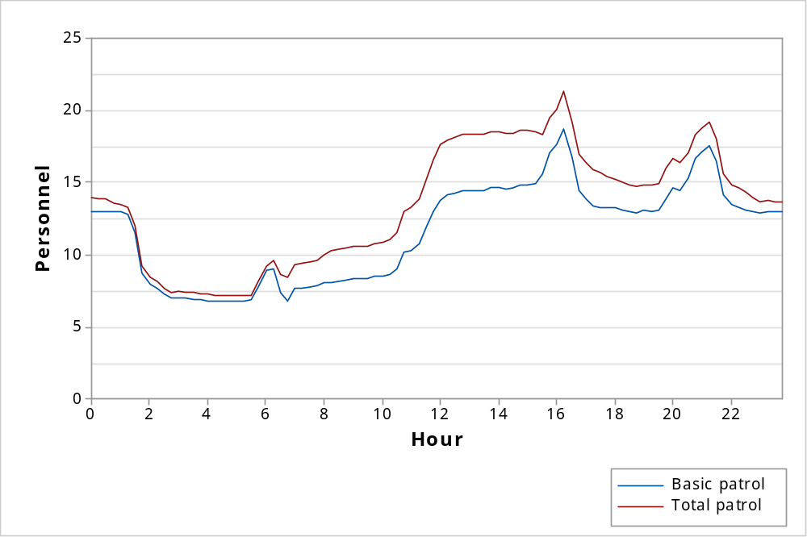
FIGURE 9-17: Deployed Officers, Weekends, Summer 2014
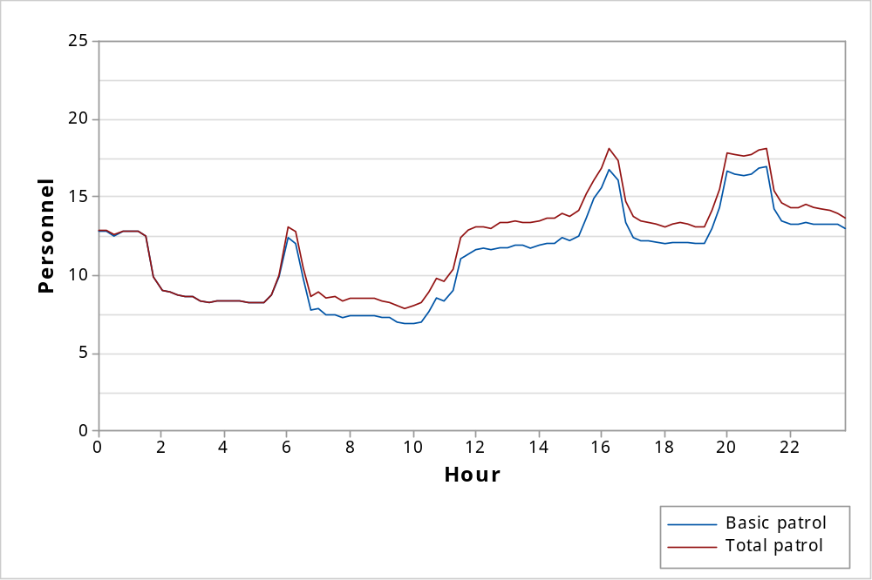
FIGURE 9-18: Deployed Officers, Weekdays, Winter 2015
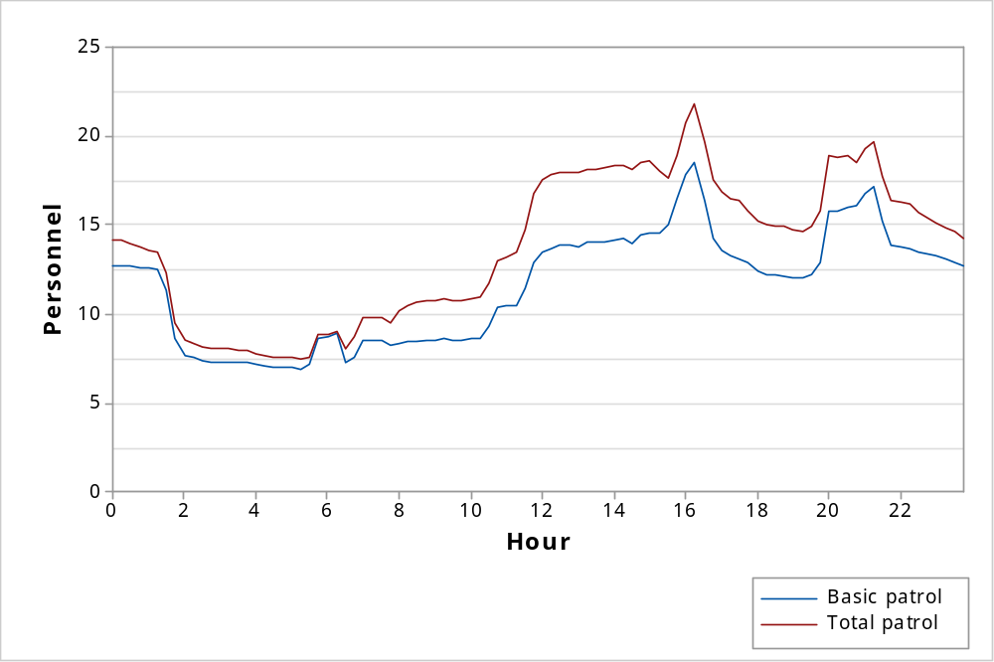
FIGURE 9-19: Deployed Officers, Weekends, Winter 2015
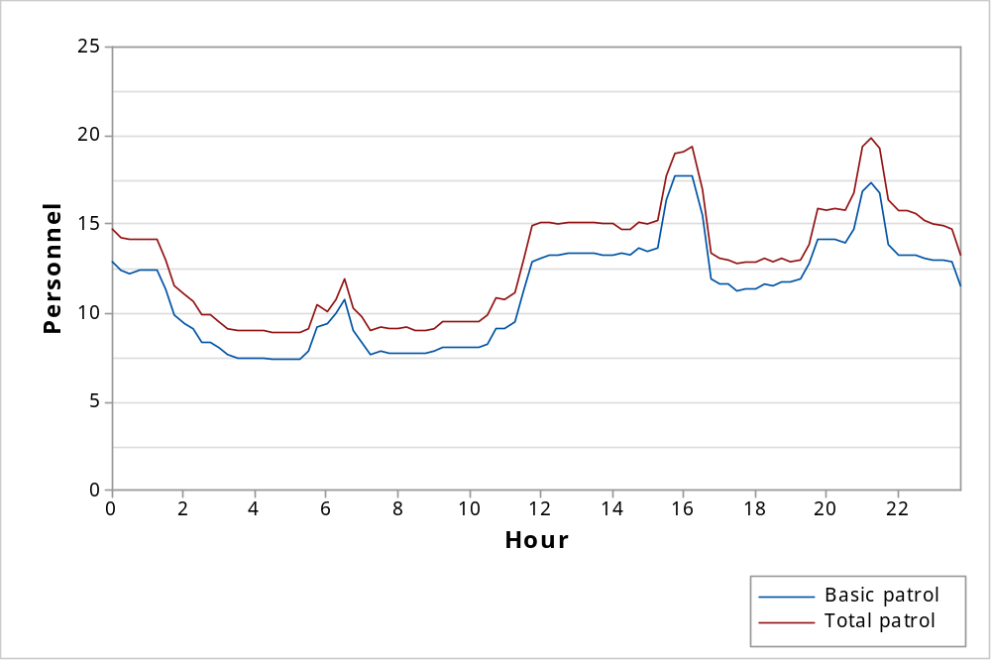
Observations:
- For summer 2014 :
- The police department’s main patrol force deployed an average of 11.6 officers during the week and 11.2 officers during the weekend. The average total deployment was 13.5 officers per hour during the week and 12.1 officers per hour on the weekend.
- Average total deployment varied from 7.2 to 21.3 officers per hour (highest during shift overlaps) on weekdays and from 7.9 to 18.1 officers (highest during shift overlaps) per hour on weekends
- For winter 2015:
- The police department's main patrol force deployed an average of 11.5 officers during the week and 11.3 officers on weekend. The average total deployment was 13.8 officers per hour during the week and 12.9 officers per hour on the weekend.
- Average deployment varied from 7.5 to 21.8 officers (highest during shift overlaps) per hour on weekdays and 8.9 to 19.9 officers (highest during shift overlaps) per hour on weekends.
FIGURE 9-20: Deployment and Other-Initiated Workload, Weekdays, Summer 2014
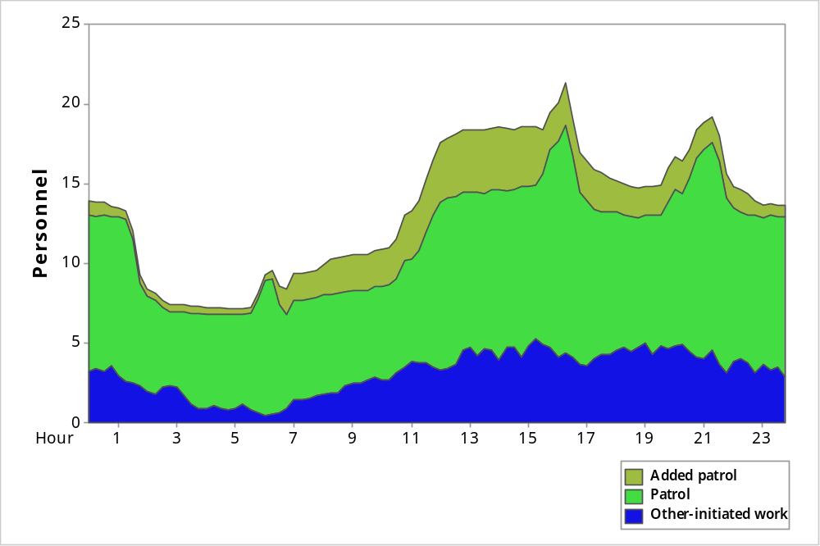
FIGURE 9-21: Deployment and Other-Initiated Workload, Weekends, Summer 2014
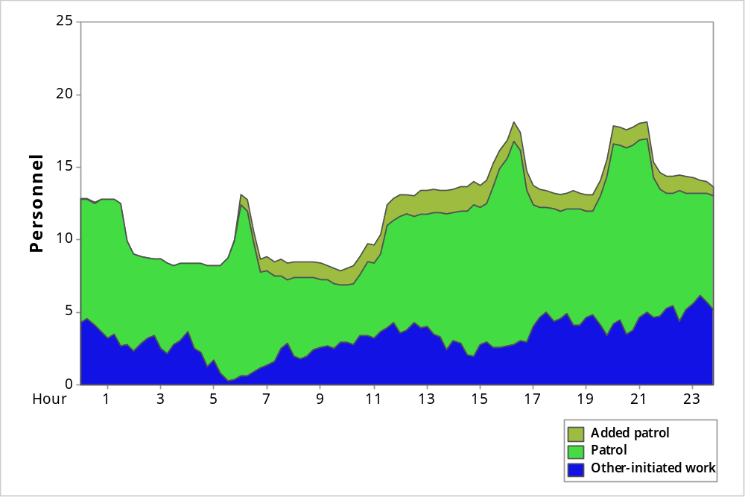

FIGURE 9-22: Deployment and Other-Initiated Workload, Weekdays, Winter 2015
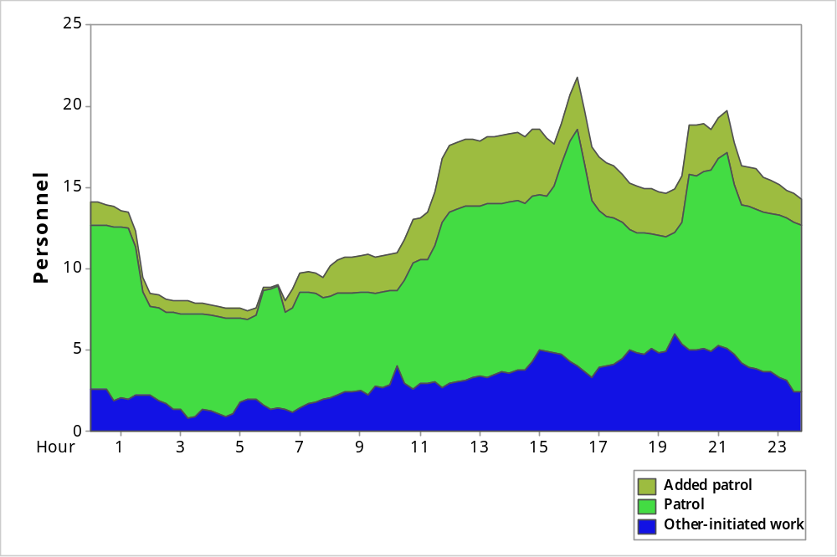
FIGURE 9-23: Deployment and Other-Initiated Workload, Weekends, Winter 2015
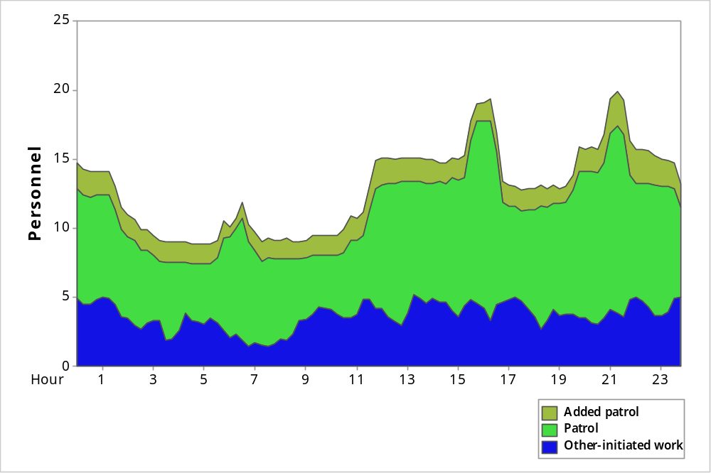
Observations:
- For summer 2014:
- Average other-initiated workload was 3.1 officers per hour during the week and
3.3 officers per hour on weekends.
- This was approximately 23 percent of hourly deployment during the week and
27 percent of hourly deployment on weekends.
- During the week, workload reached a maximum of 34 percent of deployment between 7:00 p.m. and 7:15 p.m.
- On weekends, workload reached a maximum of 44 percent of deployment between
4:00 a.m. and 4:15 a.m. and between 11:15 p.m. and 11:30 p.m.
- For winter 2015:
- Average other-initiated workload was 3.1 officers per hour during the week and
3.7 officers per hour on weekends.
- This was approximately 22 percent of hourly deployment during the week and
28 percent of hourly deployment on weekends.
- During the week, workload reached a maximum of 40 percent of deployment between 7:30 p.m. and 7:45 p.m.
- On weekends, workload reached a maximum of 45 percent of deployment between
9:30 a.m. and 10:00 a.m.

FIGURE 9-24: Deployment and Main Workload, Weekdays, Summer 2014
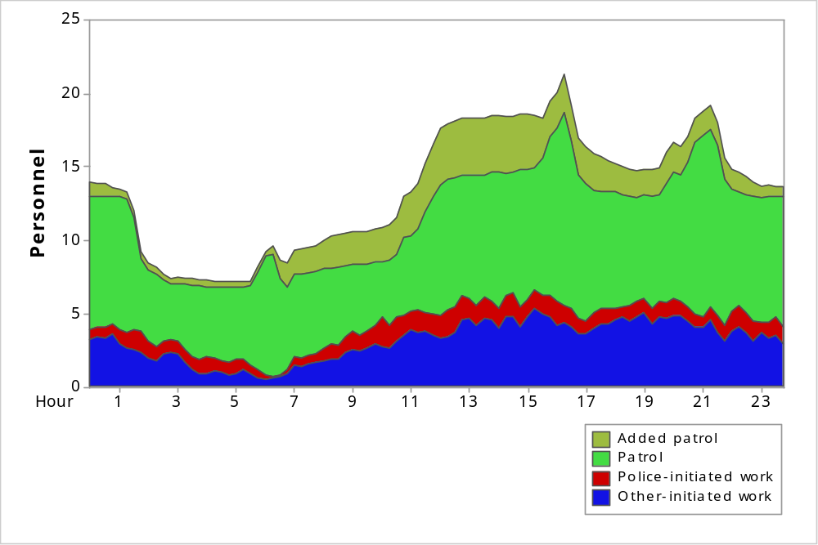
FIGURE 9-25: Deployment and Main Workload, Weekends, Summer 2014
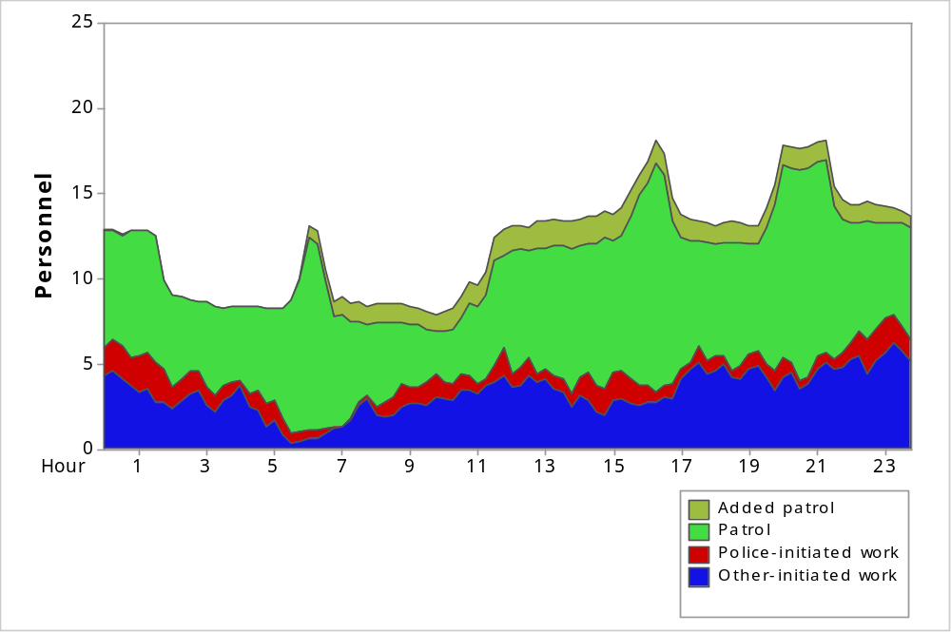
FIGURE 9-26: Deployment and Main Workload, Weekdays, Winter 2015
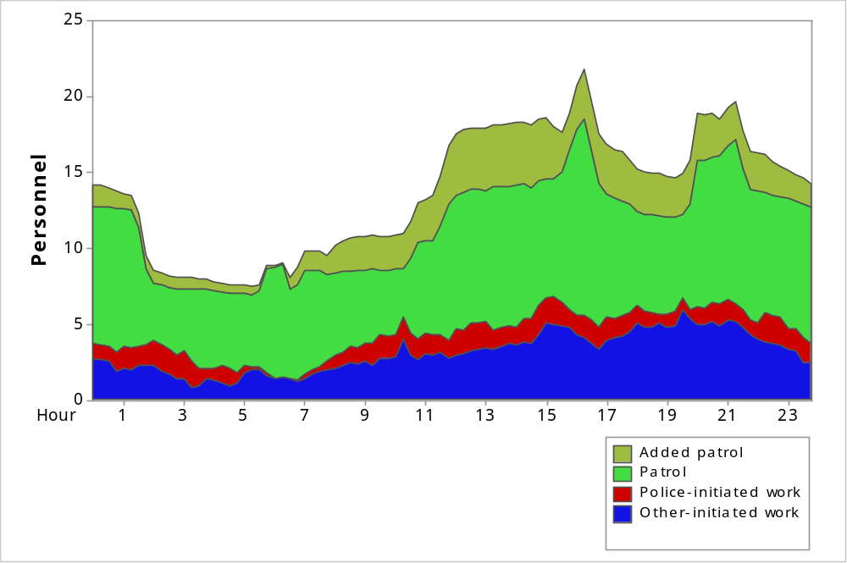
FIGURE 9-27: Deployment and Main Workload, Weekends, Winter 2015
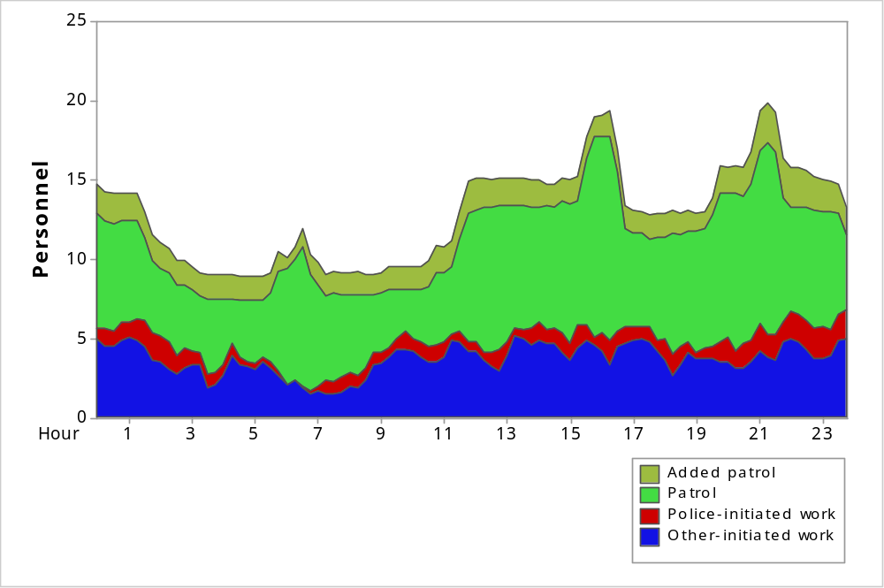
Note: Figures 9-24 to 9-27 show deployment along with workload from other-initiated calls and police-initiated calls.
Observations:
- For summer 2014:
- Average workload was 4.2 officers per hour during the week and 4.3 officers per hour on weekends.
- This was approximately 31 percent of hourly deployment during the week and
35 percent of hourly deployment on weekends.
- During the week, workload reached a maximum of 44 percent of deployment between 2:45 a.m. and 3:00 a.m. and between 10:00 a.m. and 10:15 a.m.
- On weekends, workload reached a maximum of 56 percent of deployment between
9:45 a.m. and 10:00 a.m. and between 11:15 p.m. and 11:30 p.m.
- For winter 2015:
- Average workload was 4.3 officers per hour during the week and 4.6 officers per hour on weekends.
- This was approximately 31 percent of hourly deployment during the week and
36 percent of hourly deployment on weekends.
- During the week, workload reached a maximum of 49 percent of deployment between 10:15 a.m. and 10:30 a.m.
- On weekends, workload reached a maximum of 57 percent of deployment between
9:45 a.m. and 10:00 a.m.
FIGURE 9-28: Deployment and All Workload, Weekdays, Summer 2014
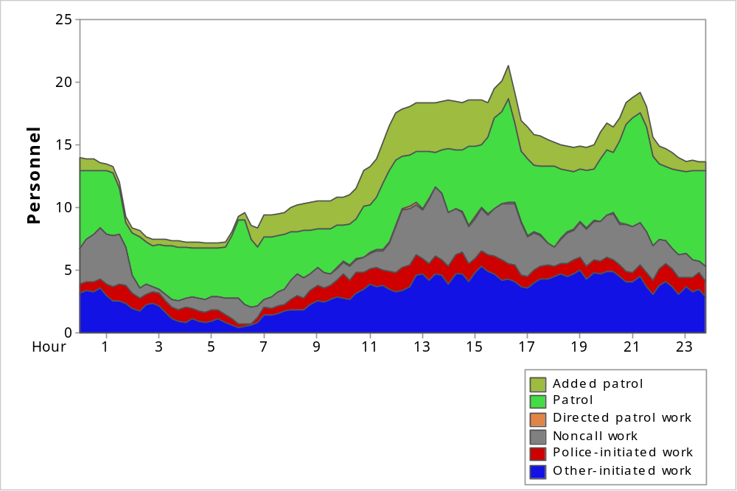
FIGURE 9-29: Deployment and All Workload, Weekends, Summer 2014
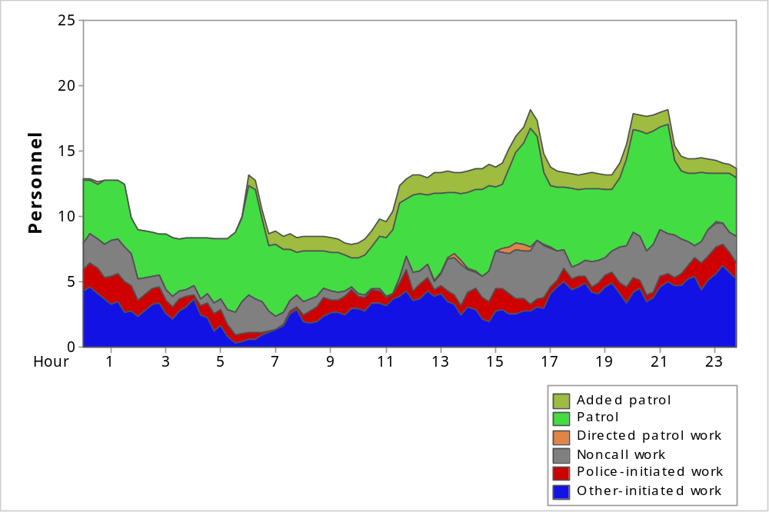
FIGURE 9-30: Deployment and All Workload, Weekdays, Winter 2015
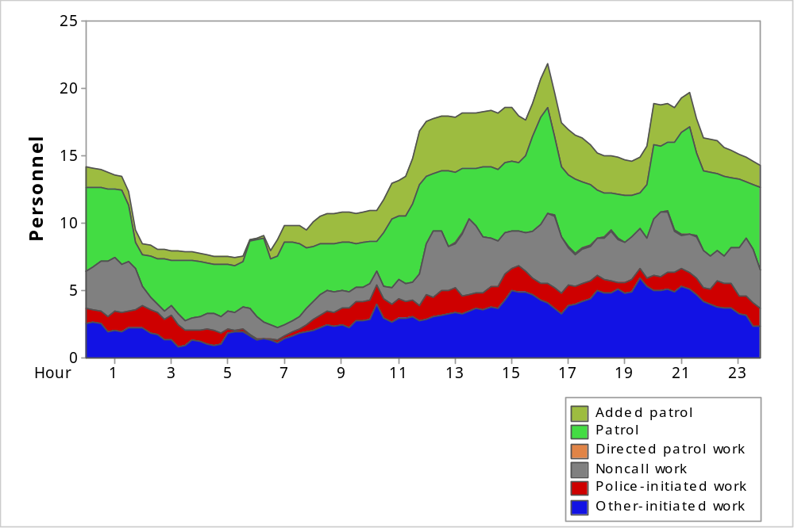
FIGURE 9-31: Deployment and All Workload, Weekends, Winter 2015
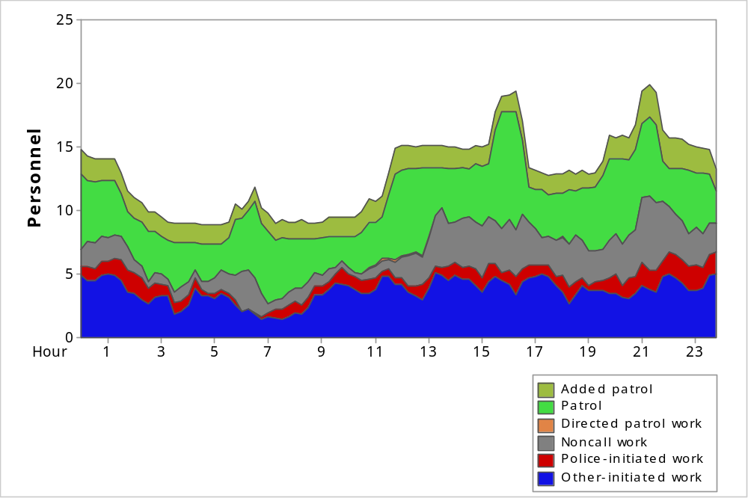
Note: Figures 9-28 to 9-31 show deployment along with all workload from other-initiated calls, police-initiated work, directed patrol activities, and noncall activities.
Observations:
- For summer 2014:
- Average workload was 6.6 officers per hour during the week and 6.1 officers per hour on weekends.
- This was approximately 49 percent of hourly deployment during the week and
50 percent of hourly deployment on weekends.
- During the week, workload reached a maximum of 73 percent of deployment between 1:45 a.m. and 2:00 a.m.
- On weekends, workload reached a maximum of 73 percent of deployment between
1:45 a.m. and 2:00 a.m.
- For winter 2015:
- Average workload was 6.8 officers per hour during the week and 6.9 officers per hour on weekends.
- This was approximately 49 percent of hourly deployment during the week and
54 percent of hourly deployment on weekends.
- During the week, workload reached a maximum of 70 percent of deployment between 1:45 a.m. and 2:00 a.m.
- On weekends, workload reached a maximum of 68 percent of deployment between
4:45 p.m. and 5:00 p.m.

Response Times
We analyzed the response times to various types of calls, separating the duration into dispatch and travel time, to determine whether response times varied by call type. Response time is measured as the difference between when a call is received and when the first unit arrives on scene. This is further divided into dispatch delay and travel time. Dispatch delay is the time between when a call is received and when the first unit is dispatched. Travel time is the remaining time until the first unit arrives on scene.
We begin the discussion with statistics that include all calls combined. We started with 4,149 events for summer and 4,404 events for winter. We limited our analysis to 2,391 other-initiated calls for summer and 2,407 other-initiated calls for winter. After excluding calls without valid arrival times, we were left with 2,208 calls in summer and 2,230 calls in winter for our analysis. For the entire year, we began with 56,029 calls, limited our analysis to 31,495 other-initiated calls, and further focused our analysis on 27,952 calls after excluding those lacking valid arrival times.
Our initial analysis does not distinguish calls on the basis of their priority; instead, it examines the difference in response for all calls by time of day and compares summer and winter periods. We then present a brief analysis of response time for high-priority calls alone.

All Calls
This section looks at all calls without considering their priorities. In addition to examining the differences in response times by both time of day and season (winter versus summer), we show differences in response times by category.
FIGURE 9-32: Average Response Time, by Hour of Day, Summer 2014, and Winter 2015
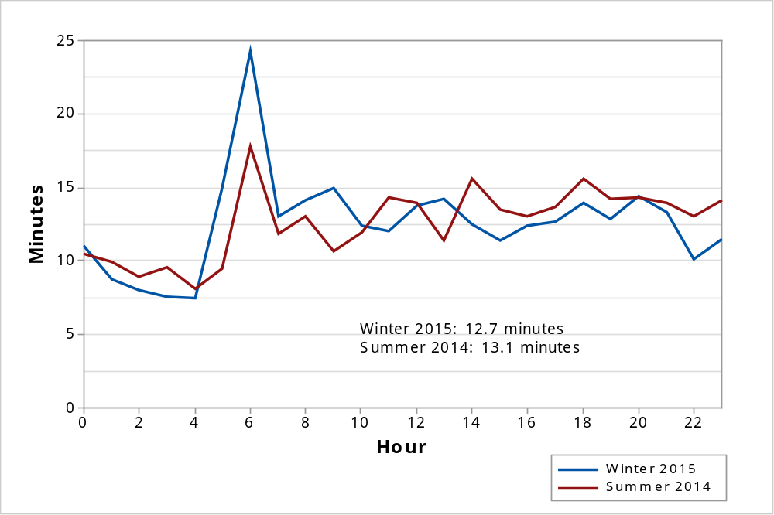
Observations:
- Average response times varied significantly by hour of day.
- In August, the longest response times were between 6:00 a.m. and 7:00 a.m., with an average of 17.8 minutes.
- In August, the shortest response times were between 4:00 a.m. and 5:00 a.m., with an average of 8.2 minutes.
- In February, the longest response times were between 6:00 a.m. and 7:00 a.m., with an average of 24.2 minutes.
- In February, the shortest response times were between 4:00 a.m. and 5:00 a.m., with an average of 7.5 minutes.
FIGURE 9-33: Average Response Time by Category, Summer 2014
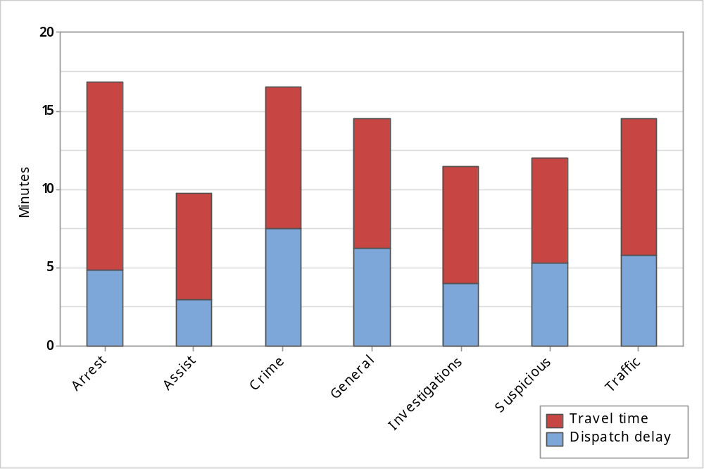
FIGURE 9-34: Average Response Time by Category, Winter 2015
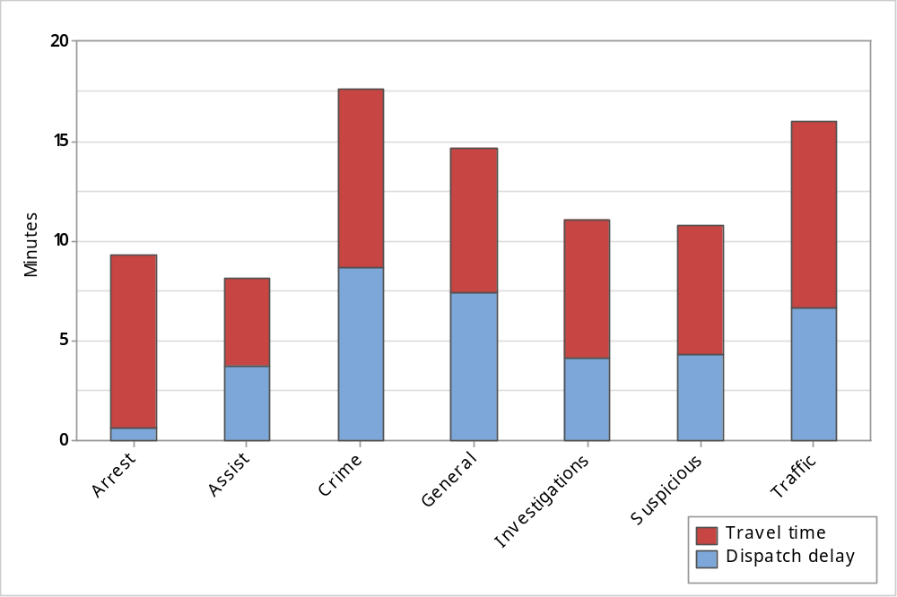
TABLE 9-16 Average Response Time Components, by Category
Category | Summer 2014 |  |  | Winter 2015
Category | Dispatch | Travel | Response | Dispatch | Travel | Response
Arrest | 4.8 | 12.0 | 16.8 | 0.6 | 8.7 | 9.3
Assist | 3.0 | 6.8 | 9.8 | 3.7 | 4.3 | 8.1
Crime | 7.5 | 9.0 | 16.5 | 8.6 | 9.0 | 17.6
General noncriminal | 6.2 | 8.2 | 14.5 | 7.4 | 7.3 | 14.7
Investigations | 4.0 | 7.4 | 11.4 | 4.2 | 6.9 | 11.1
Suspicious incident | 5.3 | 6.7 | 12.0 | 4.3 | 6.4 | 10.7
Traffic | 5.8 | 8.7 | 14.5 | 6.6 | 9.3 | 16.0
Total | 5.4 | 7.6 | 13.1 | 5.5 | 7.2 | 12.7
Note: The total average is weighted according to the number of calls per category.

TABLE 9-17: 90th Percentiles for Response Time Components, by Category
Category | Summer 2014 |  |  | Winter 2015
Category | Dispatch | Travel | Response | Dispatch | Travel | Response
Arrest | 26.5 | 20.9 | 45.0 | 3.1 | 24.8 | 25.7
Assist | 6.4 | 13.7 | 16.7 | 6.7 | 7.6 | 16.7
Crime | 21.6 | 18.6 | 33.6 | 25.8 | 18.6 | 40.5
General noncriminal | 17.6 | 18.0 | 29.7 | 23.1 | 15.0 | 32.7
Investigations | 9.1 | 13.4 | 21.0 | 9.9 | 13.6 | 21.6
Suspicious incident | 12.2 | 12.1 | 23.1 | 8.6 | 11.7 | 20.1
Traffic | 14.4 | 17.3 | 30.4 | 18.6 | 19.5 | 33.9
Total | 13.9 | 15.4 | 26.3 | 14.4 | 15.0 | 26.0
Note: A 90th percentile value of 26 minutes means that 90 percent of all calls are responded to in fewer than 26 minutes. For this reason, the columns for dispatch delay and travel time may not be equal to the total response time.

Figures 9-33 and 9-34 and Tables 9-16 and 9-17 exclude other-initiated calls classified as pedestrian/traffic stops.
Observations:
- In summer, the average response time was as short as 10 minutes (for assists) and as long as 17 minutes (for arrests).
- In winter, the average response time for most categories was between 8 minutes and
16 minutes.
- In winter, the average response time was as short as 8 minutes (for assists) and as long as 18 minutes (for crimes).
- The average response time for crimes was 16 minutes in August and 18 minutes in February.
- In summer, the 90th percentile value for response time was as short as 17 minutes (for assists) and as long as 45 minutes (for arrests).
- In winter, the 90th percentile value for response time was as short as 17 minutes (for assists) and as long as 41 minutes (for crimes).

High-Priority Calls
A priority code is assigned to calls by the department, with 1 as the highest priority. Table 18 shows average response times, separated by priority. These averages include nonzero-time-on-scene, other-initiated calls throughout the year from May 1, 2014, to April 28, 2015. There were 27,950 other-initiated calls with valid response times. Figure 35 focuses on calls with priority 1.
TABLE 9-18: Average Dispatch, Travel, and Response Times, by Priority
Priority | Dispatch | Travel | Response | Total Calls
1 | 2.7* | 4.9 | 7.6* | 1,582
2 | 3.5 | 6.0 | 9.5 | 7,060
3 | 5.7 | 7.9 | 13.6 | 10,336
4 | 8.8 | 9.6 | 18.5 | 6,541
5 | 6.8 | 9.0 | 15.9 | 1,615
6 | 7.5 | 11.2 | 18.7 | 686
7 | 17.3 | 8.3 | 25.6 | 1
8 | 19.2 | 13.3 | 32.5 | 84
9 | 18.3 | 11.0 | 29.3 | 47
All | 5.9 | 7.8 | 13.7 | 27,952
Note: The total average is weighted according to the number of calls within each priority level. The priorities shown are associated with each call’s final description. In a significant percentage of calls, a description was changed from one of low priority at time of dispatch, to a higher priority description upon arrival. Priority 1 calls were reviewed in February, and those whose priorities remained identical throughout the dispatch process had a shorter dispatch delay of 2.2 minutes.
FIGURE 9-35: Average Response Times and Dispatch Delays for High-Priority Calls, by Hour
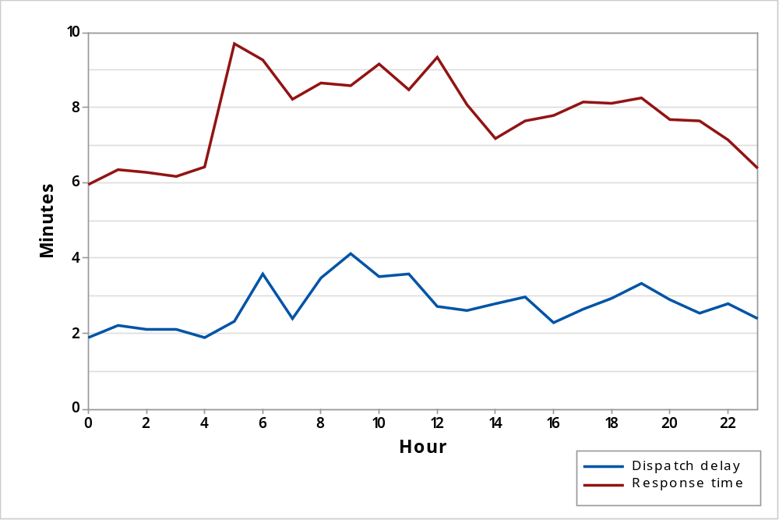
Observations:
- High-priority calls had an average response time of 7.6 minutes, lower than the overall average of 13.7 minutes for all calls.
- Average dispatch delay was 2.7 minutes for high-priority calls, compared to 5.9 minutes overall.
- Average response time for injury accidents was 7.0 minutes, with a dispatch delay of
1.4 minutes.
- For high-priority calls, the longest response times were between 5:00 a.m. and 6:00 a.m., with an average of 9.7 minutes.
- For high-priority calls, the shortest response times were between midnight and 1:00 a.m., with an average of 5.9 minutes.

Variation by Year
We compared the volume of calls in the twelve-month study period from May 2014 to April 2015 to the volume of calls in the previous twelve-month period from May 2013 to April 2014.
Between May 1, 2013, and April 30, 2014, the communications center recorded 53,586 events that were assigned call numbers and which included an adequate record of a responding patrol unit as either the primary or secondary unit. When measured daily, the department reported an average of 146.8 patrol-related events per day, approximately 1 percent of which (1.6 per day) had fewer than 30 seconds spent on the call.
FIGURE 9-36: Average Calls per Day by Year and Months
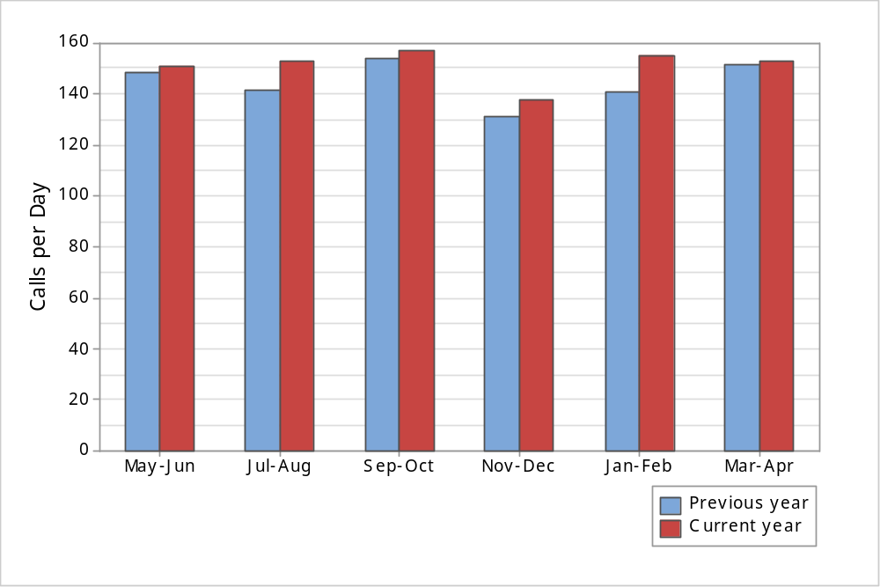

TABLE 9-19: Calls per Day, by Year and Months
Year | May-Jun | Jul-Aug | Sep-Oct | Nov-Dec | Jan-Feb | Mar-Apr
Previous | 148.6 | 141.3 | 153.7 | 131.3 | 140.7 | 151.8
Current | 151.1 | 152.5 | 157.1 | 138.1 | 155.0 | 152.9
Observations:
- The number of calls per day was consistently higher in the current year than in the previous year.
- In both years, the lowest number of calls per day was recorded in November-December, and the highest in September-October.

FIGURE 9-37: Average Response Time by Year and Call Priority
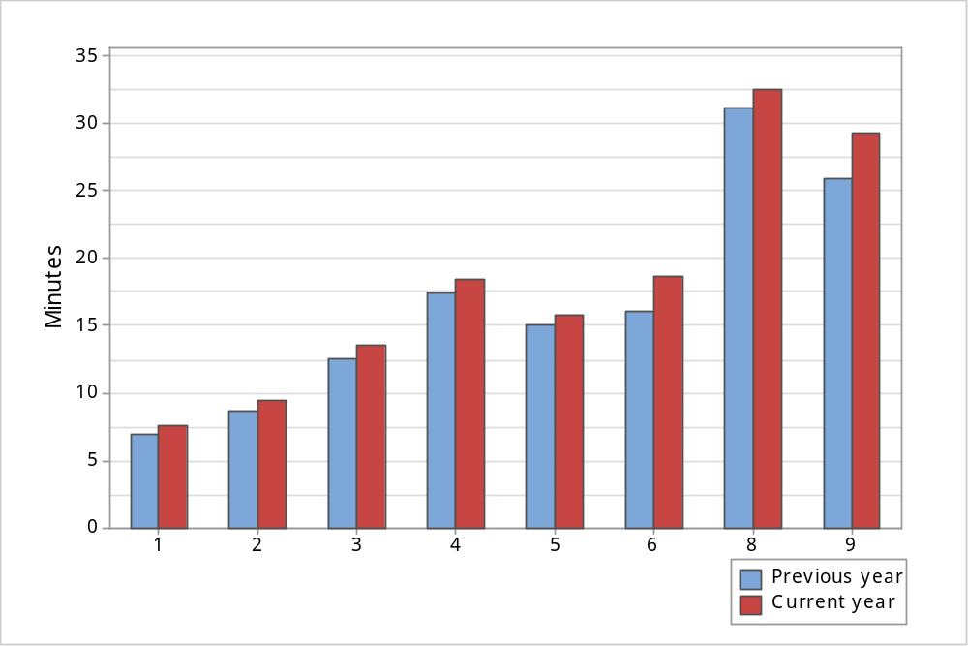
Note: Priority 7 was excluded from the analysis because only one call was assigned priority 7.

TABLE 9-20: Average Response Time by Year and Call Priority
Priority | Previous Year |  | Current Year
Priority | Response Time | Counts | Response Time | Counts
1 | 7.0 | 1,610 | 7.6 | 1,582
2 | 8.8 | 7,047 | 9.5 | 7,060
3 | 12.6 | 10,652 | 13.6 | 10,336
4 | 17.4 | 6,522 | 18.5 | 6,541
5 | 15.1 | 1,708 | 15.9 | 1,615
6 | 16.0 | 558 | 18.7 | 686
8 | 31.2 | 69 | 32.5 | 84
9 | 25.9 | 37 | 29.3 | 47
Weighted Average | 12.7 | 28,203 | 13.7 | 27,951
Observations:
- The response time was longer for all levels of calls in the current year compared to the previous year.
TABLE 9-21: Calls and Work Hours per Day, by Year and Beat
Patrol Area | Previous Year |  | Current Year
Patrol Area | Calls | Work Hours | Calls | Work Hours
PD01 | 19.2 | 15.6 | 23.4 | 17
PD02 | 22.1 | 15.8 | 26.3 | 18.1
PD03 | 33.8 | 23.4 | 31.5 | 21.3
PD04 | 17.6 | 12.8 | 15.8 | 11.8
PD05 | 22.8 | 14 | 20.5 | 13
PD06 | 23.3 | 17 | 25.4 | 18.7
Other | 6.5 | 3.4 | 8.9 | 4.3
Total | 145.2 | 102 | 151.8 | 104.3
Observations:
- Beat PD03 had the highest number of calls and workload per day in both years.
- Beat PD04 had the lowest number of calls and workload per day in both years.

Traffic Units
Between May 1, 2014, and April 30, 2015, the communications center recorded 5,010 events with call numbers assigned to traffic/motor units. Traffic units only work on weekdays, which included 263 days during the study period. When measured daily, the department reported an average of 19.1 events per day, approximately 2 percent of which (0.3 per day) had fewer than 30 seconds spent on the call. As noted, this average was over 263 days rather than the usual 365 calendar days in the same period.
During this period, the dispatch center recorded activities assigned to traffic units that were not assigned a call number. After excluding activities that lasted less than 30 seconds and more than 8 hours, 1,079 noncall activities remained.
This section gives an overview of the number of calls, noncall activities, deployment, and workload for the traffic/motor units.
TABLE 9-22: Traffic Unit Calls by Category
Category | Count | Percent
Accidents | 809 | 16.5
Alarm | 85 | 1.7
Animal calls | 4 | 0.1
Assist other agency | 29 | 0.6
Check/investigation | 96 | 2.0
Crime–persons | 51 | 1.0
Crime–property | 39 | 0.8
Disturbance | 103 | 2.1
Juvenile | 1 | 0.0
Miscellaneous | 122 | 2.5
Pedestrian/traffic stops | 3,387 | 69.0
Prisoner–arrest | 6 | 0.1
Suspicious person/vehicle | 91 | 1.9
Traffic/vehicle related | 84 | 1.7
Total | 4,907 | 100.0
Observations:
- Pedestrian/traffic stops accounted for 69 percent of calls.
- Accidents accounted for 17 percent of calls.
TABLE 9-23: Traffic Unit Noncall Activities by Activity Type
Activity type | Count | Percent
Administrative | 288 | 26.7
Authorized breaks | 64 | 5.9
Follow-up Investigation | 127 | 11.8
Report writing | 104 | 9.6
Traffic enforcement | 217 | 20.1
Transports | 112 | 10.4
Vehicle/Equipment Maintenance | 167 | 15.5
Total | 1,079 | 100.0
Observations:
- The highest percentage of noncall activities involved administrative activities, most of which were court-related activities.
- Traffic enforcement accounted for 20 percent of total noncall activities.

FIGURE 9-38: Traffic Unit Deployment and Total Workload, Weekdays, Summer 2014
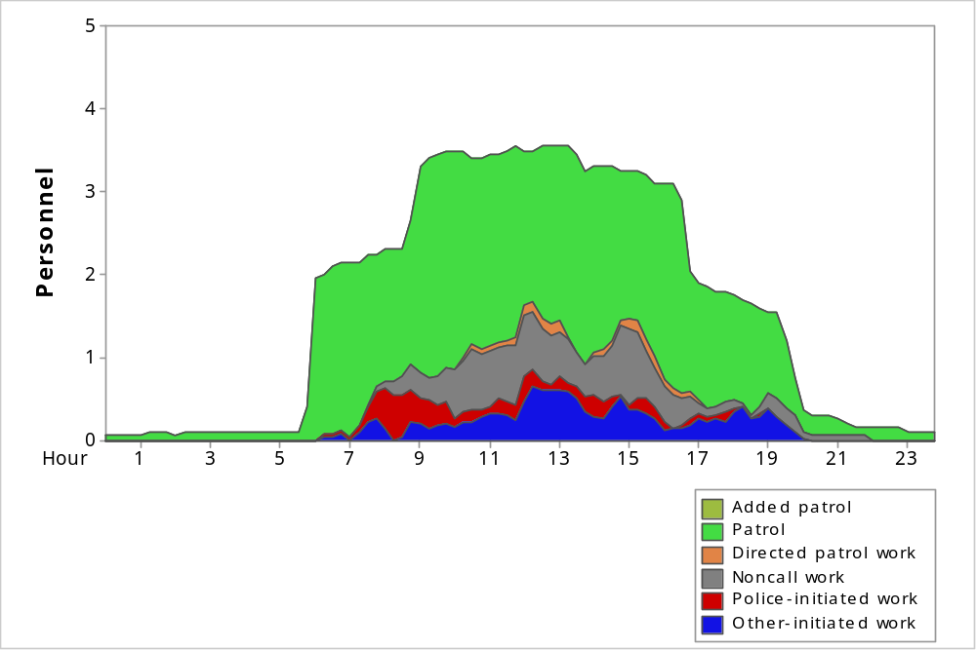

FIGURE 9-39: Traffic Unit Deployment and Total Workload, Weekdays, Winter 2015
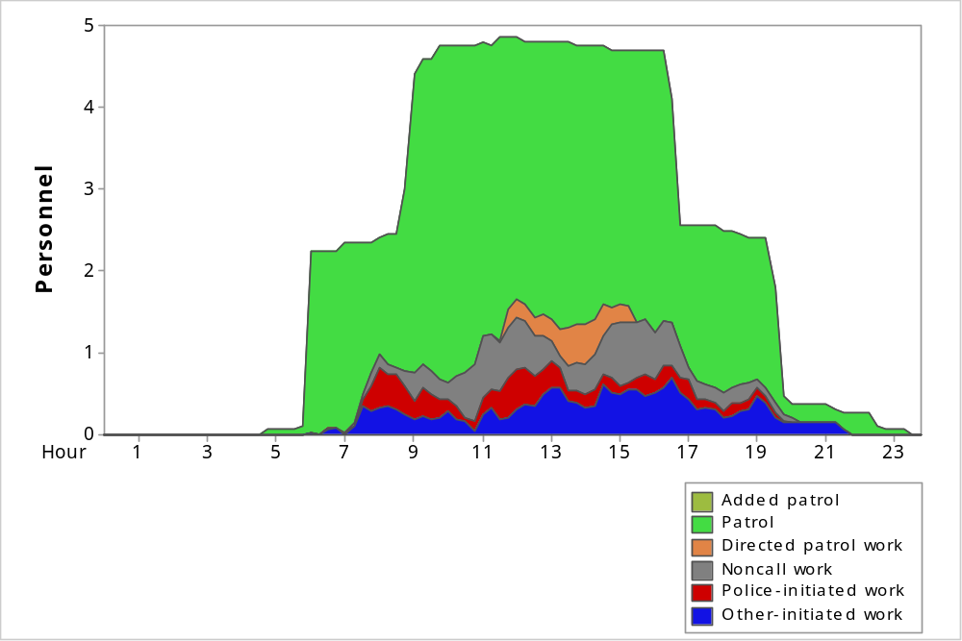
Note: Summer 2014 refers to the period from August 1, 2014 to August 28, 2014. Winter 2015 refers to the period from February 1, 2015 to February 28, 2015. There were no units deployed during the weekends in February 2015. There were two times that a traffic unit worked on a weekend in August 2014. We will exclude the weekend data for workload analysis for traffic units. In addition, all standard traffic shifts occurred between 6:00 a.m. and
8:00 p.m. For that reason, averages by hour are limited to that 14-hour period.
Observations:
- For summer weekdays between the hours of 6:00 a.m. and 8:00 p.m.:
- On average, 2.7 units per hour were deployed.
- Average total workload was 0.8 officers per hour. This was approximately 29 percent of the hourly deployment.
- Average total call-based workload was 0.4 officers per hour during the week. This was approximately 16 percent of the hourly deployment during the week.
- For winter weekdays between the hours of 6:00 a.m. and 8:00 p.m.:
- On average, 3.6 units per hour were deployed.
- Average total workload was 0.9 officers per hour. This was approximately 25 percent of the hourly deployment.
- Average total call based workload was 0.6 officers per hour. This was approximately
16 percent of the hourly deployment.

Event Day Variation
This section looks specifically at calls received on dates on which major events occurred at Levi’s Stadium, which is in Santa Clara. On the eighteen stadium event days that were part of this analysis, 2,413 events were assigned call numbers and included an adequate record of a responding patrol unit as either the primary or secondary unit.
When measured daily, there was as average of 134.1 patrol-related events per day, approximately 1.7 percent of which (42 events) had fewer than 30 seconds spent on the call. Another six events were directed patrol activities. After these are removed, there are 2,365 total calls remaining or 131.4 per day.
We look at the total number of calls received on these days by call category, comparing these days’ totals to the overall average for the year. The number of days with events are few and we do not see significant spikes in the number of calls received on the days included in the analysis. There were an average of 153.5 events and 151.1 calls for the 12-month period from May 2014 through April 2015, an average that is actually higher than what is observed when the 18 stadium event days are averaged together.
Following are two tables. The first shows the number of calls for each day with an event at the stadium. Note that the number of calls varied significantly from event date to event date. The second table shows how all calls on these days were separated by category and compares it against the corresponding yearly average.

TABLE 9-24: Number of Calls by Stadium Event Day
Date | Event | Call Count
8/17/2014 | NFL FOOTBALL (49ERS VS. DENVER BRONCOS) | 87
8/24/2014 | NFL FOOTBALL (49ERS VS. SAN DIEGO CHARGERS) | 141
9/6/2014 | INTERNATIONAL SOCCER (MEXICO VS. CHILE) | 131
9/14/2014 | NFL FOOTBALL (49ERS VS. CHICAGO BEARS) | 102
9/28/2014 | NFL FOOTBALL (49ERS VS. PHILADELPHIA EAGLES) | 131
10/5/2014 | NFL FOOTBALL (49ERS VS. KANSAS CITY CHIEFS) | 135
10/24/2014 | COLLEGIATE FOOTBALL (CAL VS. UNIVERSITY OF OREGON) | 147
11/2/2014 | NFL FOOTBALL (49ERS VS. ST. LOUIS RAMS) | 107
11/23/2014 | NFL FOOTBALL (49ERS VS. WASHINGTON REDSKINS) | 116
11/27/2014 | NFL FOOTBALL (49ERS VS. SEATTLE SEAHAWKS) | 97
12/5/2014 | COLLEGIATE FOOTBALL (PAC 12 CHAMPIONSHIP GAME) | 139
12/20/2014 | NFL FOOTBALL (49ERS VS. SAN DIEGO CHARGERS) | 167
12/28/2014 | NFL FOOTBALL (49ERS VS. ARIZONA CARDINALS) | 113
12/30/2014 | COLLEGIATE FOOTBALL (SAN FRANCISCO BOWL GAME) | 137
2/21/2015 | NHL HOCKEY (SHARKS VS. KINGS) | 142
3/29/2015 | WRESTLING (WWE WRESTLEMANIA 31) | 140
4/11/2015 | MONSTER TRUCKS | 191
4/18/2015 | MOTOCROSS RACE | 148
Total |  | 2,371

TABLE 9-25: Event Day Calls by Category
Category | Calls Per Day
Category | Event Days | All Year
Accidents | 5.7 | 5.6
Alarm | 10.7 | 9.5
Animal calls | 0.9 | 1.2
Assist other agency | 2.9 | 2.8
Check/investigation | 17.0 | 23.9
Crime–persons | 4.4 | 4.1
Crime–property | 9.5 | 11.3
Disturbance | 18.9 | 16.0
Juvenile | 0.3 | 0.4
Miscellaneous | 11.0 | 12.8
Ped/traffic stops | 32.3 | 41.9
Prisoner–arrest | 0.3 | 0.4
Suspicious person/vehicle | 8.9 | 11.4
Traffic/Vehicle related | 8.6 | 9.6
Total | 131.4 | 151.1

Appendix A: Call Description Classification
Call descriptions for the department’s calls for service from May 1, 2014, to February 28, 2015, were classified within the following categories.
TABLE 9-26: Call Descriptions, by Category
Call code | Call Description | Table Category | Figure Category
1015 | IN CUSTODY | Prisoner–arrest | Arrest
WARANT | WARRANT SERVICE | Prisoner–arrest | Arrest
1045 | INJURY CALL | Assist other agency | Assist
1080 | EXPLOSION | Assist other agency | Assist
5150 | INSANE PERSON | Assist other agency | Assist
ASSTFD | ASSIST FIRE DEPARTME | Assist other agency | Assist
FD1069 | FIRE INFORMATION FOR | Assist other agency | Assist
FDAPPL | FIRE INFORMATION FOR | Assist other agency | Assist
FDDUMP | FIRE INFORMATION FOR | Assist other agency | Assist
FDFENC | FIRE INFORMATION FOR | Assist other agency | Assist
FDGAS | FIRE INFORMATION FOR | Assist other agency | Assist
FDGRAS | FIRE INFORMATION FOR | Assist other agency | Assist
FDHAZ2 | FIRE INFORMATION FOR | Assist other agency | Assist
FDHAZ3 | FIRE INFORMATION FOR | Assist other agency | Assist
FDSMOK | FIRE INFORMATION FOR | Assist other agency | Assist
FDSOFA | FIRE INFORMATION FOR | Assist other agency | Assist
FDUNK | FIRE INFORMATION FOR | Assist other agency | Assist
FDVEH | FIRE INFORMATION FOR | Assist other agency | Assist
K9ASST | K9 ASSIST FOR OUTSID | Assist other agency | Assist
TREEDN | TREE DOWN | Assist other agency | Assist
1055 | DEAD BODY / POLICE N | Crime–persons | Crime
1056 | SUICIDE ATTEMPT /POL | Crime–persons | Crime
1056A | SUICIDE ATTEMPT /POL | Crime–persons | Crime
1056T | SUICIDE THREATS | Crime–persons | Crime
1071 | SHOOTING | Crime–persons | Crime
1072 | STABBING | Crime–persons | Crime
207R | KIDNAPPING/REPORT ON | Crime–persons | Crime
211 | ROBBERY | Crime–persons | Crime
211A | ROBBERY/ARMED | Crime–persons | Crime
211R | ROBBERY/REPORT ONLY | Crime–persons | Crime
211SA | ROBBERY/STRONG-ARMED | Crime–persons | Crime
215 | CARJACKING | Crime–persons | Crime
215R | PRIOR CARJACKING | Crime–persons | Crime
220R | ATTEMPTED RAPE/REPOR | Crime–persons | Crime
240242 | ASSAULT AND BATTERY | Crime–persons | Crime
242R | ASSAULT AND BATTERY/ | Crime–persons | Crime
243 | ASSAULT AND BATTERY | Crime–persons | Crime
2434 | SEXUAL BATTERY | Crime–persons | Crime
2434R | SEXUAL BATTERY/REPOR | Crime–persons | Crime
245 | ASSAULT W/DEADLY WEA | Crime–persons | Crime
245R | ASSAULT W/DEADLY WEA | Crime–persons | Crime
246 | SHOOTING INTO A DWEL | Crime–persons | Crime
2463 | RECKLESS FIREARMS DI | Crime–persons | Crime
246R | SHOOTING AT DWELLING | Crime–persons | Crime
261 | RAPE | Crime–persons | Crime
261R | RAPE - REPORT ONLY ( | Crime–persons | Crime
2735 | SPOUSAL ABUSE | Crime–persons | Crime
2735R | SPOUSAL ABUSE - REPO | Crime–persons | Crime
273AR | CHILD ABUSE (MISDOME | Crime–persons | Crime
273D | CHILD ABUSE | Crime–persons | Crime
273DR | CHILD ABUSE - REPORT | Crime–persons | Crime
288 | LEWD/LASCIVIOUS COND | Crime–persons | Crime
288R | LEWD/LASCIVIOUS COND | Crime–persons | Crime
290CC | 290 REGISTRANT COMPL | Crime–persons | Crime
300 | CHILD NEGLECT | Crime–persons | Crime
300R | CHILD NEGLECT - REPO | Crime–persons | Crime
311R | OBSCENE MATERIALS IN | Crime–persons | Crime
314 | INDECENT EXPOSURE | Crime–persons | Crime
314R | INDECENT EXPOSURE - | Crime–persons | Crime
422R | PRIOR THREAT TO COMM | Crime–persons | Crime
6469 | STALKING | Crime–persons | Crime
6469R | STALKING - REPORT ON | Crime–persons | Crime
6476 | CHILD ANNOYANCE | Crime–persons | Crime
6476R | CHILD ANNOYANCE - RE | Crime–persons | Crime
647B | PROSTITUTION | Crime–persons | Crime
6532AR | E-THREATS (PRIOR) - | Crime–persons | Crime
653MR | ANNOYING PHONE CALLS | Crime–persons | Crime
ELDER | ELDER ABUSE REPORT | Crime–persons | Crime
VOCO | VIOLATION OF COURT O | Crime–persons | Crime
VORO | VIOLATION OF RESTRAI | Crime–persons | Crime
10851 | STOLEN VEHICLE | Crime–property | Crime
10851R | STOLEN VEHICLE REPOR | Crime–property | Crime
10852 | TAMPERING W/VEHICLE | Crime–property | Crime
10852R | TAMPERING W/VEHICLE | Crime–property | Crime
11300 | NARCOTICS DETAIL | Crime–property | Crime
4390 | PRESCRIPTION FORGERY | Crime–property | Crime
451 | ARSON | Crime–property | Crime
451R | ARSON - REPORT ONLY | Crime–property | Crime
459 | BURGLARY | Crime–property | Crime
459R | BURGLARY - REPORT ON | Crime–property | Crime
484 | THEFT | Crime–property | Crime
484F2R | CREDIT CARD FORGERY | Crime–property | Crime
484IC | SHOPLIFTER IN CUSTOD | Crime–property | Crime
484R | THEFT - REPORT ONLY | Crime–property | Crime
487 | GRAND THEFT | Crime–property | Crime
487CCR | GRAND THEFT / CAR CL | Crime–property | Crime
487R | GRAND THEFT - REPORT | Crime–property | Crime
488 | PETTY THEFT | Crime–property | Crime
488CC | PETTY THEFT / CAR CL | Crime–property | Crime
488CCR | PETTY THEFT / CAR CL | Crime–property | Crime
488GAS | PETTY THEFT / GAS | Crime–property | Crime
488R | PETTY THEFT - REPORT | Crime–property | Crime
496 | STOLEN PROPERTY | Crime–property | Crime
496R | STOLEN PROPERTY - RE | Crime–property | Crime
502R | PRIOR UNAUTHORIZED A | Crime–property | Crime
503 | EMBEZZLEMENT | Crime–property | Crime
503R | EMBEZZLEMENT - REPOR | Crime–property | Crime
537 | DEFRAUDING AN INNKEE | Crime–property | Crime
537R | DEFRAUDING AN INNKEE | Crime–property | Crime
594 | MALICIOUS MISCHIEF | Crime–property | Crime
594G | MALICIOUS MISCHIEF I | Crime–property | Crime
594GR | MALICIOUS MISCHIEF I | Crime–property | Crime
594R | MALICIOUS MISCHIEF - | Crime–property | Crime
ABC | ABC VIOLATION | Crime–property | Crime
FRAUD | FRAUD/COUNTERFEIT | Crime–property | Crime
MAIL | MAIL TAMPERING/THEFT | Crime–property | Crime
UCBUY | UNDERCOVER BUY | Crime–property | Crime
VCHASE | VEHICLE CHASE | Crime–property | Crime
1014 | ESCORT | Directed patrol | Directed patrol
C2FILL | CODE 2 FILL REQUEST | Directed patrol | Directed patrol
C3FILL | CODE 3 FILL REQUEST | Directed patrol | Directed patrol
DETAIL | SPECIAL DETAIL/NOT A | Directed patrol | Directed patrol
1091 | GENERAL ANIMAL COMPL | Animal calls | General noncriminal
1091A | VICIOUS ANIMAL | Animal calls | General noncriminal
1091B | NOISY ANIMAL | Animal calls | General noncriminal
1091C | INJURED ANIMAL | Animal calls | General noncriminal
1091D | DEAD ANIMAL | Animal calls | General noncriminal
1091E | ANIMAL BITE | Animal calls | General noncriminal
1091G | STRAY ANIMAL | Animal calls | General noncriminal
597 | CRUELTY TO ANIMALS | Animal calls | General noncriminal
597R | CRUELTY TO ANIMALS - | Animal calls | General noncriminal
1065J | MISSING JUVENILE - U | Juvenile | General noncriminal
1065T | MISSING JUVENILE - B | Juvenile | General noncriminal
25662 | MINOR IN POSSESSION | Juvenile | General noncriminal
FOUNDJ | FOUND JUVENILE | Juvenile | General noncriminal
TRUANT | TRUANT ACTIVITY REPO | Juvenile | General noncriminal
1016 | GENERAL USE OF 10-16 | Miscellaneous | General noncriminal
1021 | PHONE MESSAGE | Miscellaneous | General noncriminal
1058 | GARBAGE COMPLAINT | Miscellaneous | General noncriminal
1058D | SPECIAL INCIDENT TYP | Miscellaneous | General noncriminal
1058R | GARBAGE COMPLAINT - | Miscellaneous | General noncriminal
1062 | MEET WITH CITIZEN | Miscellaneous | General noncriminal
1067 | PERSON CALLING FOR H | Miscellaneous | General noncriminal
1087 | MEET WITH OFFICER | Miscellaneous | General noncriminal
1088 | FILL WITH OFFICER | Miscellaneous | General noncriminal
3700K | K9-RELATED ACTIVITY: | Miscellaneous | General noncriminal
AREACK | MISCELLANEOUS USE FO | Miscellaneous | General noncriminal
BOL | BOL FOR OUTSIDE AGEN | Miscellaneous | General noncriminal
BOL4FD | BOL TO PD UNITS - GE | Miscellaneous | General noncriminal
BTINFO | BEAT INFORMATION | Miscellaneous | General noncriminal
CFD | CITIZEN FLAG DOWN | Miscellaneous | General noncriminal
CSB | CIVIL STANDBY | Miscellaneous | General noncriminal
CSVC | COURTESY SERVICE | Miscellaneous | General noncriminal
DCINFO | GENERAL INFORMATION | Miscellaneous | General noncriminal
DESK | GENERIC CALLTYPE FOR | Miscellaneous | General noncriminal
DPW | GENERAL CALLS FOR DP | Miscellaneous | General noncriminal
EVID | EVIDENCE WORK | Miscellaneous | General noncriminal
FCHASE | FOOT CHASE | Miscellaneous | General noncriminal
FD1033 | FIRE INFORMATION FOR | Miscellaneous | General noncriminal
FLOOD | GENERAL CALLS FOR RE | Miscellaneous | General noncriminal
FOLLOW | FOLLOW-UP | Miscellaneous | General noncriminal
FWBOL | GENERAL FIREWORKS CO | Miscellaneous | General noncriminal
HOTHIT | TO DOCUMENT A HOTHIT | Miscellaneous | General noncriminal
MC/O | MUNI CODE - OTHER | Miscellaneous | General noncriminal
PC/O | PENAL CODE - OTHER | Miscellaneous | General noncriminal
PDINFO | POLICE DEPARTMENT IN | Miscellaneous | General noncriminal
PHOTOS | EVIDENCE WORK/PHOTOS | Miscellaneous | General noncriminal
POSTCK | POSTING CHECK | Miscellaneous | General noncriminal
PRINTS | EVIDENCE WORK/PRINTS | Miscellaneous | General noncriminal
SIGNAL | SIGNAL MALFUNCTIONS | Miscellaneous | General noncriminal
SUPENA | SUBPEONA SERVICE | Miscellaneous | General noncriminal
1033 | ALARM | Alarm | Investigations
1033B | ALARM / BURGLARY | Alarm | Investigations
1033H | ALARM / HOLDUP | Alarm | Investigations
1033P | ALARM / PANIC | Alarm | Investigations
1033S | ALARM / BURGLARY / S | Alarm | Investigations
1033T | ETS ACTIVATION | Alarm | Investigations
1033V | ALARM / VEHICLE | Alarm | Investigations
LOJACK | LOJACK SYSTEM ACTIVA | Alarm | Investigations
1034 | OPEN DOOR | Check/investigation | Investigations
1035 | OPEN WINDOW | Check/investigation | Investigations
1053 | PERSON DOWN / POLICE | Check/investigation | Investigations
1054 | POSSIBLE DEAD BODY / | Check/investigation | Investigations
1065R | GENERAL MISSING PERS | Check/investigation | Investigations
1065SC | MISSING PERSON/SPECI | Check/investigation | Investigations
3700 | AREA CHECK | Check/investigation | Investigations
3700B | BAR CHECK | Check/investigation | Investigations
3700P | PARK CHECK | Check/investigation | Investigations
3700S | SCHOOL CHECK | Check/investigation | Investigations
911UNK | 911 HANGUP / UNKNOWN | Check/investigation | Investigations
ATC | ATTEMPT TO CONTACT | Check/investigation | Investigations
ATL | ATTEMPT TO LOCATE | Check/investigation | Investigations
CODE10 | BOMB THREAT | Check/investigation | Investigations
CODE5 | STAKE OUT | Check/investigation | Investigations
FOUNDA | FOUND ADULT | Check/investigation | Investigations
FOUNDP | FOUND PROPERTY | Check/investigation | Investigations
FREQCK | FREQUENT CHECK INFOR | Check/investigation | Investigations
LOSTP | LOST PROPERTY | Check/investigation | Investigations
MWG | MAN WITH A GUN | Check/investigation | Investigations
SEARCH | SEARCH WARRANT | Check/investigation | Investigations
SECCK | SECURITY CHECK | Check/investigation | Investigations
UNKSIT | UNKNOWN SITUATION | Check/investigation | Investigations
WELFCK | WELFARE CHECK | Check/investigation | Investigations
1095 | PEDESTRIAN STOP | Pedestrian/traffic stops | Pedestrian/traffic stops
1096 | PEDESTRIAN STOP - FI | Pedestrian/traffic stops | Pedestrian/traffic stops
1195 | TRAFFIC STOP | Pedestrian/traffic stops | Pedestrian/traffic stops
1196 | TRAFFIC STOP/FILL RE | Pedestrian/traffic stops | Pedestrian/traffic stops
1057 | FIREARMS DISCHARGED | Disturbance | Suspicious incident
12677 | FIREWORKS COMPLAINT | Disturbance | Suspicious incident
415 | DISTURBANCE | Disturbance | Suspicious incident
415D | DISTURBANCE - DOMEST | Disturbance | Suspicious incident
415DV | DISTURBANCE / DOMEST | Disturbance | Suspicious incident
415DVR | DOMESTIC DISTURBANCE | Disturbance | Suspicious incident
415F | DISTURBANCE / FIGHT | Disturbance | Suspicious incident
415G | DISTURBANCE / GANG R | Disturbance | Suspicious incident
415J | DISTURBANCE / JUVENI | Disturbance | Suspicious incident
415M | DISTURBANCE / MUSIC | Disturbance | Suspicious incident
415N | DISTURBANCE / NEIGHB | Disturbance | Suspicious incident
415P | DISTURBANCE / PARTY | Disturbance | Suspicious incident
415R | DISTURBANCE - REPORT | Disturbance | Suspicious incident
415SCU | DISTURBANCE ASSOCIAT | Disturbance | Suspicious incident
415UNK | DISTURBANCE / UNKNOW | Disturbance | Suspicious incident
415W | DISTURBANCE / WEAPON | Disturbance | Suspicious incident
417 | BRANDISHING WEAPON | Disturbance | Suspicious incident
417R | BRANDISHING - REPORT | Disturbance | Suspicious incident
647C | PANHANDLING/BEGGING | Disturbance | Suspicious incident
647F | DRUNK IN PUBLIC | Disturbance | Suspicious incident
990 | ILLEGAL SOLICITOR CO | Disturbance | Suspicious incident
NOISE | NON-SPECIFIC NOISE C | Disturbance | Suspicious incident
1066 | SUSPICIOUS PERSON | Suspicious person/vehicle | Suspicious incident
1066R | SUSPICIOUS PERSON - | Suspicious person/vehicle | Suspicious incident
1070 | PROWLER | Suspicious person/vehicle | Suspicious incident
1070R | PROWLER / REPORT ONL | Suspicious person/vehicle | Suspicious incident
1154 | SUSPICIOUS VEHICLE | Suspicious person/vehicle | Suspicious incident
1154R | SUSPICIOUS VEHICLE - | Suspicious person/vehicle | Suspicious incident
1154U | UNOCCUPIED SUSPICIOU | Suspicious person/vehicle | Suspicious incident
602 | TRESPASSING | Suspicious person/vehicle | Suspicious incident
602R | TRESPASSING - REPORT | Suspicious person/vehicle | Suspicious incident
SUSCIR | SUSPICIOUS CIRCUMSTA | Suspicious person/vehicle | Suspicious incident
SUSPKG | SUSPICIOUS PACKAGE/E | Suspicious person/vehicle | Suspicious incident
1180 | TRAFFIC ACCIDENT W/M | Accidents | Traffic
1180C | TRAFFIC ACCIDENT W/M | Accidents | Traffic
1180RO | TRAFFIC ACCIDENT - R | Accidents | Traffic
1180S | TRAFFIC ACCIDENT W/M | Accidents | Traffic
1180T | TRAFFIC ACCIDENT W/I | Accidents | Traffic
1181 | TRAFFIC ACCIDENT W/M | Accidents | Traffic
1181C | TRAFFIC ACCIDENT W/M | Accidents | Traffic
1181R | PRIOR TRAFFIC ACCIDE | Accidents | Traffic
1181RO | TRAFFIC ACCIDENT - R | Accidents | Traffic
1181S | TRAFFIC ACCIDENT W/M | Accidents | Traffic
1182 | TRAFFIC ACCIDENT W/N | Accidents | Traffic
1182C | NON INJURY ACCIDENT | Accidents | Traffic
1182PP | TRAFFIC ACCIDENT W/N | Accidents | Traffic
1182R | PRIOR TRAFFIC ACCIDE | Accidents | Traffic
1182RO | TRAFFIC ACCIDENT - R | Accidents | Traffic
1182S | TRAFFIC ACCIDENT NO | Accidents | Traffic
1183 | TRAFFIC ACCIDENT W/U | Accidents | Traffic
1183C | TRAFFIC ACCIDENT W/U | Accidents | Traffic
1183RO | TRAFFIC ACCIDENT - R | Accidents | Traffic
1183S | TRAFFIC ACCIDENT W/U | Accidents | Traffic
20001 | FELONY HIT/RUN (INJU | Accidents | Traffic
20001C | FELONY HIT/RUN (INJU | Accidents | Traffic
20001R | FELONY HIT AND RUN / | Accidents | Traffic
20002 | MISDEMEANOR HIT/RUN | Accidents | Traffic
20002C | MISDEMEANOR HIT/RUN | Accidents | Traffic
20002R | MISDEMEANOR HIT AND | Accidents | Traffic
1124 | ABANDONED VEHICLE | Traffic/vehicle related | Traffic
1125 | TRAFFIC HAZARD | Traffic/vehicle related | Traffic
1125SM | TRAFFIC HAZARD/STRAN | Traffic/vehicle related | Traffic
1126 | ABANDONED BICYCLE | Traffic/vehicle related | Traffic
1184 | TRAFFIC CONTROL DETA | Traffic/vehicle related | Traffic
1185 | TOW REQUEST | Traffic/vehicle related | Traffic
23103 | RECKLESS DRIVING | Traffic/vehicle related | Traffic
23109 | SPEED CONTEST | Traffic/vehicle related | Traffic
23110 | THROWING SUBSTANCE A | Traffic/vehicle related | Traffic
23152 | DRIVING UNDER THE IN | Traffic/vehicle related | Traffic
970 | PARKING COMPLAINT | Traffic/vehicle related | Traffic
970AVA | PARKING COMPLAINT - | Traffic/vehicle related | Traffic
970CRZ | PARKING COMPLAINT - | Traffic/vehicle related | Traffic
970RED | PARKING COMPLAINT - | Traffic/vehicle related | Traffic
970VBD | PARKING COMPLAINT - | Traffic/vehicle related | Traffic
970VBH | PARKING COMPLAINT - | Traffic/vehicle related | Traffic
970VBS | PARKING COMPLAINT - | Traffic/vehicle related | Traffic
970VHZ | PARKING COMPLAINT - | Traffic/vehicle related | Traffic
FTY | FAILURE TO YIELD | Traffic/vehicle related | Traffic
STRAND | STRANDED MOTORIST | Traffic/vehicle related | Traffic
TRAF | GENERAL TRAFFIC COMP | Traffic/vehicle related | Traffic
TRANSP | TRANSPORTATION DETAI | Traffic/vehicle related | Traffic
VC/O | VEHICLE CODE - OTHER | Traffic/vehicle related | Traffic
VEHREC | VEHICLE RECOVERY | Traffic/vehicle related | Traffic
VINVER | VIN VERIFICATION | Traffic/vehicle related | Traffic

TABLE 9-27: Noncall Activity Codes, by Activity Type
Code | Activity type
USAB | Administrative
USBC | Administrative
USBI | Administrative
USBJ | Administrative
USBK | Administrative
USBS | Administrative
USBV | Administrative
USCT | Administrative
USTC | Administrative
USTE | Administrative
USTR | Administrative
USC7 | Authorized breaks
USE7 | Authorized breaks
USPS | Authorized breaks
USFU | Follow-up investigation
USMT | Follow-up investigation
USNN | Report writing
USRA | Report writing
USRW | Report writing
USSR | Report writing
USCS | Transports
USEC | Transports
USEF | Transports
USEJ | Transports
USEO | Transports
USEP | Transports
USES | Transports
USEV | Transports
USVA | Vehicle abatement
USVU | Vehicle abatement
EM | Vehicle/equipment maintenance
USEM | Vehicle/equipment maintenance
USVM | Vehicle/equipment maintenance

Appendix B: Uniform Crime Report Information
This section presents information obtained from Uniform Crime Reports (UCR) collected by the Federal Bureau of Investigation (FBI). The table and figures include the most recent information that is publicly available at the national level. This includes crime reports for 2004 through 2013 along with clearance rates for 2013. It is likely the department has more recent information and which will be included in a separate portion of this study.
TABLE 9-27: Reported Crime Rates in 2013, by City
City | State | Population | Crime rates
City | State | Population | Violent | Property | Total
Campbell | CA | 40,549 | 261.41 | 3,854.60 | 4,116.01
Cupertino | CA | 60,440 | 67.836 | 1,343.48 | 1,411.32
Gilroy | CA | 51,240 | 351.29 | 3,395.78 | 3,747.07
Los Altos | CA | 30,225 | 76.096 | 1,184.45 | 1,260.55
Los Gatos | CA | 30,351 | 82.37 | 1,815.43 | 1,897.80
Milpitas | CA | 69,522 | 133.77 | 2,973.16 | 3,106.93
Morgan Hill | CA | 39,907 | 157.87 | 1,693.94 | 1,851.81
Mountain View | CA | 77,399 | 202.85 | 2,204.16 | 2,407.01
Palo Alto | CA | 66,964 | 80.64 | 2,214.62 | 2,295.26
San Jose | CA | 992,143 | 324.05 | 2,571.20 | 2,895.25
Santa Clara | CA | 120,150 | 143.15 | 2,516.02 | 2,659.17
Saratoga | CA | 30,897 | 45.312 | 718.516 | 763.828
Sunnyvale | CA | 148,160 | 97.192 | 1,642.82 | 1,740.01
California |  | 38,332,521 | 402.1 | 2,658.10 | 3,060.20
United States |  | 316,128,839 | 367.9 | 2,730.70 | 3,098.60

FIGURE 9-40: Reported Violent and Property Crime Rates, by Year
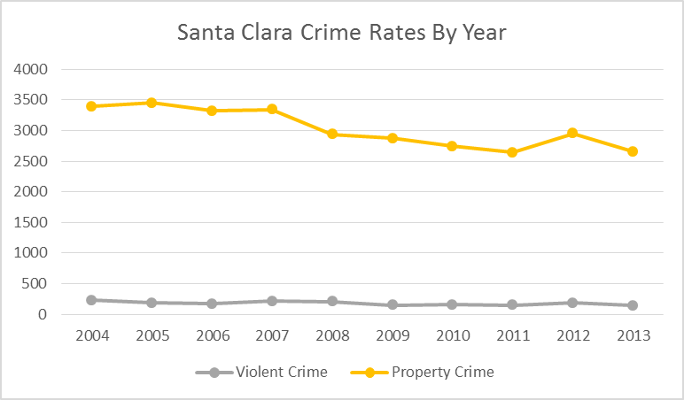

FIGURE 9-41: Reported Municipal and State Crime Rates, by Year
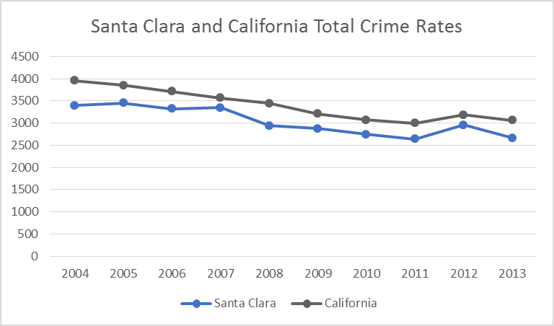

TABLE 9-28: Reported Municipal, State, and National Crime Rates, by Year
Year | Santa Clara PD |  |  |  | California |  |  |  | National
Year | Population | Violent | Property | Total | Population | Violent | Property | Total | Population | Violent | Property | Total
2004 | 103,273 | 231.4 | 3,159.6 | 3,391.0 | 35,842,038 | 527.8 | 3,423.9 | 3,951.7 | 293,656,842 | 463.2 | 3,514.1 | 3,977.3
2005 | 104,692 | 181.5 | 3,266.7 | 3,448.2 | 36,154,147 | 526.0 | 3,321.0 | 3,847.0 | 296,507,061 | 469.0 | 3,431.5 | 3,900.5
2006 | 106,351 | 169.3 | 3,153.7 | 3,323.0 | 36,457,549 | 533.5 | 3,181.7 | 3,715.2 | 299,398,484 | 479.3 | 3,346.6 | 3,825.9
2007 | 109,420 | 211.1 | 3,134.7 | 3,345.8 | 36,553,215 | 524.1 | 3,043.5 | 3,567.6 | 301,621,157 | 471.8 | 3,276.4 | 3,748.2
2008 | 110,712 | 208.6 | 2,731.4 | 2,940.0 | 36,756,666 | 504.2 | 2,941.0 | 3,445.2 | 304,059,724 | 458.6 | 3,214.6 | 3,673.2
2009 | 111,106 | 151.2 | 2,725.3 | 2,876.5 | 36,961,664 | 473.3 | 2,731.0 | 3,204.3 | 307,006,550 | 431.9 | 3,041.3 | 3,473.2
2010 | 116,468 | 156.3 | 2,589.6 | 2,745.9 | 37,338,198 | 439.6 | 2,629.9 | 3,069.5 | 309,330,219 | 404.5 | 2,945.9 | 3,350.4
2011 | 117,837 | 150.2 | 2,489.0 | 2,639.2 | 37,683,933 | 411.2 | 2,584.2 | 2,995.4 | 311,587,816 | 387.1 | 2,905.4 | 3,292.5
2012 | 119,360 | 185.2 | 2,769.8 | 2,955.0 | 38,041,430 | 423.1 | 2,758.7 | 3,181.8 | 313,914,040 | 386.9 | 2,859.2 | 3,246.1
2013 | 120,150 | 143.2 | 2,516.0 | 2,659.2 | 38,332,521 | 402.1 | 2,658.1 | 3,060.2 | 316,128,839 | 367.9 | 2,730.7 | 3,098.6

TABLE 9-29: Reported Santa Clara PD Clearance Rates in 2013
Crime | Santa Clara PD |  |  | California |  |  | National
Crime | Crimes | Clearances | Rate | Crimes | Clearances | Rate | Crimes | Clearances | Rate
Murder & manslaughter | 0 | 0 | NA | 1,766 | 1,164 | 65.9% | 14,749 | 9,106 | 61.7%
Rape | 13 | 4 | 30.8% | 7,463 | 3,114 | 41.7% | 96,316 | 36,794 | 38.2%
Robbery | 55 | 9 | 16.4% | 53,632 | 15,419 | 28.7% | 341,538 | 95,591 | 28.0%
Aggravated assault | 104 | 57 | 54.8% | 89,010 | 49,632 | 55.8% | 713,479 | 395,145 | 55.4%
Burglary | 461 | 26 | 5.6% | 232,009 | 30,008 | 12.9% | 1,884,360 | 240,004 | 12.7%
Larceny | 2,169 | 319 | 14.7% | 621,430 | 94,181 | 15.2% | 5,882,210 | 1,272,290 | 21.6%
Vehicle Theft | 393 | 8 | 2.0% | 165,262 | 13,064 | 7.9% | 690,038 | 95,111 | 13.8%

Appendix C: Staffing Overview
The following table represents the current staffing of the Santa Clara Police Department to include vacant and frozen positions. A category has been added to allow import of the recommended changes offered by CPSM. Each of these recommended changes was addressed in the narrative of this report. As was previously stated, CPSM recognizes that political and fiscal influences necessarily impact staffing decisions. As those influences are beyond the scope of our assessment, these recommendations reflect what CPSM believes to be reasonable staffing levels based upon the workload demand.

Position | Authorized  (including Frozen) | Actual | Vacancies | Frozen | Recommended
Chief | 1 | 1
Assistant Chief | 1 | 1
Captain | 3 | 3
Lieutenant | 8 | 8
Sergeant | 31 | 26 | 5 |  | -3
Officer | 105 | 103 | 2 |  | +14
TOTAL SWORN | 149 | 142 | 7 |  | +11
flexibly staffed
Community Service Officer I | 3 | 3
Community Service Officer II | 14 | 12 |  | 2 | +4 (2 unfrozen)
TOTAL CSO | 17 | 15 |  | 2 | +2
flexibly staffed
Public Safety Dispatcher I
Public Safety Dispatcher II | 13 | 12 | 1 |  | +2
Public Safety Dispatcher III | 3 | 3
Senior Public Safety Dispatcher | 3 | 3
TOTAL DISPATCH | 19 | 18 | 1 |  | +2
Office Specialist IV | 1 | 1
Office Specialist III | 3 | 3
Office Specialist II | 3 | 1 | 2 |  | +1
TOTAL OS | 7 | 5 | 2 |  | +1
flexibly staffed
Records Specialist I | 2 |  |  | 2 | +2 (2 unfrozen)
Records Specialist II | 12 | 12
TOTAL RS | 14 | 12 |  | 2
Records Supervisor | 4 | 2 | 1 | 1 | +1 (1 unfrozen)
Records Manager | 1 | 1
Jail Service Officer | 5 | 5 |  |  | +1
Communications Center Manager | 1 | 1
Comm. Tech. II | 1 | 1
Management Analyst | 1 | 1
Crime Analyst | 1 |  |  | 1
Staff Analyst I | 1 | 1
Forensic Coordinator | 1 | 1
IT Tech (New classification) |  |  |  |  | +2
TOTAL MISCELLANEOUS | 16 | 13 | 1 | 2 | +3
TOTAL | 222 | 205 | 11 | 6 | +19

Field Operations Division | Authorized  (including Frozen) | Actual | Actual  by Unit | Vacancies | Recommended
Captain | 1 | 1 | 1
Lieutenant | 5 | 5
Team 1A/2A and Traffic/Motors |  |  | 1
Team 3A/4A and FTO Program |  |  | 1
Team 1B/2B and Police Reserves |  |  | 1
Team 3B/4B and Scheduling |  |  | 1
Administrative (K9, SRT, HNT, AED, SVACA, THF, Front Desk) |  |  | 1
Sergeant | 16 | 11 |  | 1
Patrol |  |  | 8 | 4
Traffic / Motors |  |  | 2
Traffic Investigator
Temporary Holding Facility |  |  | 1
Front Desk
Officer | 79 | 77
Patrol |  |  | 66 | -2 | +6
Traffic / Motors |  |  | 8
Traffic Investigator |  |  | 1
Temporary Holding Facility
Front Desk |  |  | 2 |  | -2 (Re-assign to Patrol)
Community Service Officer II | 9 * | 7 |  |  | +3 (2 unfrozen)
Parking Control |  |  | 4
Traffic |  |  | 2
Vehicle Management |  |  | 1
Office Specialist III | 1 | 1 | 1
Jail Service Officer | 5 | 5 | 5 |  | +1
TOTAL | 116 | 107 | 107 | 7 | +8
*Two (2) Frozen CSO II.

Investigations Division | Authorized (including Frozen) | Actual | Actual by Unit | Vacancies | Recommended
Captain
Lieutenant | 1 | 1
Sergeant | 7 | 7 |  |  | -3
Robbery / Assaults / Homicide |  |  | 1
Property Crimes |  |  | 1
General Assaults / Domestic Violence |  |  | 1
Special Enforcement Team |  |  | 1
Sex Crimes / Elder Abuse |  |  | 1
Financial Crimes / Identity Theft |  |  | 1
SCCSET |  |  | 1
Officer | 15 | 15
Detectives | 7 |  |  |  | +7
Robbery / Assaults / Homicide |  |  | 1
Property Crimes |  |  | 2
General Assaults / Domestic Violence |  |  | 1
Special Enforcement Team |  |  | 4
Sex Crimes / Elder Abuse |  |  | 2
Financial Crimes / Identity Theft |  |  | 1
SCCSET |  |  | 4
Community Service Officer II | 2 | 2
Subpoenas / Court |  |  | 1
Front Desk |  |  | 1
Office Specialist II | 1 |  |  | 1 | +1 (Detectives)
Office Specialist III | 1 | 1 | 1
Records Specialist II | 14 * | 12 | 12 |  | +2 (unfreeze)
Records Supervisor | 4 ** | 2 | 2 | 1 | +1 (unfreeze)
Records Manager | 1 | 1 | 1
Management Analyst | 1 | 1 | 1
Forensic Coordinator | 1 | 1 | 1
Crime Analyst | 1 ***
TOTAL | 49 | 43 | 43 | 2 | +5
*Two (2) Frozen Records Specialist II.
**One (1) Frozen Records Supervisor.
*** One (1) Frozen Crime Analyst.

Special Operations Division | Authorized (including Frozen) | Actual | Actual by Unit | Vacancies | Recommended
Captain | 1 | 1 | 1
Lieutenant | 1 | 1 | 1
Sergeant | 3 | 3 | 3
Officer | 1 | 1 | 3 * |  | +1
Office Specialist II | 1 |  |  | 1
TOTAL | 7 | 6 | 8 | 1 | +1
*Two (2) Officers temporarily reassigned to the Special Operations Division to support the training and planning needs for SB50.

Services Division | Authorized (including Frozen) | Actual | Actual by Unit | Vacancies | Recommended
Chief | 1 | 1 | 1
Assistant Chief | 1 | 1 | 1
Captain | 1 | 1 | 1
Lieutenant | 1 | 1 | 1
Sergeant | 5 | 5
Professional Standards |  |  | 2
Community Services |  |  | 1
Nuisance Suppression |  |  | 1
Training / K9 |  |  | 1
Evidence
Police Activities League
Officer | 8 | 8
Professional Standards |  |  | 1
Community Services |  |  | 3
Nuisance Suppression |  |  | 2
Training / K9 |  |  | 1
Evidence
Police Activities League |  |  | 1
Community Service Officer II | 6 | 6
Professional Standards
Community Services |  |  | 3 |  | +1 (Crime Prevnt)
Nuisance Suppression |  |  | 1
Training / K9
Evidence |  |  | 2
Police Activities League
Public Safety Dispatcher II | 13 | 12 | 12 | 1 | +2
Public Safety Dispatcher III | 3 | 3 | 3
Senior Public Safety Dispatcher | 3 | 3 | 3
Office Specialist IV | 1 | 1
Chief’s Office |  |  | 1
Office Specialist III | 1 | 1
Services Division |  |  | 1
Office Specialist II | 1 | 1
Training |  |  | 1
Communications Center Manager | 1 | 1 | 1
Comm. Tech. II | 1 | 1 | 1
Staff Analyst I | 1 | 1 | 1
ID Tech (new classification) |  |  |  |  | +2
TOTAL | 48 | 47 | 47 | 1 | +5

Once again, thank you for the opportunity to be of service
to the City of Santa Clara and its Police Department.

CPSM benchmarks are derived from data analyses of police agencies similar to the SCPD.
John Campbell, Joseph Brann, and David Williams, “Officer-per-Thousand Formulas and Other Policy Myths,” Public Management 86 (March 2004): 22−27.
Karen L. Amendola, et al, The Shift Length Experiment: What We Know about 8-, 10-, and 12-hour Shifts in Policing (Washington, DC: Police Foundation, 2012).
L.B. Bell, T. B. Virden, D.J. Lewis, and B.A. Cassidy (2015). Effects of 13-Hour 20-Minute Work Shifts on Law Enforcement Officers’ Sleep, Cognitive Abilities, Health, Quality of Life, and Work Performance: The Phoenix Study. Police Quarterly, Vol. 18(3), pgs. 293-337.
DDACTS is short for Data Driven Approaches to Crime and Traffic Safety. According to the University of Maryland, DDACTS integrates location-based crime and traffic data to establish effective and efficient methods for deploying law enforcement and other resources. Using geomapping to identify areas that have high incidences of crime and crashes, DDACTS uses traffic enforcement strategies that play a dual role in fighting crime and reducing crashes and traffic violations. Drawing on the deterrent of highly visible traffic enforcement and the knowledge that crime often involves the use of motor vehicles, the goal of DDACTS is to reduce the incidence of crime, crashes, and traffic violations across the country.

